如若需要可以查看最新在线文档:

<http://www.zhenchao.cf/bigdata_dw_real_atguigu>

<http://www.zhenchao.tk/bigdata_dw_real_atguigu>

<https://zhenchao125.github.io/bigdata_dw_real_atguigu>

# 第 1 部分: 日活

## 第 1 章 需求概述

大数据处理分离线分析架构和实时处理架构.

* 离线需求

一般是根据前一日的数据生成报表等数据，虽然统计指标、报表繁多，但是对时效性不敏感。

* 实时需求

主要侧重于对当日数据的实时监控，通常业务逻辑相对离线需求简单一下，统计指标也少一些，但是更注重数据的时效性，以及用户的交互性。

### 1.1 离线处理架构

离线分析架构（如Hive，Map/Reduce，Spark Sql等）可以满足数据后分析，数据挖掘的应用需求。

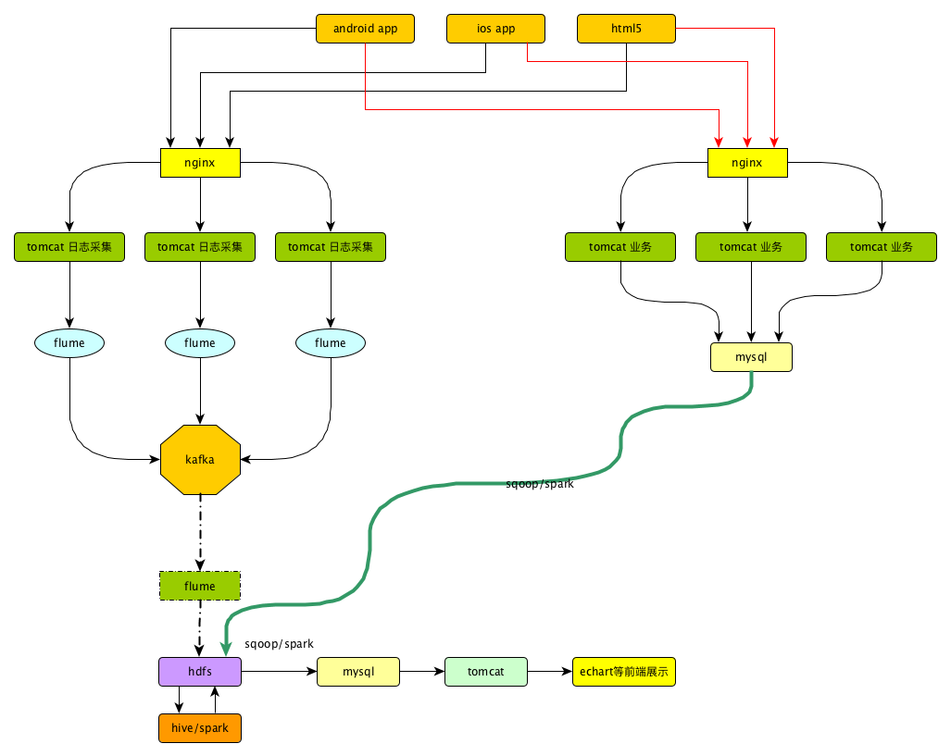

### 1.2 实时处理架构

对于实时性要求高的应用，如用户即时详单查询，业务量监控等，需要应用实时处理架构。

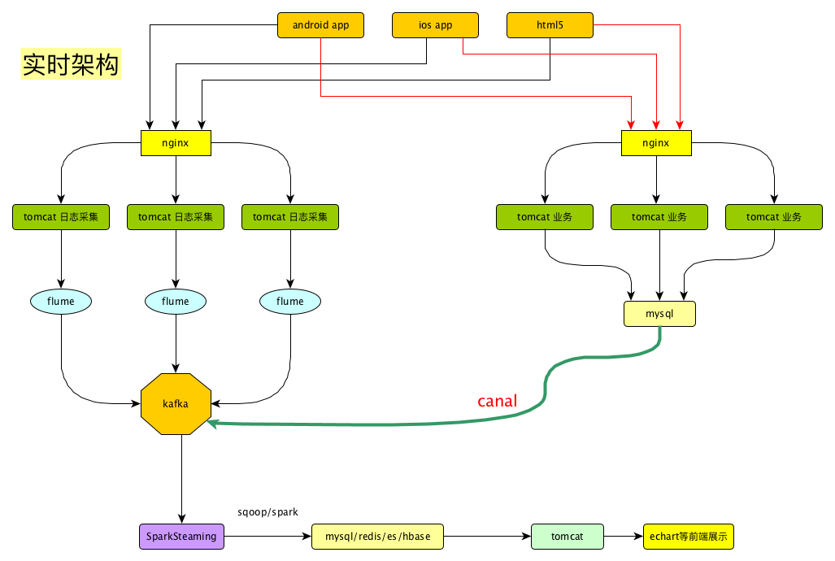

### 1.3 需求

#### 1.3.1 需求1: 当日活跃用户及分时趋势图，昨日对比图(主讲)

当日登录过的用户就可以认为是活跃用户.

这个可以从日志记录来获取到哪些用户登录了.

#### ~~1.3.2 需求2: 当日新增用户数及分时趋势图，昨日对比图~~

#### 1.3.3 需求3: 当日交易额及分时趋势图，昨日对比图(主讲)

#### ~~1.3.4 需求4: 当日订单数及分时趋势图，昨日对比图~~

#### 1.3.5 需求5: 购物券功能风险预警

#### 1.3.6 需求6: 用户购买明细灵活分析功能

## 第 2 章 模拟数据

整个项目我们要做的事情:

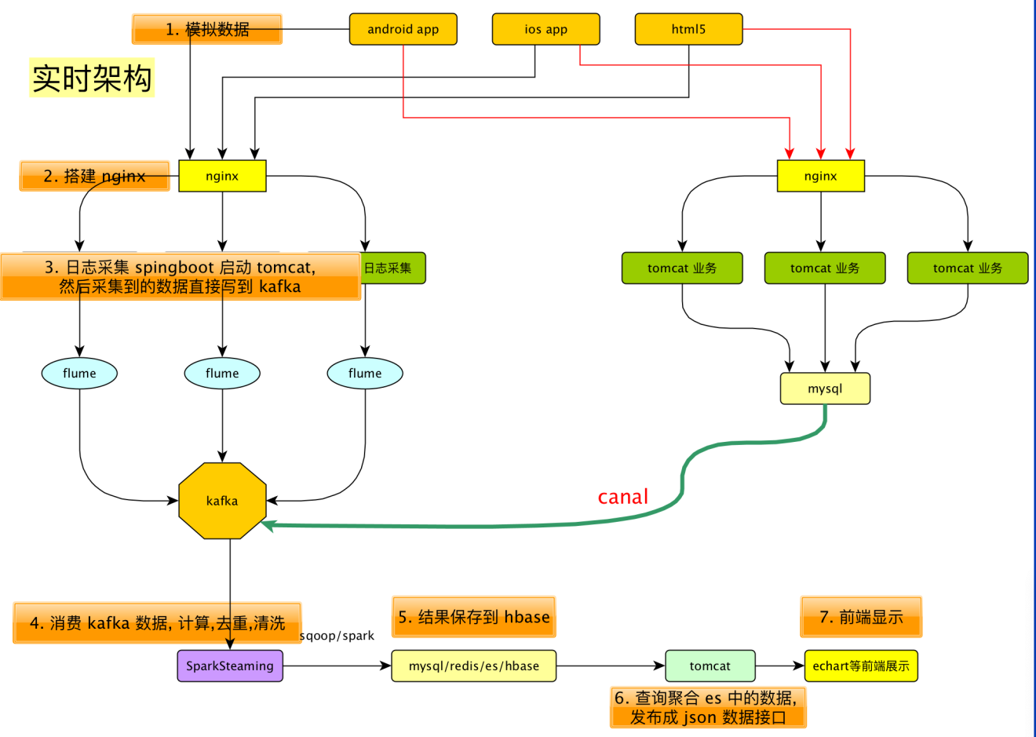

*注意:*

* 考虑到数仓项目已经使用过flume, 所以这次我们省略了 flume 这一层

### 2.1 创建父工程

父工程: gmall

<groupId>com.atguigu.dw</groupId>  
<artifactId>gmall</artifactId>

#### 给父工程添加依赖

<!-- 由于子模块会用到 springboot, 而 springboot 必须使用这个父项目: spring-boot-starter-parent,  
 所以让我们的父项目使用spring-boot-starter-parent,  
 spring-boot-starter-parent 会成为我们 springboot 模块的爷爷了 -->  
<parent>  
 <groupId>org.springframework.boot</groupId>  
 <artifactId>spring-boot-starter-parent</artifactId>  
 <version>1.5.20.RELEASE</version>  
 <relativePath/> <!-- lookup parent from repository -->  
</parent>  
  
<properties>  
 <spark.version>2.1.1</spark.version>  
 <scala.version>2.11.8</scala.version>  
 <log4j.version>1.2.17</log4j.version>  
 <slf4j.version>1.7.22</slf4j.version>  
  
 <fastjson.version>1.2.47</fastjson.version>  
 <httpclient.version>4.5.5</httpclient.version>  
 <httpmime.version>4.3.6</httpmime.version>  
  
 <project.build.sourceEncoding>UTF-8</project.build.sourceEncoding>  
 <project.reporting.outputEncoding>UTF-8</project.reporting.outputEncoding>  
 <java.version>1.8</java.version>  
</properties>  
  
<dependencies>  
 <!--此处放日志包，所有项目都要引用-->  
 <!-- 所有子项目的日志框架 -->  
 <dependency>  
 <groupId>org.slf4j</groupId>  
 <artifactId>jcl-over-slf4j</artifactId>  
 <version>${slf4j.version}</version>  
 </dependency>  
 <dependency>  
 <groupId>org.slf4j</groupId>  
 <artifactId>slf4j-api</artifactId>  
 <version>${slf4j.version}</version>  
 </dependency>  
 <dependency>  
 <groupId>org.slf4j</groupId>  
 <artifactId>slf4j-log4j12</artifactId>  
 <version>${slf4j.version}</version>  
 </dependency>  
 <!-- 具体的日志实现 -->  
 <dependency>  
 <groupId>log4j</groupId>  
 <artifactId>log4j</artifactId>  
 <version>${log4j.version}</version>  
 </dependency>  
</dependencies>  
  
<dependencyManagement>  
 <dependencies>  
 <!-- https://mvnrepository.com/artifact/org.apache.httpcomponents/httpclient -->  
 <dependency>  
 <groupId>org.apache.httpcomponents</groupId>  
 <artifactId>httpclient</artifactId>  
 <version>${httpclient.version}</version>  
 </dependency>  
 <dependency>  
 <groupId>org.apache.httpcomponents</groupId>  
 <artifactId>httpmime</artifactId>  
 <version>${httpmime.version}</version>  
 </dependency>  
  
 <dependency>  
 <groupId>com.alibaba</groupId>  
 <artifactId>fastjson</artifactId>  
 <version>${fastjson.version}</version>  
 </dependency>  
  
  
 <dependency>  
 <groupId>org.apache.spark</groupId>  
 <artifactId>spark-core_2.11</artifactId>  
 <version>${spark.version}</version>  
 </dependency>  
  
 <dependency>  
 <groupId>org.apache.spark</groupId>  
 <artifactId>spark-hive_2.11</artifactId>  
 <version>${spark.version}</version>  
 </dependency>  
  
 <dependency>  
 <groupId>org.apache.spark</groupId>  
 <artifactId>spark-sql_2.11</artifactId>  
 <version>${spark.version}</version>  
 </dependency>  
  
 <dependency>  
 <groupId>org.apache.spark</groupId>  
 <artifactId>spark-streaming_2.11</artifactId>  
 <version>${spark.version}</version>  
 </dependency>  
  
 <dependency>  
 <groupId>org.apache.spark</groupId>  
 <artifactId>spark-streaming-kafka-0-8_2.11</artifactId>  
 <version>${spark.version}</version>  
 </dependency>  
 </dependencies>  
</dependencyManagement>  
<build>  
 <plugins>  
 <!-- 该插件用于将Scala代码编译成class文件 -->  
 <plugin>  
 <groupId>net.alchim31.maven</groupId>  
 <artifactId>scala-maven-plugin</artifactId>  
 <version>3.4.6</version>  
 <executions>  
 <execution>  
 <!-- 声明绑定到maven的compile阶段 -->  
 <goals>  
 <goal>compile</goal>  
 <goal>testCompile</goal>  
 </goals>  
 </execution>  
 </executions>  
 </plugin>  
 </plugins>  
</build>

### 2.2 创建 common 子模块

模块名

<artifactId>gmall-common</artifactId>

#### 给 common 子模块添加依赖

<dependencies>  
 <dependency>  
 <groupId>com.alibaba</groupId>  
 <artifactId>fastjson</artifactId>  
 </dependency>  
  
 <dependency>  
 <groupId>org.apache.httpcomponents</groupId>  
 <artifactId>httpclient</artifactId>  
 </dependency>  
 <dependency>  
 <groupId>org.apache.httpcomponents</groupId>  
 <artifactId>httpmime</artifactId>  
 </dependency>  
</dependencies>

*说明:*

* 这个模块内放一些通用代码. 以后用到其他依赖再添加

### 2.3 创建 mock 子模块

本模块用来生成模拟数据

模块名:

<artifactId>gmall-mock</artifactId>

给 mock 子模块添加依赖

<dependency>  
 <groupId>com.atguigu.dw</groupId>  
 <artifactId>gmall-common</artifactId>  
 <version>1.0-SNAPSHOT</version>  
</dependency>

#### 2.3.1 工具类: RandomNumUtil

生成随机整数的工具类

创建包: com.atguigu.dw.gmall.mock.util

package com.atguigu.dw.gmall.mock.util  
  
import scala.collection.mutable  
import scala.util.Random  
  
/**  
 * 生成随机数据的工具  
 */  
object RandomNumUtil {  
 /*随机数生成器对象*/  
 private val random = new Random()  
   
 /**  
 * 生成随机的整数, 区间: [from, to]  
 *  
 * @param from  
 * @param to  
 * @return  
 */  
 def randomInt(from: Int, to: Int): Int = {  
 if (from > to) throw new IllegalArgumentException(s"from: $from 不能大于 to: $to")  
 else random.nextInt(to - from + 1) + from  
 }  
   
 /**  
 * 创建多个 Int 值  
 *  
 * @param from  
 * @param to  
 * @param count 创建的 Int 值的顺序  
 * @param canRepeat 是否允许重复  
 * @return List[Int] 集合  
 */  
 def randomMultiInt(from: Int, to: Int, count: Int, canRepeat: Boolean = true): List[Int] = {  
 if (canRepeat) {  
 (1 to count).toList.map(_ => randomInt(from, to))  
 } else {  
 val set = mutable.Set[Int]()  
 while (set.size < count) {  
 set += randomInt(from, to)  
 }  
 set.toList  
 }  
 }  
   
 /**  
 * 生成一个随机的 Long 值 范围: [from, to]  
 *  
 * @param from  
 * @param to  
 * @return  
 */  
 def randomLong(from: Long, to: Long): Long = {  
 if (from > to) throw new IllegalArgumentException(s"from: $from 不能大于 to: $to")  
 else math.abs(random.nextLong) % (to - from + 1) + from  
 }  
}

#### 2.3.2 工具类: RandomDate

生成随机日期的工具类

package com.atguigu.dw.gmall.mock.util  
  
import java.util.Date  
  
object RandomDate {  
 def apply(startDate: Date, stopDate: Date, step: Int) = {  
 val randomDate = new RandomDate  
 val avgStepTime = (stopDate.getTime - startDate.getTime) / step  
 randomDate.maxStepTime = 4 * avgStepTime  
 randomDate.lastDateTIme = startDate.getTime  
 randomDate  
 }  
}  
  
class RandomDate {  
 // 上次 action 的时间  
 var lastDateTIme: Long = _  
 // 每次最大的步长时间  
 var maxStepTime: Long = _  
   
 /**  
 * 得到一个随机时间  
 * @return  
 */  
 def getRandomDate = {  
 // 这次操作的相比上次的步长  
 val timeStep = RandomNumUtil.randomLong(0, maxStepTime)  
 lastDateTIme += timeStep  
 new Date(lastDateTIme)  
 }  
}

#### 2.3.3 工具类: RadomOptions

按照一定的分布生成随机选项的工具类

package com.atguigu.dw.gmall.mock.util  
  
import scala.collection.mutable.ListBuffer  
  
/**  
 * 根据提供的值和比重, 来创建RandomOptions对象.  
 * 然后可以通过getRandomOption来获取一个随机的预定义的值  
 */  
object RandomOptions {  
 def apply[T](opts: (T, Int)*) = {  
 val randomOptions = new RandomOptions[T]()  
 randomOptions.totalWeight = (0 /: opts) (_ + _._2) // 计算出来总的比重  
 opts.foreach {  
 case (value, weight) => randomOptions.options ++= (1 to weight).map(_ => value)  
 }  
 randomOptions  
 }  
}  
  
class RandomOptions[T] {  
 var totalWeight: Int = _  
 var options = ListBuffer[T]()  
   
 /**  
 * 获取随机的 Option 的值  
 *  
 * @return  
 */  
 def getRandomOption() = {  
 options(RandomNumUtil.randomInt(0, totalWeight - 1))  
 }  
}

#### 2.3.4 日志发送工具类: LogUploader

向服务器发送生成的日志的工具类

package com.atguigu.dw.gmall.mock.util  
  
import java.io.OutputStream  
import java.net.{HttpURLConnection, URL}  
  
/**  
 * Author lzc  
 * Date 2019/5/14 11:25 AM  
 */  
object LogUploader {  
 /*发送日志*/  
 def sendLog(log: String): Unit = {  
 try {  
 // 1. 日志服务器的地址  
 val logUrl = new URL("http://hadoop201:8080/log")  
 // 2. 得到一个 HttpURLConnection  
 val conn: HttpURLConnection = logUrl.openConnection().asInstanceOf[HttpURLConnection]  
 // 3. 设置请求方法(上传数据一般使用 post 请求)  
 conn.setRequestMethod("POST")  
 // 4. 用来供server进行时钟校对的  
 conn.setRequestProperty("clientTime", System.currentTimeMillis + "")  
 // 5. 允许上传数据  
 conn.setDoOutput(true)  
 // 6. 设置请求的头信息, post 请求必须这样设置  
 conn.setRequestProperty("Content-Type", "application/x-www-form-urlencoded")  
 // 7. 获取上传用的输出流  
 val out: OutputStream = conn.getOutputStream  
 // 8. 写出数据  
 out.write(("log=" + log).getBytes())  
 // 9. flush  
 out.flush()  
 // 10. 关闭资源  
 out.close()  
 // 11. 获取响应码. (或者获取响应信息也行, 否则不会发送请求到服务器)  
 val code: Int = conn.getResponseCode  
 println(code)  
 } catch {  
 case e: Exception => e.printStackTrace()  
 }  
 }  
}

#### 2.3.4 生成日志: JsonMock

生成模拟数据

package com.atguigu.dw.gmall.mock  
  
import java.util.Date  
  
import com.alibaba.fastjson.{JSON, JSONObject}  
import com.atguigu.dw.gmall.mock.util.{LogUploader, RandomNumUtil, RandomOptions}  
  
object JsonMock {  
   
 val startupNum = 100000 // 生成的启动日志的记录数  
 val eventNum = 200000 // 生成的事件日志的记录数  
   
 // 操作系统的分布  
 val osOpts = RandomOptions(("ios", 3), ("android", 7))  
   
 // 日志开始时间  
 var startDate: Date = _  
 // 日志结束时间  
 var endDate: Date = _  
   
 // 地理位置分布  
 val areaOpts = RandomOptions(  
 ("beijing", 20), ("shanghai", 20), ("guangdong", 20),  
 ("hebei", 5), ("heilongjiang", 5), ("shandong", 5),  
 ("tianjin", 5), ("guizhou", 5), ("shangxi", 5),  
 ("sichuan", 5), ("xinjiang", 5)  
 )  
   
 // appId  
 val appId = "gmall"  
   
 // app 的版本分布  
 val versionOpts = RandomOptions(  
 ("1.2.0", 50), ("1.1.2", 15),  
 ("1.1.3", 30), ("1.1.1", 5))  
   
 // 用户行为的分布(事件分布)  
 val eventOpts = RandomOptions(  
 ("addFavor", 10), ("addComment", 30),  
 ("addCart", 20), ("clickItem", 40))  
   
 // app 分发渠道分布  
 val channelOpts = RandomOptions(  
 ("xiaomi", 10), ("huawei", 20), ("wandoujia", 30),  
 ("360", 20), ("tencent", 20), ("baidu", 10), ("website", 10))  
   
 // 生成模拟数据的时候是否结束退出  
 val quitOpts = RandomOptions((true, 5), (false, 95))  
   
 // 模拟出来一条启动日志  
 def initOneStartupLog(): String = {  
 /*  
 `logType` string COMMENT '日志类型',  
 `mid` string COMMENT '设备唯一标识',  
 `uid` string COMMENT '用户标识',  
 `os` string COMMENT '操作系统', ,  
 `appId` string COMMENT '应用id', ,  
 `version` string COMMENT '版本号',  
 `ts` bigint COMMENT '启动时间', 考虑每个终端的时间的不准群性, 时间是将来在服务器端来生成  
 `area` string COMMENT '城市'  
 `channel` string COMMENT '渠道'  
 */  
 val mid: String = "mid_" + RandomNumUtil.randomInt(1, 500)  
 val uid: String = "" + RandomNumUtil.randomInt(1, 10000)  
 val os: String = osOpts.getRandomOption()  
 val appId: String = this.appId  
 val area: String = areaOpts.getRandomOption()  
 val version: String = versionOpts.getRandomOption()  
 val channel: String = channelOpts.getRandomOption()  
   
 val obj = new JSONObject()  
 obj.put("logType", "startup")  
 obj.put("mid", mid)  
 obj.put("uid", uid)  
 obj.put("os", os)  
 obj.put("appId", appId)  
 obj.put("area", area)  
 obj.put("channel", channel)  
 obj.put("version", version)  
 // 返回 json 格式字符串  
 obj.toJSONString  
 }  
   
 // 模拟出来一条事件日志 参数: json 格式的启动日志  
 def initOneEventLog(startupLogJson: String) = {  
 /*`  
 logType` string COMMENT '日志类型',  
 `mid` string COMMENT '设备唯一标识',  
 `uid` string COMMENT '用户标识',  
 `os` string COMMENT '操作系统',  
 `appId` string COMMENT '应用id',  
 `area` string COMMENT '地区' ,  
 `eventId` string COMMENT '事件id',  
 `pageId` string COMMENT '当前页',  
 `nextPageId` string COMMENT '跳转页',  
 `itemId` string COMMENT '商品编号',  
 `ts` bigint COMMENT '时间'  
 */  
 val startupLogObj: JSONObject = JSON.parseObject(startupLogJson)  
   
 val eventLogObj = new JSONObject()  
 eventLogObj.put("logType", "event")  
 eventLogObj.put("mid", startupLogObj.getString("mid"))  
 eventLogObj.put("uid", startupLogObj.getString("uid"))  
 eventLogObj.put("os", startupLogObj.getString("os"))  
 eventLogObj.put("appId", this.appId)  
 eventLogObj.put("area", startupLogObj.getString("area"))  
 eventLogObj.put("eventId", eventOpts.getRandomOption())  
 eventLogObj.put("pageId", RandomNumUtil.randomInt(1, 50))  
 eventLogObj.put("nextPageId", RandomNumUtil.randomInt(1, 50))  
 eventLogObj.put("itemId", RandomNumUtil.randomInt(1, 50))  
 eventLogObj.toJSONString  
 }  
   
 // 开始生成日志  
 def generateLog(): Unit = {  
 (0 to startupNum).foreach(_ => {  
 // 生成一条启动日志  
 val oneStartupLog: String = initOneStartupLog()  
 // 发送启动日志  
 LogUploader.sendLog(oneStartupLog)  
 // 模拟出来多条事件日志  
 while (!quitOpts.getRandomOption()) {  
 // 生成一条事件日志  
 val oneEventLog: String = initOneEventLog(oneStartupLog)  
 // 发送事件日志  
 LogUploader.sendLog(oneEventLog)  
 Thread.sleep(100)  
 }  
 Thread.sleep(1000)  
 })  
 }  
   
 def main(args: Array[String]): Unit = {  
 // 测试  
 generateLog()  
 }  
}

## 第 3 章 启动数据采集服务器

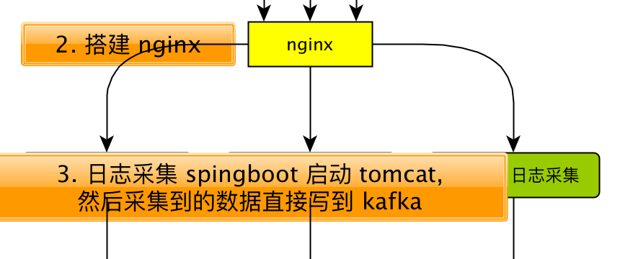

第 2 步我们稍后再来配置, 我们先完成第 3 步: 使用 Springboot 来处理发送过来的日志数据

### 3.1 Spring boot 简介

#### 3.1.1 简介

Spring Boot 是由 Pivotal 团队提供的全新框架，其设计目的是用来简化新 Spring 应用的初始搭建以及开发过程。

该框架使用了特定的方式来进行配置，从而使开发人员不再需要定义样板化的配置。

使用 Spring boot 好处:

1. 内嵌 Tomcat, 不再需要外部的 Tomcat
2. 不再需要那些千篇一律，繁琐的 xml 文件。
3. 更方便的和各个第三方工具（ mysql,redis,elasticsearch,dubbo 等等整合），而只要维护一个配置文件即可。

#### 3.1.2 Sprint boot 和 SSM 的关系

springboot 整合了springmvc, spring 等核心功能。

也就是说本质上实现功能的还是原有的spring ,springmvc 的包，但是 springboot单独包装了一层，这样用户就不必直接对 springmvc， spring 等，在 xml 中配置。

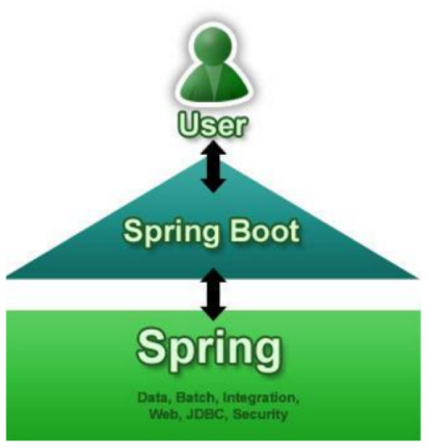

#### 3.1.3 如何修改配置

1. springboot 实际上就是把以前需要用户手工配置的部分，全部作为默认项。除非用户需要额外更改不然不用配置。这就是所谓的: 约定大于配置
2. 如果需要特别配置的时候，去修改application.properties

### 3.2 快速搭建 Spring boot

#### 创建子模块gmall-logger

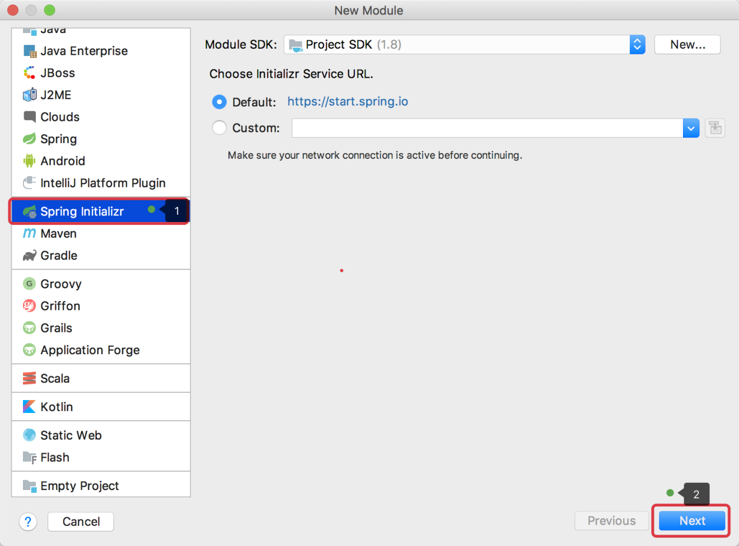

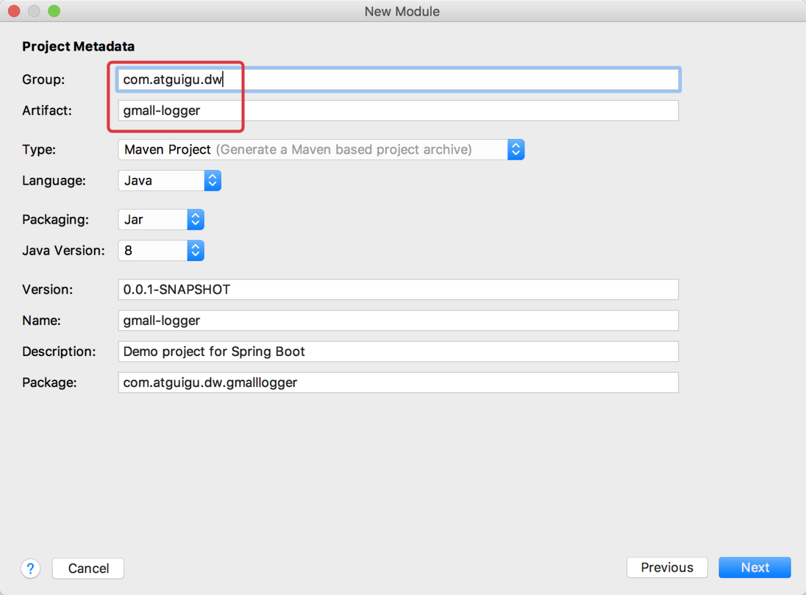

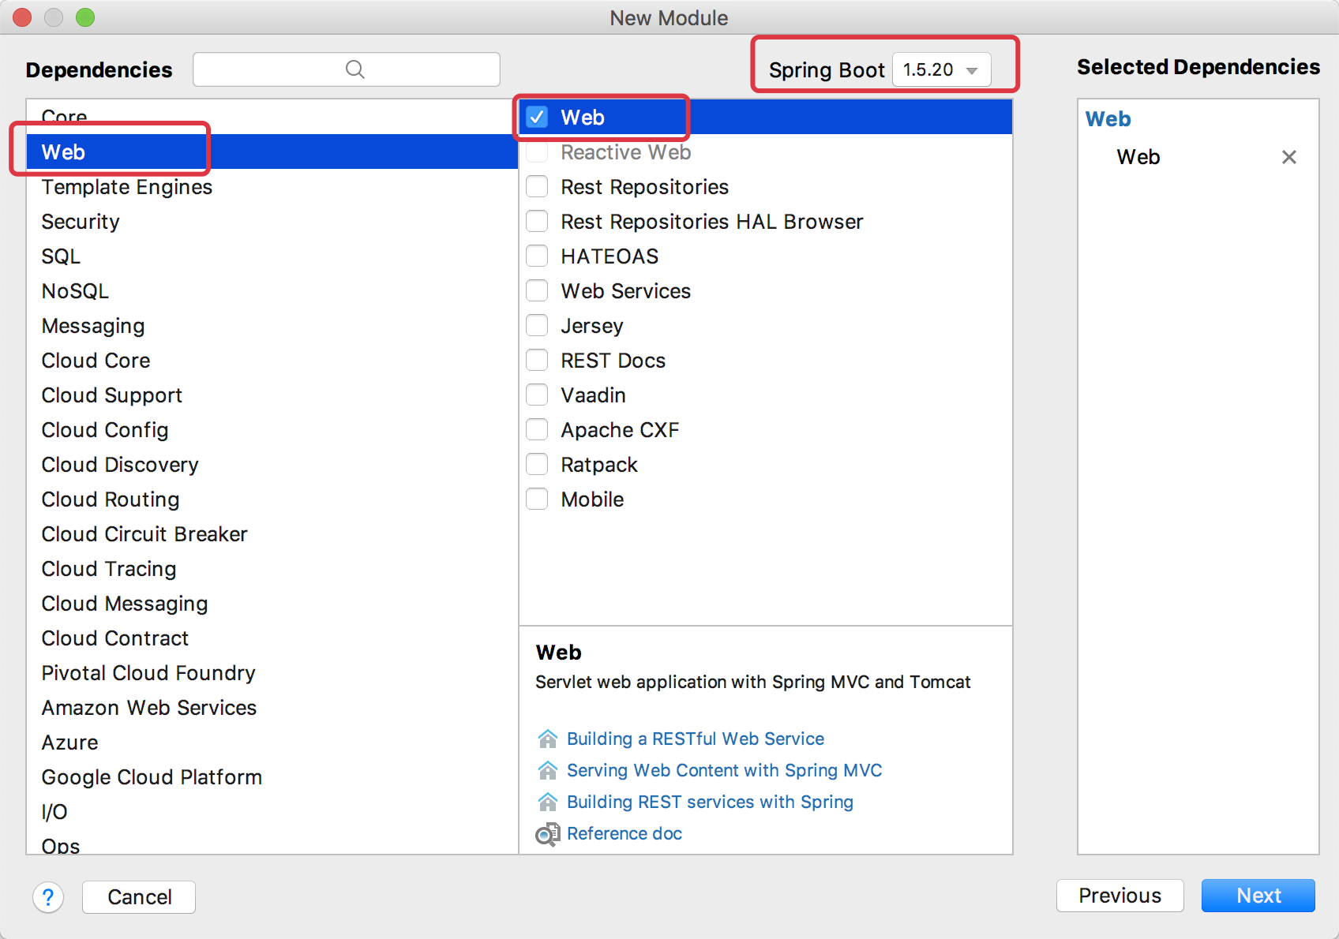

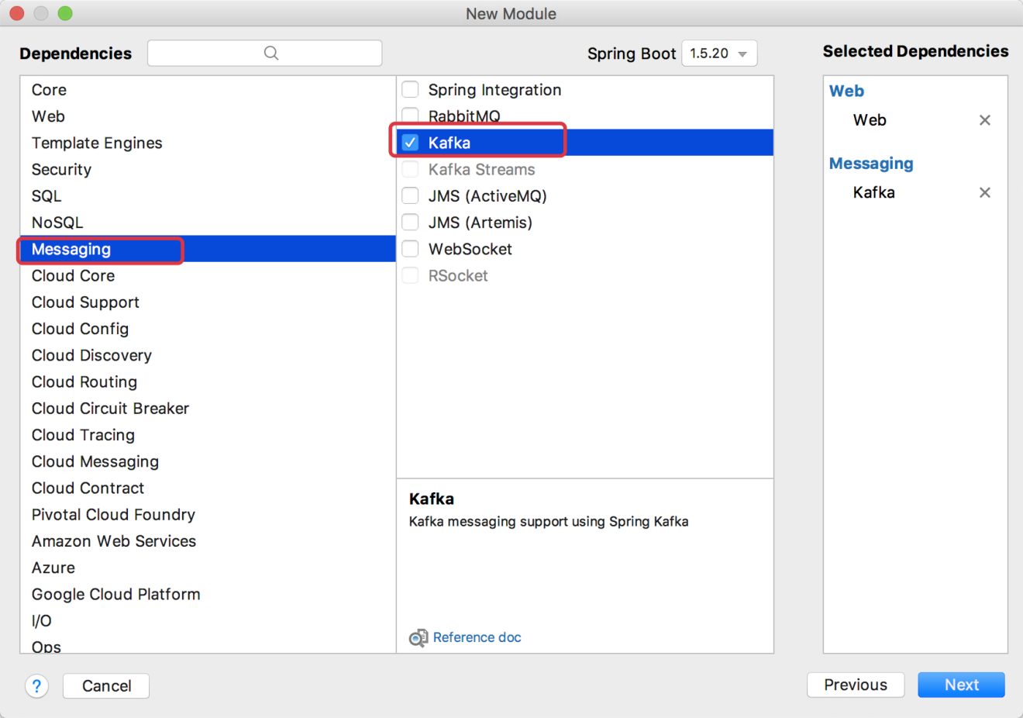

*注意:*

1. 需要把该子项目依赖的父工程来替换成我们自己的父工程.

<parent>  
 <artifactId>gmall</artifactId>  
 <groupId>com.atguigu.dw</groupId>  
 <version>1.0-SNAPSHOT</version>  
</parent>  
<modelVersion>4.0.0</modelVersion>  
  
<artifactId>gmall-logger</artifactId>

1. 把java 标示为Sources Root

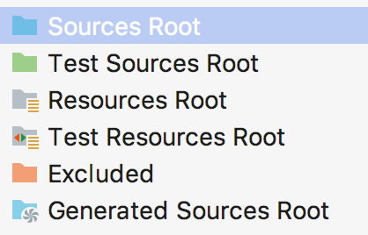

1. 把resources目录标识为Resources Root

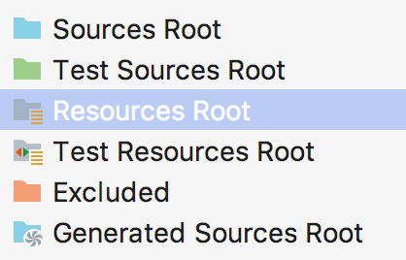

1. 在父工程的pom.xml中添加: <module>gmall-logger</module>

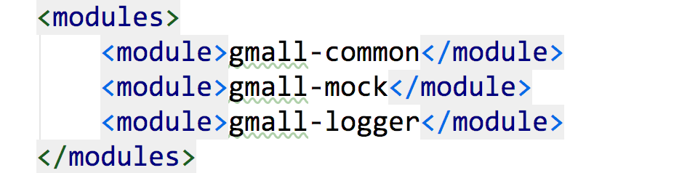

### 3.3 创建 Controller

Controller用来处理http请求

package com.atguigu.dw.gmalllogger.controller;  
  
import org.springframework.web.bind.annotation.PostMapping;  
import org.springframework.web.bind.annotation.RequestParam;  
import org.springframework.web.bind.annotation.RestController;  
  
  
// @Controller  
@RestController // 等价于: @Controller + @ResponseBody  
public class LoggerController {  
 // @RequestMapping(value = "/log", method = RequestMethod.POST)  
 // @ResponseBody //表示返回值是一个 字符串, 而不是 页面名  
 @PostMapping("/log") // 等价于: @RequestMapping(value = "/log", method = RequestMethod.POST)  
 public String doLog(@RequestParam("log") String log) {  
 System.out.println(log);  
 return "success";  
 }  
  
 /**  
 * 业务:  
 *  
 * 1. 给日志添加时间戳 (客户端的时间有可能不准, 所以使用服务器端的时间)  
 *  
 * 2. 日志落盘  
 *  
 * 3. 日志发送 kafka  
 */  
  
}

#### 对日志进行业务处理

##### 1. 添加对gmall-common的依赖

<dependency>  
 <groupId>com.atguigu.dw</groupId>  
 <artifactId>gmall-common</artifactId>  
 <version>1.0-SNAPSHOT</version>  
</dependency>

##### 2. 具体的业务实现

###### 2.1 添加时间戳

在LoggerController中添加如下方法

/**  
 * 添加时间戳  
 * @param logObj  
 * @return  
 */  
public JSONObject addTS(JSONObject logObj){  
 logObj.put("ts", System.currentTimeMillis());  
 return logObj;  
}

###### 2.2 使用log4j给日志落盘

添加log4j.properties 文件

log4j.appender.atguigu.MyConsole=org.apache.log4j.ConsoleAppender  
log4j.appender.atguigu.MyConsole.target=System.err  
log4j.appender.atguigu.MyConsole.layout=org.apache.log4j.PatternLayout   
log4j.appender.atguigu.MyConsole.layout.ConversionPattern=%d{yyyy-MM-dd HH:mm:ss} %6p (%c:%M) - %m%n   
  
log4j.appender.atguigu.File=org.apache.log4j.DailyRollingFileAppender  
log4j.appender.atguigu.File.file=C:/applog/gmall/log/app.log  
log4j.appender.atguigu.File.DatePattern='.'yyyy-MM-dd  
log4j.appender.atguigu.File.layout=org.apache.log4j.PatternLayout  
log4j.appender.atguigu.File.layout.ConversionPattern=%m%n  
  
log4j.logger.com.atguigu.dw.gmalllogger.controller.LoggerController=info,atguigu.File,atguigu.MyConsole

把logging更换成log4j

由于 Spring boot 默认是使用的 logging 来输出日志, 最好更换成log4j

<!-- 去除 logging-->  
<dependency>  
 <groupId>org.springframework.boot</groupId>  
 <artifactId>spring-boot-starter</artifactId>  
 <exclusions>  
 <exclusion>  
 <groupId>org.springframework.boot</groupId>  
 <artifactId>spring-boot-starter-logging</artifactId>  
 </exclusion>  
 </exclusions>  
</dependency>  
<!-- 添加 spring log4j 支持 -->  
<dependency>  
 <groupId>org.springframework.boot</groupId>  
 <artifactId>spring-boot-starter-log4j</artifactId>  
 <version>1.3.8.RELEASE</version>  
</dependency>

日志落盘

// 初始化 Logger 对象  
private final Logger logger = LoggerFactory.getLogger(LoggerController.class);  
/**  
 * 日志落盘  
 * 使用 log4j  
 * @param logObj  
 */  
public void saveLog(JSONObject logObj) {  
 logger.info(logObj.toJSONString());  
}

###### 2.3 发送日志到 kafka

在文件Application.properties中添加kafka配置

#============== kafka 开始===================  
# 指定kafka 代理地址，可以多个  
spring.kafka.bootstrap-servers=hadoop201:9092,hadoop202:9092,hadoop203:9092  
   
# 指定消息key和消息体的编解码方式  
spring.kafka.producer.key-serializer=org.apache.kafka.common.serialization.StringSerializer  
spring.kafka.producer.value-serializer=org.apache.kafka.common.serialization.StringSerializer  
#============== kafka 配置结束===================

发送到 kafka

在 gmall-common子模块中创建一个存放常量的类, 存储topic名字

package com.atguigu.dw.gmall.common.constant;  
  
/**  
 * @Author lzc  
 * @Date 2019/5/14 6:08 PM  
 */  
public class GmallConstant {  
 public static final String TOPIC_STARTUP = "gmall_startup";  
 public static final String TOPIC_EVENT = "gmall_event";  
}

具体发送代码

// 使用注入的方式来实例化 KafkaTemplate. Spring boot 会自动完成  
@Autowired  
KafkaTemplate<String, String> kafkaTemplate;  
  
/**  
 * 发送日志到 kafka  
 *  
 * @param logObj  
 */  
private void sendToKafka(JSONObject logObj) {  
 String logType = logObj.getString("type");  
 String topicName = GmallConstant.TOPIC_STARTUP;  
  
 if ("event".equals(logType)) {  
 topicName = GmallConstant.TOPIC_EVENT;  
 }  
 kafkaTemplate.send(topicName, logObj.toJSONString());  
}

###### 2.4 最终的doLog方法

// 日志转成 JSONObject  
JSONObject logObj = JSON.parseObject(log);  
// 添加时间戳  
logObj = addTS(logObj);  
// 日志落盘  
saveLog(logObj);  
// 发送到 kafka  
sendToKafka(logObj);  
return "success";

### 3.4 部署到 Linux 服务器

把数据采集部署到 Linux 服务器

#### 步骤 1: 更改日志落盘的目录

需要罗盘目录改成 linux 中的目录

log4j.appender.atguigu.File.file=/home/atguigu/applog/gmall/log/app.log

#### 步骤 2: 打包

#### 步骤 3: 启动日志采集服务

java -jar gmall-logger-1.0-SNAPSHOT.jar

#### 步骤 4: 启动模拟数据

注意: 服务器地址换成你的 Linux 地址

#### 步骤 5: 制作启动脚本

制作启动脚本, 以备下次启动方便

后台启动, 并且不显示控制台日志

#!/bin/bash  
java -jar gmall-logger-1.0-SNAPSHOT.jar >/dev/null 2>&1 &

## 第 4 章 使用 Nginx 负载均衡



### 4.1 Nginx 简介

维基百科: https://zh.wikipedia.org/wiki/Nginx

#### 4.1.1 介绍

   Nginx (读作“engine x”), 是一个高性能的 HTTP 和反向代理服务器 , 特点是占有内存少，并发能力强，事实上 nginx 的并发能力确实在同类型的网页服务器中表现较好，中国大陆使用 nginx 网站用户有：百度、京东、新浪、网易、腾讯、淘宝等。

#### 4.1.2 Nginx 和 Tomcat 的关系

除了 tomcat 以外， apache,nginx,jboss,jetty 等都是 http 服务器。

nginx 和 apache 只支持静态页面和 CGI 协议的动态语言，比如 perl 、 php 等， 但是nginx不支持 java 。

Java 程序只能通过与 tomcat 配合完成。   nginx 与 tomcat 配合，为 tomcat 集群提供反向代理服务、负载均衡等服务

#### 4.1.3 Nginx 三大功能

1. 反向代理

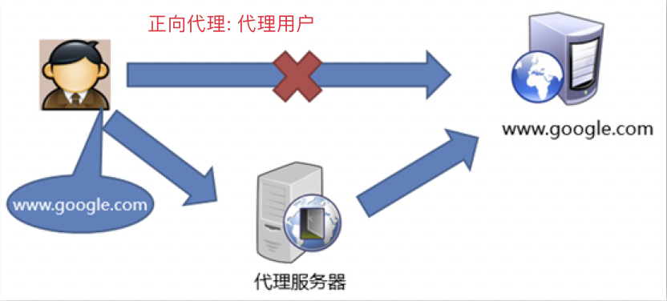

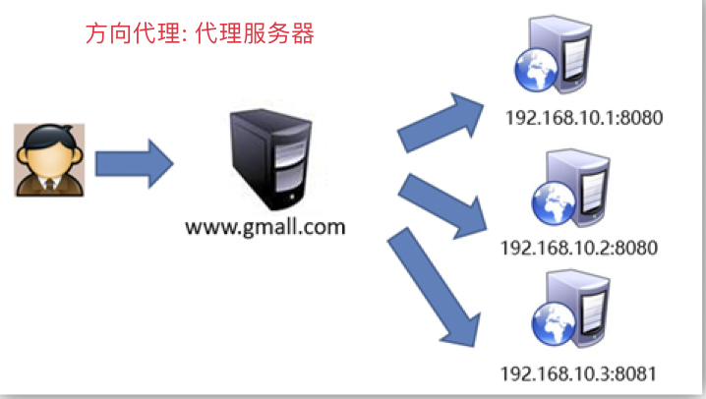

1. 负载均衡 常见均衡算法:

* 轮询（默认） 每个请求按时间顺序逐一分配到不同的后端服务器，如果后端某台服务器宕机，则自动剔除故障机器，使用户访问不受影响
* weight 指定轮询权重，weight值越大，分配到的几率就越高，主要用于后端每台服务器性能不均衡的情况。
* 备机模式 平时不公正, 只有其他down 机的时候才会开始工作
* 公平模式(第三方) 更智能的一个负载均衡算法，此算法可以根据页面大小和加载时间长短智能地进行负载均衡，也就是根据后端服务器的响应时间来分配请求，响应时间短的优先分配。如果想要使用此调度算法，需要Nginx的upstream_fair模块。

1. 动静分离 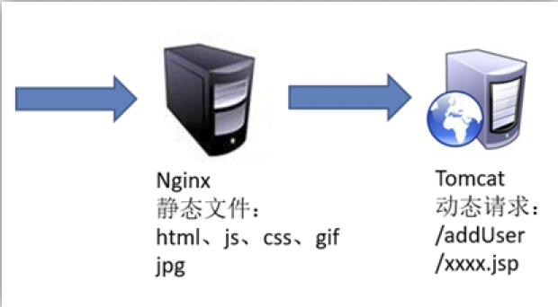

### 4.2 Nginx 安装

#### 步骤 1: 使用 yum 安装依赖包

sudo yum -y install    openssl openssl-devel pcre pcre-devel    zlib zlib-devel gcc gcc-c++

#### 步骤 2: 下载 Nginx

如果已经有下载好的安装包, 此步骤可以省略

/opt/software » wget http://nginx.org/download/nginx-1.12.2.tar.gz

#### 步骤 3: 解压

tar -zxvf nginx-1.12.2.tar.gz -C /opt/module

#### 步骤 4: 编译和安装

进入解压缩的目录

为了防止出现权限问题, 建议切换到 root 用户

./configure   --prefix=/usr/local/webserver/nginx  
make && make install

#### 步骤 5: 启动 Nginx

进入目录: /usr/local/webserver/nginx

* 启动 nginx: sbin/nginx
* 关闭 nginx: sbin/nginx -s stop
* 重新加载: sbin/nginx -s reload

注意:

* Nginx 默认使用的是 80 端口, 由于非root用户不能使用 1024 以内的端口, 所以建议使用 root 用户启动 Nginx
* 如果使用普通用户启动 Nginx, 需要先执行下面的命令来突破上面的限制:sudo setcap cap_net_bind_service=+eip /usr/local/webserver/nginx

#### 步骤 6: 查看是否启动成功

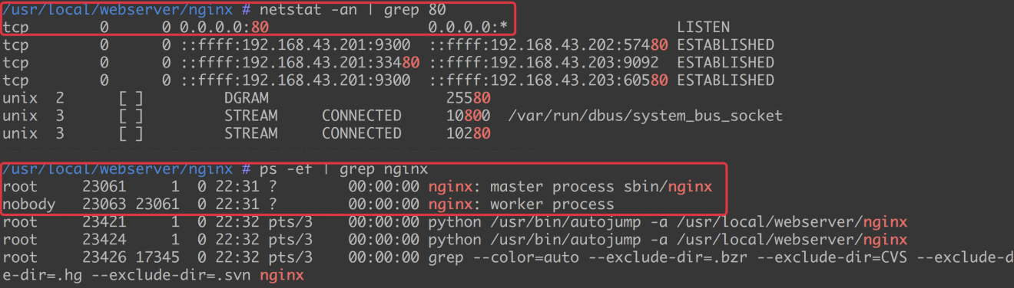

通过网页访问: http://hadoop201

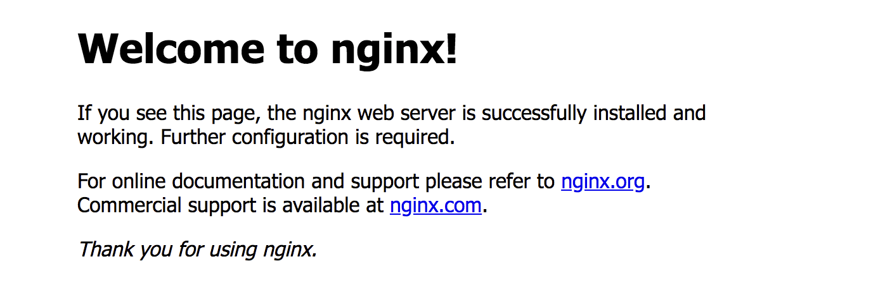

### 4.3 配置负载均衡

#### 步骤 1: 修改/usr/local/webserver/nginx/conf/nginx.conf

增加如下配置:

http {  
 .....  
  
 # 配置上游服务器: 其实就被代理的服务器, springboot  
 upstream logserver{  
 server hadoop201:8080 weight=1;  
 server hadoop202:8080 weight=1;  
 server hadoop203:8080 weight=1;  
 }  
 server {  
 listen 80;  
 server_name logserver;  
  
 location / {  
 root html;  
 index index.html index.htm;  
 # 配置代理  
 proxy_pass http://logserver;  
 proxy_connect_timeout 10;  
 }  
  
 ...  
 }  
}

#### 步骤 2: 分发数据采集服务器的 jar 包

把第 3 章打包的 jar 分发到多个其他节点

#### 步骤 3: 启动 Ngin

#### 步骤 4: 分别在 3 个节点启动 jar

#### 步骤 5: 为了方便启动制作统一启动脚本gmall_cluster

在步骤 3 中, 分别在 3 个节点启动 jar 比较麻烦, 制作统一启动脚本.

#!/bin/bash  
case $1 in  
 "start")  
 {  
 for i in hadoop201 hadoop202 hadoop203  
 do  
 echo "========启动日志服务: $i==============="  
 ssh $i "source /etc/profile ; java -jar /opt/module/gmall/gmall-logger-1.0-SNAPSHOT.jar >/dev/null 2>&1  &"  
 done  
 };;  
 "stop")  
 {  
 for i in hadoop201 hadoop202 hadoop203  
 do  
 echo "========关闭日志服务: $i==============="  
 ssh $i "ps -ef|grep gmall-logger-1.0-SNAPSHOT.jar | grep -v grep|awk '{print \$2}'|xargs kill" >/dev/null 2>&1  
 done  
 };;  
   
 *)  
 {  
 echo 启动姿势不对, 请使用参数 start 启动日志服务, 使用参数 stop 停止服务  
 };;  
esac

#### 步骤 6: 启动脚本

./gmall_cluster start

如果在启动的时候报错: bad interpreter: /bin/bash^M: no such file or directory, 是因为在 window 下写的脚本回车的时候使用的是\r\n, 而在 linux 使用\n就可以了, 所在每行的末尾多了一个\r.

使用下面的命令去掉行尾的\r:

sed -i -e 's/\r$//' gmall_cluster

#### 步骤 7: 做测试

查看落盘目录中是否有产生的日志.

## 第 5 章 使用 Spark Streaming 搭建实时处理模块

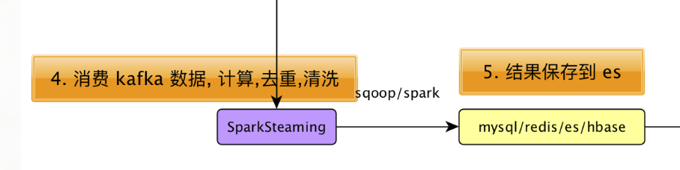

什么叫日活:

1. 通常: 打开应用的用户即为活跃用户，不考虑用户的使用情况。每天一台设备打开多次会被计为一个活跃用户。 也就是只需要统计第一次打开即可
2. 游戏用户: 每天打开/登录游戏的用户数（针对游戏DAU的定义）

我们采用第一种日活的定义, 日活(DAU)统计思路:

1. 从 kafka 读取用户启动日志
2. 当天只保留用户的第一次启动记录, 过滤掉其他启动记录: 借助于 Redis
3. 然后把第一次启动记录保存在 ES, 以供其他应用查询

### 5.1 创建实现处理模块

模块命名: gmall-realtime

#### 加入依赖

<dependencies>  
 <dependency>  
 <groupId>com.atguigu.dw</groupId>  
 <artifactId>gmall-common</artifactId>  
 <version>1.0-SNAPSHOT</version>  
 </dependency>  
  
 <dependency>  
 <groupId>org.apache.spark</groupId>  
 <artifactId>spark-core_2.11</artifactId>  
 </dependency>  
 <dependency>  
 <groupId>org.apache.spark</groupId>  
 <artifactId>spark-streaming_2.11</artifactId>  
 </dependency>  
  
 <dependency>  
 <groupId>org.apache.spark</groupId>  
 <artifactId>spark-streaming-kafka-0-8_2.11</artifactId>  
 </dependency>  
  
 <dependency>  
 <groupId>redis.clients</groupId>  
 <artifactId>jedis</artifactId>  
 <version>2.9.0</version>  
 </dependency>  
  
</dependencies>  
<build>  
 <plugins>  
 <!-- 用于项目的打包插件 -->  
 <plugin>  
 <groupId>org.apache.maven.plugins</groupId>  
 <artifactId>maven-assembly-plugin</artifactId>  
 <version>3.0.0</version>  
 <executions>  
 <execution>  
 <id>make-assembly</id>  
 <phase>package</phase>  
 <goals>  
 <goal>single</goal>  
 </goals>  
 </execution>  
 </executions>  
 </plugin>  
 </plugins>  
</build>

### 5.2 从 Kafka 读取数据

#### 5.2.1 配置文件config.properties

# Kafka配置  
kafka.broker.list=hadoop201:9092,hadoop202:9092,hadoop203:9092  
kafka.group=bigdata  
  
# Redis配置  
redis.host=hadoop201  
redis.port=6379

#### 5.2.2 配置文件log4j.properties

log4j.appender.atguigu.MyConsole=org.apache.log4j.ConsoleAppender  
log4j.appender.atguigu.MyConsole.target=System.err  
log4j.appender.atguigu.MyConsole.layout=org.apache.log4j.PatternLayout   
log4j.appender.atguigu.MyConsole.layout.ConversionPattern=%d{yyyy-MM-dd HH:mm:ss} %10p (%c:%M) - %m%n   
  
log4j.rootLogger=error,atguigu.MyConsole

#### 5.2.3 读取配置文件PropertiesUtil

package com.atguigu.dw.gmall.realtime.util  
  
import java.io.InputStream  
import java.util.Properties  
  
/**  
 * Author lzc  
 * Date 2019/5/15 11:31 AM  
 */  
object PropertiesUtil {  
 private val is: InputStream = ClassLoader.getSystemResourceAsStream("config.properties")  
 private val properties = new Properties()  
 properties.load(is)  
 def getProperty(propertyName: String): String = properties.getProperty(propertyName)  
   
 def main(args: Array[String]): Unit = {  
 println(getProperty("kafka.broker.list"))  
 }  
}

#### 5.2.4 MyKafkaUtil

可以返回一个kafkaStream, 我们使用高级消费者

package com.atguigu.dw.gmall.realtime.util  
  
import kafka.serializer.StringDecoder  
import org.apache.kafka.clients.consumer.ConsumerConfig  
import org.apache.spark.streaming.StreamingContext  
import org.apache.spark.streaming.dstream.InputDStream  
import org.apache.spark.streaming.kafka.KafkaUtils  
  
/**  
 * Author lzc  
 * Date 2019/5/15 11:19 AM  
 */  
object MyKafkaUtil {  
   
 def getKafkaStream(ssc: StreamingContext, topic: String): InputDStream[(String, String)] = {  
 val params: Map[String, String] = Map(  
 ConsumerConfig.BOOTSTRAP_SERVERS_CONFIG -> PropertiesUtil.getProperty("kafka.broker.list"),  
 ConsumerConfig.GROUP_ID_CONFIG -> PropertiesUtil.getProperty("kafka.group")  
 )  
 KafkaUtils.createDirectStream[String, String, StringDecoder, StringDecoder](ssc, params, Set(topic))  
 }  
}

#### 5.2.5 样例类:StartupLog

为了数据访问方便, 把用户访问记录封装在样例类中.

由于 ES 要建索引, 为了以后从 ES 中查询数据的方便, 把日期拆成多个需要的格式.

case class StartupLog(mid: String,  
 uid: String,  
 appId: String,  
 area: String,  
 os: String,  
 channel: String,  
 logType: String,  
 version: String,  
 ts: Long,  
 var logDate: String,  
 var logHour: String)

#### 5.2.6 RedisUtil

package com.atguigu.dw.gmall.realtime.util  
  
import redis.clients.jedis.{Jedis, JedisPool, JedisPoolConfig}  
  
object RedisUtil {  
 val host = PropertiesUtil.getProperty("redis.host")  
 val port = PropertiesUtil.getProperty("redis.port").toInt  
 private val jedisPoolConfig = new JedisPoolConfig()  
 jedisPoolConfig.setMaxTotal(100) //最大连接数  
 jedisPoolConfig.setMaxIdle(20) //最大空闲  
 jedisPoolConfig.setMinIdle(20) //最小空闲  
 jedisPoolConfig.setBlockWhenExhausted(true) //忙碌时是否等待  
 jedisPoolConfig.setMaxWaitMillis(500) //忙碌时等待时长 毫秒  
 jedisPoolConfig.setTestOnBorrow(false) //每次获得连接的进行测试  
 private val jedisPool: JedisPool = new JedisPool(jedisPoolConfig, host, port)  
   
 // 直接得到一个 Redis 的连接  
 def getJedisClient: Jedis = {  
 jedisPool.getResource  
 }  
}

#### 5.2.7 DauApp

在保存到 Redis 的时候, key为dau:日期, value 使用 set 结构.

value 存的值为uid

package com.atguigu.dw.gmall.realtime.app  
  
import com.alibaba.fastjson.JSON  
import com.atguigu.dw.gmall.common.constant.GmallConstant  
import com.atguigu.dw.gmall.realtime.bean.StartupLog  
import com.atguigu.dw.gmall.realtime.util.{MyKafkaUtil, RedisUtil}  
import org.apache.spark.SparkConf  
import org.apache.spark.streaming.dstream.InputDStream  
import org.apache.spark.streaming.{Seconds, StreamingContext}  
import redis.clients.jedis.Jedis  
import redis.clients.util.JedisClusterHashTagUtil  
  
object DauApp {  
 def main(args: Array[String]): Unit = {  
 val conf: SparkConf = new SparkConf().setMaster("local[*]").setAppName("DauApp")  
 val ssc = new StreamingContext(conf, Seconds(5))  
 val sourceStream: InputDStream[(String, String)] =  
 MyKafkaUtil.getKafkaStream(ssc, GmallConstant.TOPIC_STARTUP)  
   
 // 1. 调整数据结构  
 val starupLogDSteam = sourceStream.map {  
 case (_, log) => JSON.parseObject(log, classOf[StartupLog])  
 }  
 // 2. 保存到 redis  
 starupLogDSteam.foreachRDD(rdd => {  
 rdd.foreachPartition(it => {  
 val client: Jedis = RedisUtil.getJedisClient  
 it.foreach(startupLog => {  
 // 存入到 Redis value 类型 set, 存储 uid  
 val key = "dau:" + startupLog.logDate  
 client.sadd(key, startupLog.uid)  
 })  
 client.close()  
 })  
 })  
 ssc.start()  
 ssc.awaitTermination()  
 }  
}

### 5.3 对数据进行清洗和过滤

利用 redis 来完成数据清洗和过滤.

清洗和过滤的目的是为了减轻向 Redis 写数据的压力.

类似于上个项目的黑名单机制, 对已经启动过的用户, 不需要再次向 Redis 写入这样的用户, 所以我们可以提前做过滤.

import java.text.SimpleDateFormat  
import java.util  
import java.util.Date  
  
import com.alibaba.fastjson.JSON  
import com.atguigu.gmall0225.common.util.GmallConstant  
import com.atguigu.gmall0225.realtime.bean.StartupLog  
import com.atguigu.gmall0225.realtime.util.MyKafkaUtil  
import com.atguigu.gmall0225.realtime.util.com.atguigu.dw.gmall.realtime.util.RedisUtil  
import org.apache.hadoop.conf.Configuration  
import org.apache.spark.SparkConf  
import org.apache.spark.broadcast.Broadcast  
import org.apache.spark.streaming.dstream.{DStream, InputDStream}  
import org.apache.spark.streaming.{Seconds, StreamingContext}  
import redis.clients.jedis.Jedis  
  
/**  
 * Author lzc  
 * Date 2019-07-23 08:50  
 */  
object DAUApp {  
 def main(args: Array[String]): Unit = {  
 // 1. 从kafka消费数据(启动日志)  
 val conf = new SparkConf().setAppName("DAUApp").setMaster("local[1]")  
 val ssc = new StreamingContext(conf, Seconds(5))  
 val sourceDStream: InputDStream[(String, String)] = MyKafkaUtil.getKafkaStream(ssc, GmallConstant.TOPIC_STARTUP)  
   
 // 2. 使用redis清洗,  
 // 2.1 对数据进行封装  
 val startupLogDStream: DStream[StartupLog] = sourceDStream.map {  
   
 case (_, json) => {  
 val log = JSON.parseObject(json, classOf[StartupLog])  
 // 给 log 的另外两个字段赋值: logDate logHour  
 val date = new Date(log.ts)  
 log.logDate = new SimpleDateFormat("yyyy-MM-dd").format(date)  
 log.logHour = new SimpleDateFormat("HH").format(date)  
 log  
 }}  
 // 2.2 写入之前先做过滤  
 var filteredStartupLogDStream: DStream[StartupLog] = startupLogDStream.transform(rdd => {  
   
 val client: Jedis = RedisUtil.getJedisClient  
 val uidSet: util.Set[String] = client.smembers(GmallConstant.REDIS_DAU_KEY + ":" + new SimpleDateFormat("yyyy-MM-dd").format(new Date()))  
 val uidSetBC: Broadcast[util.Set[String]] = ssc.sparkContext.broadcast(uidSet)  
 client.close()  
   
 rdd.filter(startupLog => {  
 val uids: util.Set[String] = uidSetBC.value  
 // 返回没有写过的  
 !uids.contains(startupLog.uid)  
 })  
 })  
   
 // 2.3 批次内去重: 如果一个批次内, 一个设备多次启动(对这个设备来说是第一个批次), 则前面的没有完成去重  
 filteredStartupLogDStream = filteredStartupLogDStream  
 .map(log => (log.uid, log))  
 .groupByKey  
 .flatMap {  
 case (_, logIt) => logIt.toList.sortBy(_.ts).take(1)  
 }  
   
 // 2.4 写入到redis  
 filteredStartupLogDStream.foreachRDD(rdd => {  
 rdd.foreachPartition(startupLogIt => {  
 // redis客户端  
 val client: Jedis = RedisUtil.getJedisClient  
 val startupLogList = startupLogIt.toList  
 startupLogList.foreach(startupLog => {  
 // 写入到redis的set中  
 client.sadd(GmallConstant.REDIS_DAU_KEY + ":" + startupLog.logDate, startupLog.uid)  
 })  
 client.close()  
   
 })  
 })  
   
 ssc.start()  
 ssc.awaitTermination()  
 }  
}  
  
/*  
日活:  
 key value(set)  
 "dau:" + 2019-07-23 uid  
  
  
 */

## 第 6 章 数据写入到 ElasticSearch

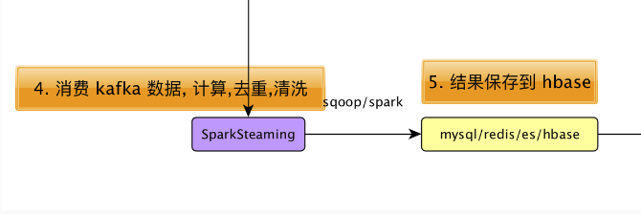

### 为什么选择 ES

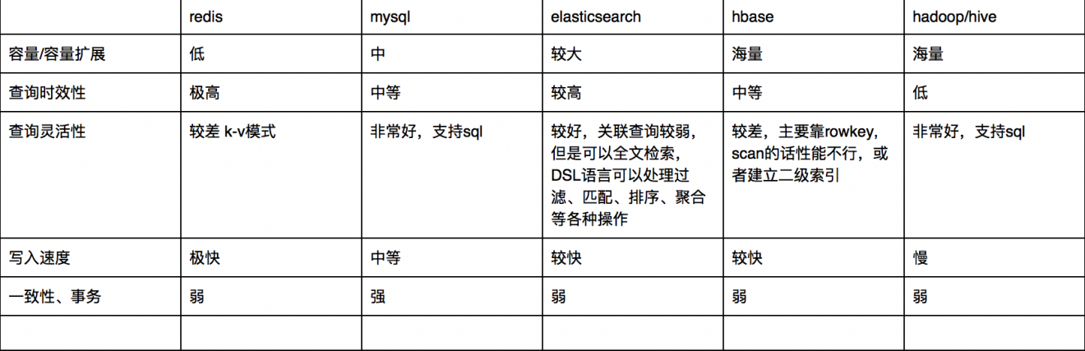

综上 ，在实际环境中，需要一种能够容纳较大规模数据且交互性好的数据库。 mysql 虽然交互性好，但是容量扩展性有限。 hbase 虽然能够支持海量数据，但是查询的灵活度不足。 所以 ES 在容量及交互性上达到一个非常不错的平衡，而且还能支持全文检索。

### 6.1 ElasticSearch 回顾

#### 6.1.1 基本概念

|  |  |
| --- | --- |
| cluster | 整个elasticsearch 默认就是集群状态，整个集群是一份完整、互备的数据。 |
| node | 集群中的一个节点，一般只一个进程就是一个node |
| shard | 分片，即使是一个节点中的数据也会通过hash算法，分成多个片存放，默认是5片。（7.0默认改为1片） |
| index | 相当于rdbms的database, 对于用户来说是一个逻辑数据库，虽然物理上会被分多个shard存放，也可能存放在多个node中。 |
| type | 类似于rdbms的table，但是与其说像table，其实更像面向对象中的class , 同一Json的格式的数据集合。（6.x只允许建一个，7.0被废弃，造成index实际相当于table级） |
| document | 类似于rdbms的 row、面向对象里的object |
| field | 相当于字段、属性 |

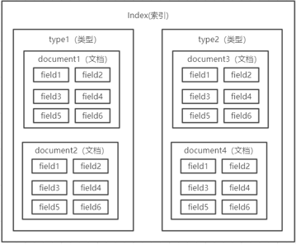

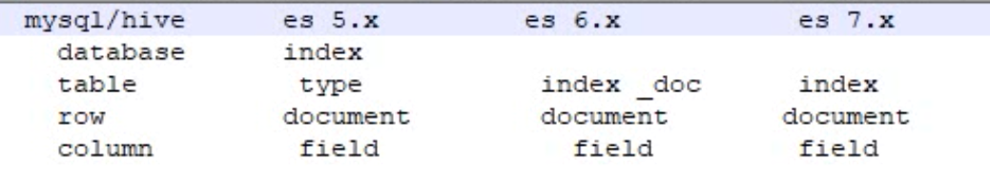

#### 6.1.2 启动脚本

#!/bin/bash  
es_home=/opt/module/elasticsearch-6.3.1  
kibana_home=/opt/module/kibana-6.3.1  
case $1 in  
 "start") {  
 for i in hadoop201 hadoop202 hadoop203  
 do  
 ssh $i "source /etc/profile;${es_home}/bin/elasticsearch >/dev/null 2>&1 &"  
  
 done  
  
 nohup ${kibana_home}/bin/kibana >kibana.log 2>&1 &  
  
 };;  
 "stop") {  
 ps -ef|grep ${kibana_home} |grep -v grep|awk '{print $2}'|xargs kill  
  
 for i in hadoop201 hadoop202 hadoop203  
 do  
 ssh $i "ps -ef|grep $es_home |grep -v grep|awk '{print \$2}'|xargs kill" >/dev/null 2>&1  
 done  
  
  
 };;  
 *){  
 echo "你启动的姿势不正确, 请使用参数 start 来启动es集群, 使用参数 stop 来关闭es集群"  
 };;  
esac

#### 6.1.2 常用操作

# 查询健康状态  
GET /_cat/health?v  
# 查看所有的索引  
GET /_cat/indices?v  
# 查看索引分片情况  
  
# 增加一个索引  
PUT /movie_index   
  
# 删除一个索引  
DELETE /movie_index  
  
# 新增文档  
PUT /movie_index/movie/1  
{ "id":1,  
 "name":"operation red sea",  
 "doubanScore":8.5,  
 "actorList":[   
 {"id":1,"name":"zhang yi"},  
 {"id":2,"name":"hai qing"},  
 {"id":3,"name":"zhang han yu"}  
 ]  
}  
PUT /movie_index/movie/2  
{  
 "id":2,  
 "name":"operation meigong river",  
 "doubanScore":8.0,  
 "actorList":[   
 {"id":3,"name":"zhang han yu"}  
 ]  
}  
  
PUT /movie_index/movie/3  
{  
 "id":3,  
 "name":"incident red sea",  
 "doubanScore":5.0,  
 "actorList":[   
 {"id":4,"name":"zhang chen"}  
 ]  
}  
  
# 根据 _id 查找  
GET /movie_index/movie/1  
  
# 修改某一个 field 的值  
POST /movie_index/movie/1/_update  
{  
 "doc": {  
 "doubanScore": 10  
 }  
}  
  
# 搜索 匹配 过滤  
  
# 分词匹配  
GET /movie_index/movie/_search  
{  
 "query": {  
 "match": {  
 "name": "sea"  
 }  
 }  
}  
# 子查询匹配, 层级结构  
GET /movie_index/movie/_search  
{  
 "query": {  
 "match": {  
 "actorList.name": "zhang"  
 }  
 }  
}  
# 短语匹配: 不拆词 比如查询人名  
GET /movie_index/movie/_search  
{  
 "query": {  
 "match_phrase": {  
 "name": "operation meigong"  
 }  
 }  
}  
  
# 过滤  
  
## 查询后过滤  
GET /movie_index/movie/_search  
{  
 "query": {  
 "match": {  
 "name": "red sea"  
 }  
 }  
 , "post_filter": {  
 "term": {  
 "actorList.id": 4  
 }  
 }  
}  
## 查询前过滤  
GET /movie_index/movie/_search  
{  
 "query": {  
 "bool": {  
 "filter": {  
 "term": {  
 "actorList.name": "zhang"  
 }  
 }  
 , "must": [  
 {"match": {  
 "actorList.id": 3  
 }},{  
 "match": {  
 "actorList.name": "hai"  
 }  
 }  
 ]  
 }  
 }  
}  
  
# 排序  
GET /movie_index/movie/_search  
{  
 "query": {  
 "match": {  
 "actorList.name": "zhang"  
 }  
 }  
 , "sort": [  
 {  
 "doubanScore": {  
 "order": "asc"  
 }  
 }  
 ]  
}  
  
# 分页  
GET /movie_index/movie/_search  
{  
 "from": 1  
 , "size": 2  
}  
  
# 高亮  
GET /movie_index/movie/_search  
{  
 "query": {  
 "match": {  
 "name": "sea"  
 }  
 }  
 , "highlight": {  
 "fields": {  
 "name": {}  
 }  
 }  
}  
  
# 聚合  
GET /movie_index/movie/_search  
{  
 "aggs": {  
 "groupby_actor": {  
 "terms": {  
 "field": "actorList.name.keyword",  
 "size": 10  
 }  
 , "aggs": {  
 "avg_douban": {  
 "avg": {  
 "field": "doubanScore"  
 }  
 }  
 }  
 }  
 }  
}

### 6.2 设计 ES 索引结构

#### 6.2.1 设计索引结构需要考虑的问题

1. 每个字段的类型
2. 索引类型:

* 需要索引, 也需要分词(type=text):
* 例如, 标题，商品名称，分类名称
* 需要索引，但不需要分词(type=keyword)
* 类型id , 日期，数量 ，年龄 ，各种id
* 既不需要索引，也不需要分词(index=false)
* 不会用于条件过滤，经过脱敏的字段，138****0101

1. 保存数据之前一定要先定义好 mapping

#### 6.2.2 创建索引结构

在 Kibana 中执行下面的代码

PUT gmall_dau  
{  
  "mappings": {  
    "_doc":{  
      "properties":{  
         "mid":{  
           "type":"keyword"   
         },  
         "uid":{  
           "type":"keyword"  
         },  
         "area":{  
           "type":"keyword"  
         },  
         "os":{  
           "type":"keyword"  
         },  
         "channel":{  
           "type":"keyword"  
         },  
         "version":{  
           "type":"keyword"  
         },  
         "logDate":{  
           "type":"keyword"  
         },  
         "logHour":{  
           "type":"keyword"  
         },  
         "logHourMinute":{  
           "type":"keyword"  
         },  
         "ts":{  
           "type":"long"  
         }   
      }  
    }  
  }  
}

### 6.3 创建操作 ES 的工具类

由于多个子模块都会操作 ES, 所以, 我们把这个工具类定义在gmall-common包下.

#### 步骤 1: 在gmall-common模块中添加对 ES 的依赖

<!--es 相关依赖开始-->  
<dependency>  
 <groupId>io.searchbox</groupId>  
 <artifactId>jest</artifactId>  
 <version>6.3.1</version>  
</dependency>  
  
<dependency>  
 <groupId>net.java.dev.jna</groupId>  
 <artifactId>jna</artifactId>  
 <version>4.5.2</version>  
</dependency>  
  
<dependency>  
 <groupId>org.codehaus.janino</groupId>  
 <artifactId>commons-compiler</artifactId>  
 <version>2.7.8</version>  
</dependency>  
<!-- es 相关依赖结束 -->

#### 步骤 2: MyESUtil工具类源码

package com.atguigu.dw.gmall.common.util  
  
import io.searchbox.client.config.HttpClientConfig  
import io.searchbox.client.{JestClient, JestClientFactory}  
import io.searchbox.core.{Bulk, DocumentResult, Index}  
  
import scala.collection.mutable  
  
/**  
 * Author lzc  
 * Date 2019/5/15 6:50 PM  
 */  
object MyESUtil {  
 private val ES_HOST = "http://hadoop201"  
 private val ES_HTTP_PORT = 9200  
 private var factory: JestClientFactory = _  
   
 /**  
 * 构建客户端工厂对象  
 */  
 def buildFactory(): Unit = {  
 val config: HttpClientConfig = new HttpClientConfig.Builder(s"$ES_HOST:$ES_HTTP_PORT")  
 .multiThreaded(true)  
 .maxTotalConnection(20)  
 .connTimeout(10000)  
 .readTimeout(10000)  
 .build()  
 factory = new JestClientFactory()  
 factory.setHttpClientConfig(config)  
 }  
   
 /**  
 * 获取客户端对象  
 *  
 * @return  
 */  
 def getClient(): JestClient = {  
 if (factory == null) buildFactory()  
 factory.getObject  
 }  
   
 /**  
 * 关闭客户端  
 *  
 * @param client  
 */  
 def closeClient(client: JestClient) = {  
 if (client != null) {  
 try {  
 client.shutdownClient()  
 } catch {  
 case e => e.printStackTrace()  
 }  
 }  
 }  
   
 /**  
 * 批量插入数据  
 * 插入的时候保证至少传一个 source 进来  
 *  
 * @param index  
 * @param doc  
 * @param source  
 * @param otherSource  
 */  
 def insertBulk(index: String, sources: Iterable[Any]) = {  
 val bulkBuilder = new Bulk.Builder().defaultIndex(index).defaultType("_doc")  
 sources.foreach(any => {  
 bulkBuilder.addAction(new Index.Builder(any).build())  
 })  
 val client: JestClient = getClient()  
 client.execute(bulkBuilder.build())  
 closeClient(client)  
 }  
 def main(args: Array[String]): Unit = {  
 /*val client: JestClient = getClient()  
 // singleOperation(client)  
 multiOperation(client)  
 closeClient(client)*/  
   
   
 val source1 = Startup("mid777111", "uid222", "", "", "", "", "", "", "", "", "", 123124141)  
 val source2 = Startup("mid888222", "uid333", "", "", "", "", "", "", "", "", "", 123124141)  
 insertBulk("gmall_dau", source1::source2::Nil)  
 }  
   
 /**  
 * 批量操作测试  
 *  
 * @param client  
 * @return  
 */  
 def multiOperation(client: JestClient) = {  
 val source1 = Startup("mid777", "uid222", "", "", "", "", "", "", "", "", "", 123124141)  
 val source2 = Startup("mid888", "uid333", "", "", "", "", "", "", "", "", "", 123124141)  
 val bulkBuilder = new Bulk.Builder().defaultIndex("gmall_dau").defaultType("_doc")  
 bulkBuilder.addAction(new Index.Builder(source1).build())  
 bulkBuilder.addAction(new Index.Builder(source2).build())  
 client.execute(bulkBuilder.build())  
 }  
   
 /**  
 * 单次操作测试  
 *  
 * @param client  
 * @return  
 */  
 private def singleOperation(client: JestClient): DocumentResult = {  
 // 测试  
 // 1. 写入操作(单个) index? type? 内容?  
 // 1.1 插入json 格式的字符串  
 val source1 =  
 """  
 |{  
 | "mid": "mid_1234",  
 | "uid": "123"  
 |}  
 """.stripMargin  
 // 1.2 插入样例类  
 val source2 = Startup("mid777", "uid222", "", "", "", "", "", "", "", "", "", 123124141)  
 val index: Index = new Index.Builder(source2)  
 .index("gmall_dau")  
 .`type`("_doc")  
 .build()  
 client.execute(index)  
 }  
}  
  
case class Startup(mid: String,  
 uid: String,  
 appid: String,  
 area: String,  
 os: String,  
 ch: String,  
 logType: String,  
 vs: String,  
 var logDate: String,  
 var logHour: String,  
 var logHourMinute: String,  
 var ts: Long  
 ) {  
   
}

### 6.4 把用户 Startup 信息写入到 ES

DauApp中增加一行:

package com.atguigu.dw.gmall.realtime.app  
  
import java.text.SimpleDateFormat  
import java.util  
import java.util.Date  
  
import com.alibaba.fastjson.JSON  
import com.atguigu.dw.gmall.common.constant.GmallConstant  
import com.atguigu.dw.gmall.common.util.MyESUtil  
import com.atguigu.dw.gmall.realtime.bean.StartupLog  
import com.atguigu.dw.gmall.realtime.util.{MyKafkaUtil, RedisUtil}  
import org.apache.spark.SparkConf  
import org.apache.spark.broadcast.Broadcast  
import org.apache.spark.rdd.RDD  
import org.apache.spark.streaming.dstream.{DStream, InputDStream}  
import org.apache.spark.streaming.{Seconds, StreamingContext}  
import redis.clients.jedis.Jedis  
  
object DauApp {  
 def main(args: Array[String]): Unit = {  
 val conf: SparkConf = new SparkConf().setMaster("local[*]").setAppName("DauApp")  
 val ssc = new StreamingContext(conf, Seconds(5))  
 val sourceStream: InputDStream[(String, String)] =  
 MyKafkaUtil.getKafkaStream(ssc, GmallConstant.TOPIC_STARTUP)  
   
 // 1. 调整数据结构  
 val startupLogDSteam = sourceStream.map {  
 case (_, log) => JSON.parseObject(log, classOf[StartupLog])  
 }  
 // 2. 对 startupLogDStream 做去重过滤  
 val filteredDSteam: DStream[StartupLog] = startupLogDSteam.transform(rdd => {  
 // a: 按照 uid 进行去重: 按照 uid 进行分组, 每组取一个  
 val distinctRDD: RDD[StartupLog] = rdd.groupBy(_.uid).flatMap {  
 case (_, it) => it.take(1)  
 }  
 distinctRDD.collect.foreach(println)  
 // b: 从 redis 中读取清单过滤  
 val client: Jedis = RedisUtil.getJedisClient  
 val key = "dau:" + new SimpleDateFormat("yyyy-MM-dd").format(new Date())  
 // 获取到 redis 清单, 每个周期获取一次  
 val uids: util.Set[String] = client.smembers(key)  
 // 必须把得到的 uids 进行广播, 否则在其他 Executor 上无法得到这个变量的值  
 val uidsBD: Broadcast[util.Set[String]] = ssc.sparkContext.broadcast(uids)  
 // 返回过滤后的 RDD  
 client.close()  
 distinctRDD.filter(log => !uidsBD.value.contains(log.uid))  
 })  
   
 // 3. 保存到 redis.  
 filteredDSteam.foreachRDD(rdd => {  
 rdd.foreachPartition(it => {  
 val client: Jedis = RedisUtil.getJedisClient  
 val startupLogs: List[StartupLog] = it.toList  
 startupLogs.foreach(startupLog => {  
 // 存入到 Redis value 类型 set, 存储 uid  
 val key = "dau:" + startupLog.logDate  
 client.sadd(key, startupLog.uid)  
 })  
 client.close()  
 // 4. 保存到 ES  
 MyESUtil.insertBulk(GmallConstant.ES_INDEX_DAU, startupLogs)  
 })  
 })  
 ssc.start()  
 ssc.awaitTermination()  
 }  
}

## 第 6 章 数据写入到 Hbase 中

### 6.1 使用 phoenix

phoenix 是 Hbase 的 sql 化插件.

具体使用参加文档: bigdata_phoenix_atguigu

https://zhenchao125.github.io/bigdata_phoenix_atguigu/

### 6.2 使用 Phoenix 创建表: gmall_dau

create table gmall_dau(  
 mid varchar,  
 uid varchar,  
 appid varchar,  
 area varchar,  
 os varchar,  
 ch varchar,  
 type varchar,  
 vs varchar,  
 logDate varchar,  
 logHour varchar,  
 ts bigint  
 CONSTRAINT dau_pk PRIMARY KEY (mid,logDate));

### 6.3 添加依赖

<dependency>  
 <groupId>org.apache.phoenix</groupId>  
 <artifactId>phoenix-spark</artifactId>  
 <version>4.14.2-HBase-1.3</version>  
</dependency>  
<dependency>  
 <groupId>org.apache.spark</groupId>  
 <artifactId>spark-sql_2.11</artifactId>  
</dependency>

### 6.4 具体实现代码

// 2.5 写入到 Phoenix(HBase)  
import org.apache.phoenix.spark._  
filteredStartupLogDStream.foreachRDD(rdd => {  
 rdd.foreach(log => {  
 println(log.logType)  
 })  
 // 参数1: 表名 参数2: 列名组成的 seq 参数 zkUrl: zookeeper 地址  
 rdd.saveToPhoenix(  
 "GMALL_DAU",  
 Seq("MID", "UID", "APPID", "AREA", "OS", "CHANNEL", "LOGTYPE", "VERSION", "TS", "LOGDATE", "LOGHOUR"),  
 zkUrl = Some("hadoop201,hadoop202,hadoop203:2181"))  
})

## 第 7 章 提供查询日活和小时明细的接口(旧)

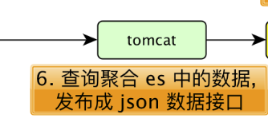

### 7.1 使用 Kibana 查询日活和小时明细

要查询的数据格式:

1. 日活

[  
 {"id":"dau","name":"新增日活","value":1200},  
 {"id":"new_mid","name":"新增用户","value":233}  
]

1. 小时明细:

{  
 "yesterday":{"钟点":数量, "钟点":数量, ...},  
 "today":{"钟点":数量, "钟点":数量, ...}  
 }   
   
 例如:     
  
{  
 "yesterday":{"11":383,"12":123,"17":88,"19":200 },  
 "today":{"12":38,"13":1233,"17":123,"19":688 }  
}

#### 查询某天日活总数

不需要做聚合, 直接得到命中的总数即可

GET /gmall_dau/_search  
{  
 "query": {  
 "bool": {  
 "filter": {  
 "term": {  
 "logDate": "2019-05-15"  
 }  
 }  
 }  
 }  
}

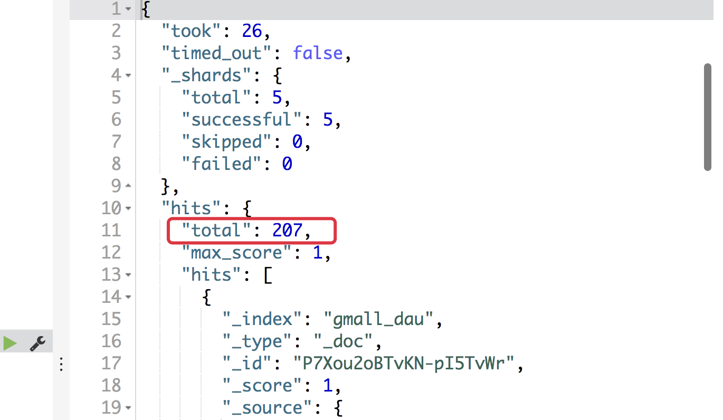

#### 查询某天日活小时明细

GET /gmall_dau/_search  
{  
 "query": {  
 "bool": {  
 "filter": {  
 "term": {  
 "logDate": "2019-05-15"  
 }  
 }  
 }  
 }  
 , "aggs": {  
 "groupby_hour": {  
 "terms": {  
 "field": "logHour",  
 "size": 24  
 }  
 }  
 }  
}

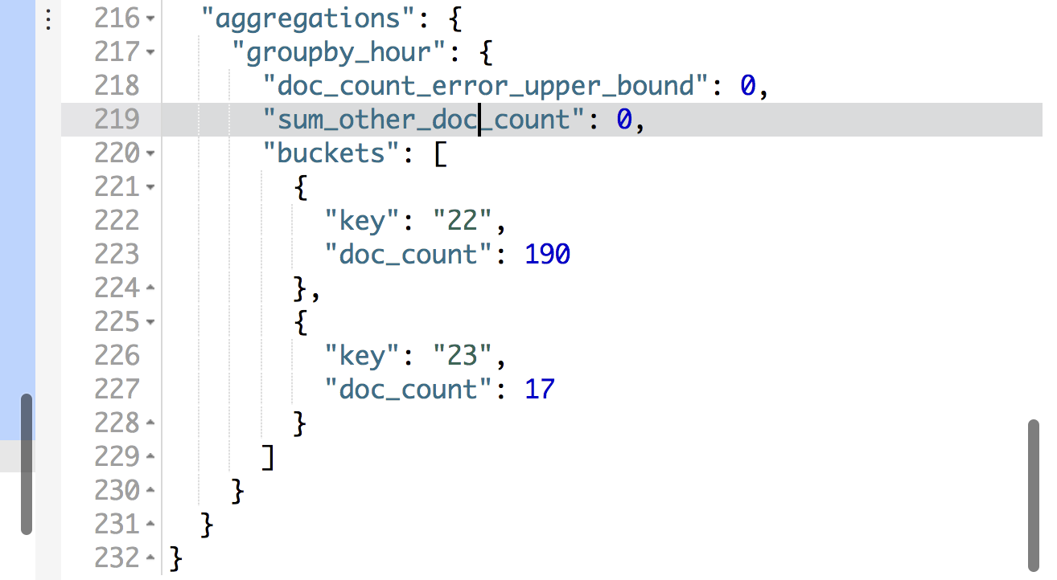

### 7.2 创建 Spring boot 子模块来提供对外查询接口

#### 创建项目

1. 依赖选择

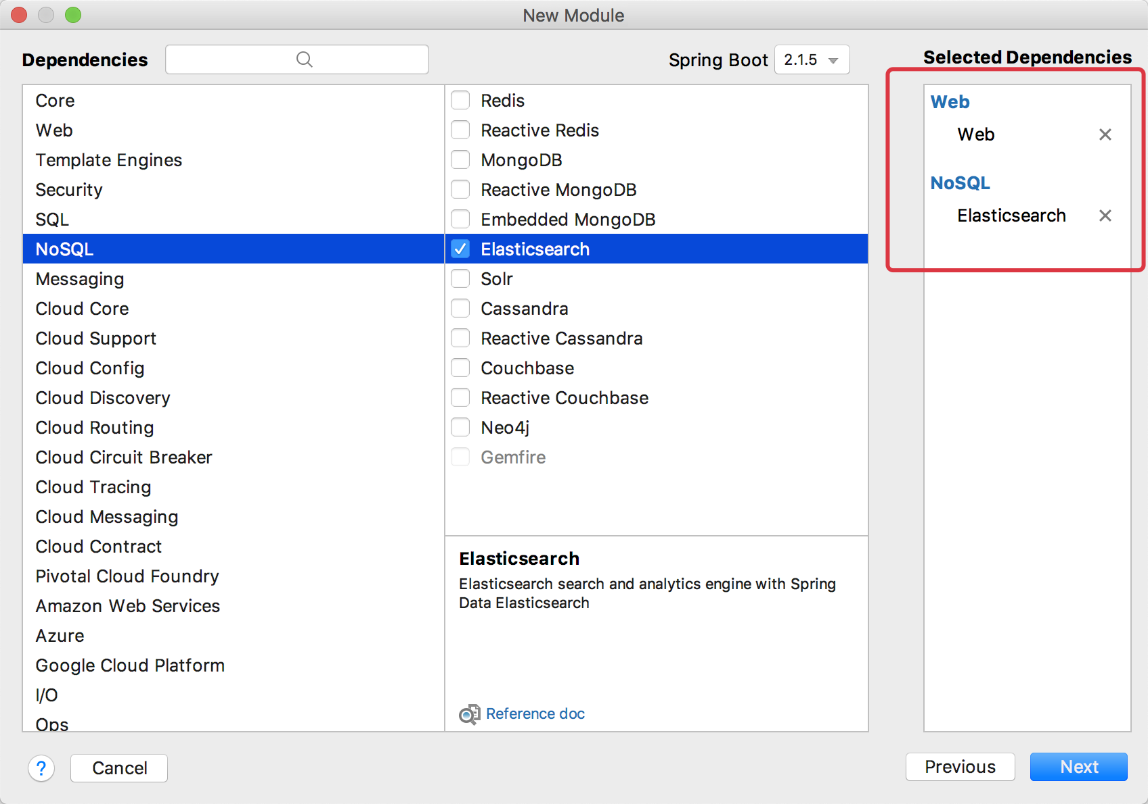

1. 把父依赖更改成我们自己的父工程

* <parent>  
   <artifactId>gmall</artifactId>  
   <groupId>com.atguigu.dw</groupId>  
   <version>1.0-SNAPSHOT</version>  
  </parent>

1. 再在父工程pom.xml中添加如下配置

* <module>gmall-publisher</module>

1. 添加对gmall-common的依赖

* <dependency>  
   <groupId>com.atguigu.dw</groupId>  
   <artifactId>gmall-common</artifactId>  
   <version>1.0-SNAPSHOT</version>  
  </dependency>

1. 在gmall-common子模块中添加 scala 专用的 Json 解析工具

<!-- 转为 scala 准备的 json 解析工具 -->  
 <!-- https://mvnrepository.com/artifact/org.json4s/json4s-jackson -->  
 <dependency>  
 <groupId>org.json4s</groupId>  
 <artifactId>json4s-jackson_2.11</artifactId>  
 <version>3.2.11</version>  
 </dependency>

#### 我们对外提供的两个接口

1. 日活总数接口

* http://hadoop201:8070/realtime-total?date=2019-05-15

1. 日活小时明细接口

* http://hadoop201:8070/realtime-hour?id=dau&&date=2019-05-15

#### 在application.properties添加如下配置

# 默认端口  
server.port=8070  
  
# es 路径  
spring.elasticsearch.jest.uris = http://hadoop201:9200,http://hadoop202:9200,http://hadoop203:9200

### 7.3 使用 service 层来从 es 读取数据

为了书写 json 方便, 我们使用 scala 来完成.

#### 定义 Service 接口

package com.atguigu.dw.gmallpublisher.service  
  
trait PublisherService {  
 /**  
 * 获取指定日期的日活总数  
 *  
 * @param date 指定的日期: 格式 2019-05-15  
 * @return 日活总数  
 */  
 def getDauTotal(date: String): Long  
   
 /**  
 * 获取指定日期日活的小时统计  
 *  
 * @param date  
 * @return  
 */  
 def getDauHour2countMap(date: String): Map[String, Long]  
}

#### 实现 Service 接口

package com.atguigu.dw.gmallpublisher.service  
  
import java.util  
  
import com.atguigu.dw.gmall.common.constant.GmallConstant  
import io.searchbox.client.JestClient  
import io.searchbox.core.search.aggregation.TermsAggregation  
import io.searchbox.core.{Search, SearchResult}  
import org.springframework.beans.factory.annotation.Autowired  
import org.springframework.stereotype.Service  
  
import scala.collection.mutable  
  
// 加此注解 将来可以给PublisherService做注入  
@Service  
class PublisherServiceImp extends PublisherService {  
 // 自动注入  
 @Autowired  
 private var jestClient: JestClient = _  
   
 /**  
 * 获取指定日期的日活总数  
 *  
 * @param date 指定的日期: 格式 2019-05-15  
 */  
 override def getDauTotal(date: String): Long = {  
 // 1. 定义查询 DSL  
 val queryDSL =  
 s"""  
 |{  
 | "query": {  
 | "bool": {  
 | "filter": {  
 | "term": {  
 | "logDate": "$date"  
 | }  
 | }  
 | }  
 | }  
 |}  
 """.stripMargin  
 // 2. 创建 Search 对象  
 val search: Search = new Search.Builder(queryDSL)  
 .addIndex(GmallConstant.ES_INDEX_DAU)  
 .addType("_doc").build()  
 // 3. 执行查询  
 val result: SearchResult = jestClient.execute(search)  
 // 4. 返回总数  
 result.getTotal.toLong  
 }  
   
 /**  
 * 获取指定日期日活的小时统计  
 *  
 * @param date  
 * @return  
 */  
 override def getDauHour2countMap(date: String): Map[String, Long] = {  
 val queryDSL =  
 s"""  
 |{  
 | "query": {  
 | "bool": {  
 | "filter": {  
 | "term": {  
 | "logDate": "$date"  
 | }  
 | }  
 | }  
 | }  
 | , "aggs": {  
 | "groupby_hour": {  
 | "terms": {  
 | "field": "logHour",  
 | "size": 24  
 | }  
 | }  
 | }  
 |}  
 """.stripMargin  
   
 val search = new Search.Builder(queryDSL)  
 .addIndex(GmallConstant.ES_INDEX_DAU)  
 .addType("_doc")  
 .build()  
 val result: SearchResult = jestClient.execute(search)  
 val buckets: util.List[TermsAggregation#Entry] = result.getAggregations.getTermsAggregation("groupby_hour").getBuckets  
   
 val hour2countMap: mutable.Map[String, Long] = mutable.Map[String, Long]()  
 for (i <- 0 until buckets.size) {  
 val bucket: TermsAggregation#Entry = buckets.get(i)  
 hour2countMap += bucket.getKey -> bucket.getCount  
 }  
 hour2countMap.toMap  
 }  
}

### 7.4 定义 Controller 来接收用户请求

package com.atguigu.dw.gmallpublisher.controller  
  
import java.text.SimpleDateFormat  
import java.util.Date  
  
import com.atguigu.dw.gmallpublisher.service.PublisherService  
import org.apache.commons.lang.time.DateUtils  
import org.json4s.jackson.JsonMethods  
import org.springframework.beans.factory.annotation.Autowired  
import org.springframework.web.bind.annotation.{GetMapping, RequestParam, RestController}  
  
import scala.collection.mutable  
  
  
/*  
日活:  
 http://hadoop201:8070/realtime-total?date=2019-05-15  
   
 [  
 {"id":"dau","name":"新增日活","value":1200},  
 {"id":"new_mid","name":"新增用户","value":233}  
 ]  
*/  
/*  
明细:  
 http://hadoop201:8070/realtime-hour?id=dau&&date=2019-05-15  
   
 {  
 "yesterday":{"钟点":数量, "钟点":数量, ...},  
 "today":{"钟点":数量, "钟点":数量, ...}  
 }  
*/  
  
@RestController  
class PublisherController {  
 @Autowired  
 var publisherService: PublisherService = _  
   
 @GetMapping(Array("realtime-total"))  
 def getRealTimeTotal(@RequestParam("date") date: String): String = {  
 val total: Long = publisherService.getDauTotal(date)  
   
 val result =  
 s"""  
 |[  
 | {"id":"dau","name":"新增日活","value":$total},  
 | {"id":"new_mid","name":"新增用户","value":233}  
 |]  
 """.stripMargin  
 result  
 }  
   
 @GetMapping(Array("realtime-hour"))  
 def getRealTimeHour(@RequestParam("id") id: String, @RequestParam("date") date: String) = {  
 if (id == "dau") {  
 val todayMap: Map[String, Long] = publisherService.getDauHour2countMap(date)  
 val yesterdayMap: Map[String, Long] = publisherService.getDauHour2countMap(date2Yesterday(date))  
   
 val resultMap: mutable.Map[String, Map[String, Long]] = mutable.Map[String, Map[String, Long]]()  
 resultMap += "today" -> todayMap  
 resultMap += "yesterday" -> yesterdayMap  
 println(resultMap)  
 // 转变成 json 格式字符串输出  
 import org.json4s.JsonDSL._  
 JsonMethods.compact(JsonMethods.render(resultMap))  
 } else {  
 null  
 }  
 }  
   
 private val dateFormat = new SimpleDateFormat("yyyy-MM-dd")  
   
 // 通过今天计算出来昨天  
 private def date2Yesterday(date: String): String = {  
 val today: Date = dateFormat.parse(date)  
 val yesterday: Date = DateUtils.addDays(today, -1)  
 dateFormat.format(yesterday)  
 }  
}

## 第 7 章 日活统计数据查询接口(新)

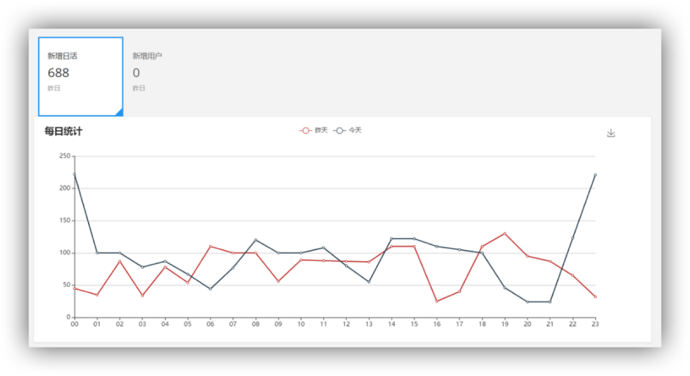

### 7.1 提供的接口和返回的数据类型

#### 7.1.1 需要提供的接口

1. 日活总数:

http://localhost:8070/realtime-total?date=2019-09-20

1. 日活分时统计

http://localhost:8070/realtime-hour?id=dau&date=2019-02-20

#### 7.1.2 返回的数据格式

1. 日活总数

[{"id":"dau","name":"新增日活","value":1200},  
{"id":"new_mid","name":"新增设备","value":233} ]

1. 日活分时统计

{"yesterday":{"11":383,"12":123,"17":88,"19":200 },  
"today":{"12":38,"13":1233,"17":123,"19":688 }}

### 7.2 创建 Spring boot 子模块来提供对外查询接口

1. 依赖选择

操作数据库我们选择使用 MyBatis 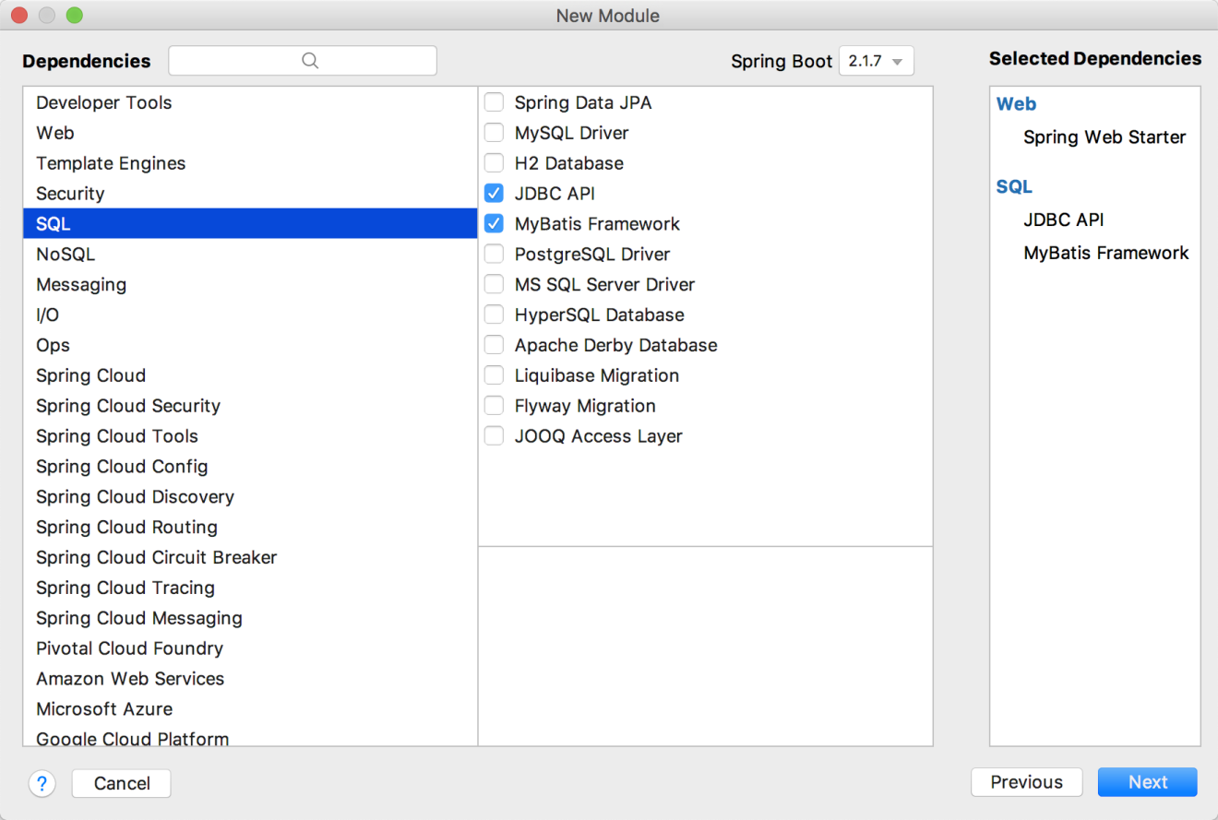

1. 父依赖改成我们自己的父工程

* <parent>  
   <artifactId>gmall</artifactId>  
   <groupId>com.atguigu.dw</groupId>  
   <version>1.0-SNAPSHOT</version>  
  </parent>

1. 再在父工程pom.xml中添加如下配置

* <module>gmall-publisher</module>

1. 添加对gmall-common的依赖

* <dependency>  
   <groupId>com.atguigu.dw</groupId>  
   <artifactId>gmall-common</artifactId>  
   <version>1.0-SNAPSHOT</version>  
  </dependency>

1. 添加其他依赖

<!--phoenix-->  
<dependency>  
 <groupId>org.apache.phoenix</groupId>  
 <artifactId>phoenix-core</artifactId>  
 <version>4.14.2-HBase-1.3</version>  
</dependency>  
<!--phoenix 用到的工具包-->  
<dependency>  
 <groupId>com.google.guava</groupId>  
 <artifactId>guava</artifactId>  
 <version>20.0</version>  
</dependency>

1. 配置文件: application.properties

server.port=8070  
logging.level.root=error  
# jdbc  
spring.datasource.driver-class-name=org.apache.phoenix.jdbc.PhoenixDriver  
spring.datasource.url=jdbc:phoenix:hadoop201,hadoop202,hadoop203:2181  
spring.datasource.data-username=  
spring.datasource.data-password=  
  
# mybatis  
# 做映射的时候会在 resources/mapper 目录找对应的 xml 文件  
mybatis.mapperLocations=classpath:mapper/*.xml  
# 字段名是否自动从下划线映射到驼峰命名 一般都是使用 true  
mybatis.configuration.map-underscore-to-camel-case=true

### 7.3 代码部分

我们队整个项目分层设计

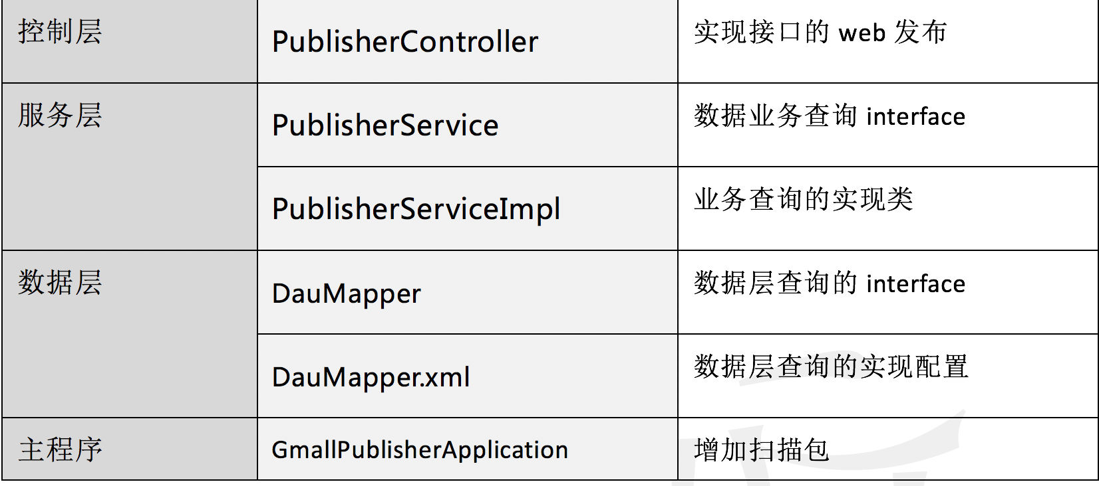

#### 创建相应的包或目录

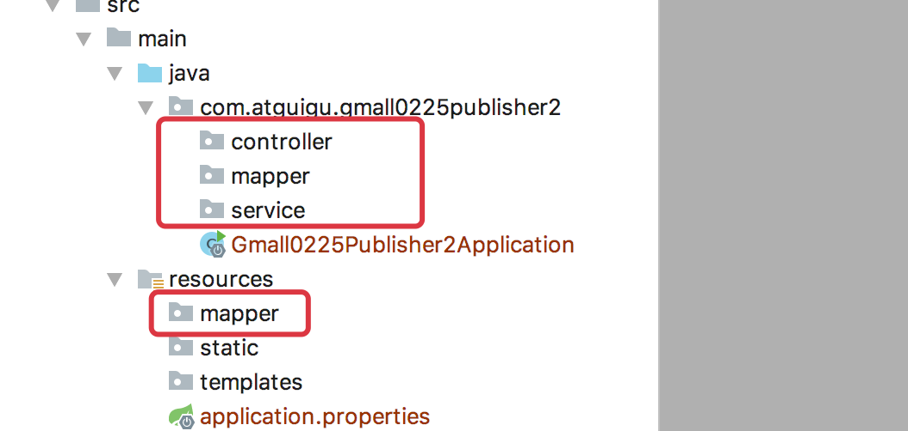

#### 7.3.1 数据层

##### 数据层 Mapper 接口

DauMapper.java

import java.util.List;  
import java.util.Map;  
  
/*  
从数据库查询数据的接口  
 */  
public interface DauMapper {  
 // 查询日活总数  
 long getDauTotal(String date);  
 // 查询小时明细  
 List<Map> getDauHour(String date);  
}

##### 数据层的 sql

在resources/mapper目录下创建与前面接口同名的 xml 文件

<?xml version="1.0" encoding="UTF-8" ?>  
<!DOCTYPE mapper SYSTEM "http://mybatis.org/dtd/mybatis-3-mapper.dtd" >  
<!--namespace 对应前面定义的接口-->  
<mapper namespace="com.atguigu.gmall0225publisher2.mapper.DauMapper">  
 <!--对应前面接口中的方法, 标签内写响应的查询语句, 查询的接口会赋值给这个方法的返回值-->  
 <select id="getDauTotal" resultType="java.lang.Long">  
 select count(1) from gmall_dau where logdate=#{date}  
 </select>  
  
 <!--分时明细-->  
 <select id="getDauHour" resultMap="dauHourList">  
 select loghour, count(1) count from gmall_dau where logdate=#{date} group by loghour  
 </select>  
 <resultMap id="dauHourList" type="java.util.Map" autoMapping="true"></resultMap>  
  
</mapper>

#### 7.3.2 服务层

##### 接口

package com.atguigu.gmall0225publisher2.service;  
  
import java.util.Map;  
  
public interface PublisherService {  
 /*  
 查询总数  
 */  
 long getDauTotal(String date);  
 /*  
 查询小时明细  
  
 相比数据层, 我们把数据结构做下调整, 更方便使用  
 */  
 Map getDauHour(String date);  
}

##### 实现

package com.atguigu.gmall0225publisher2.service;  
  
import com.atguigu.gmall0225publisher2.mapper.DauMapper;  
import org.apache.commons.collections.map.HashedMap;  
import org.springframework.beans.factory.annotation.Autowired;  
import org.springframework.stereotype.Service;  
  
import java.time.LocalDate;  
import java.util.List;  
import java.util.Map;  
  
/**  
 * @Author lzc  
 * @Date 2019/8/27 4:03 PM  
 */  
@Service // 必须添加 Service 注解  
public class PublisherServiceImpl implements PublisherService {  
 /*自动注入 DauMapper 对象*/  
 @Autowired  
 DauMapper dauMapper;  
  
 @Override  
 public long getDauTotal(String date) {  
 return dauMapper.getDauTotal(date);  
 }  
  
 @Override  
 public Map getDauHour(String date) {  
 List<Map> dauHourList = dauMapper.getDauHour(date);  
  
 Map dauHourMap = new HashedMap();  
 for (Map map : dauHourList) {  
 String hour = (String)map.get("LOGHOUR");  
 Long count = (Long) map.get("COUNT");  
 dauHourMap.put(hour, count);  
 }  
  
 return dauHourMap;  
 }  
  
  
}

#### 7.3.3 控制层

package com.atguigu.gmall0225publisher2.controller;  
  
import com.alibaba.fastjson.JSON;  
import com.atguigu.gmall0225publisher2.service.PublisherService;  
import org.springframework.beans.factory.annotation.Autowired;  
import org.springframework.web.bind.annotation.GetMapping;  
import org.springframework.web.bind.annotation.RequestParam;  
import org.springframework.web.bind.annotation.RestController;  
  
import java.time.LocalDate;  
import java.util.ArrayList;  
import java.util.HashMap;  
import java.util.List;  
import java.util.Map;  
  
/**  
 * @Author lzc  
 * @Date 2019/8/27 4:06 PM  
 */  
@RestController  
public class PublisherController {  
 @Autowired  
 PublisherService publisherService;  
   
 @GetMapping("realtime-total")  
 public String getRealtimeTotal(@RequestParam("date") String date) {  
 List<Map> totalList = new ArrayList<>();  
  
 Map dauMap = new HashMap<>();  
 dauMap.put("id", "dau");  
 dauMap.put("name", "新增日活");  
 dauMap.put("value", publisherService.getDauTotal(date));  
 totalList.add(dauMap);  
  
 Map midMap = new HashMap<>();  
 midMap.put("id", "new_mid");  
 midMap.put("name", "新增设备");  
 midMap.put("value", "1000");  
 totalList.add(midMap);  
 return JSON.toJSONString(totalList);  
 }  
  
 @GetMapping("realtime-hour")  
 public String getRealtimeHour(@RequestParam("id") String id, @RequestParam("date") String date){  
 if("dau".equals(id)){  
 Map todayDauHourMap = publisherService.getDauHour(date);  
 Map yesterdayDauHourMap = publisherService.getDauHour(date2Yesterday(date));  
  
 Map<String, Map> hourMap = new HashMap<>();  
 hourMap.put("today", todayDauHourMap);  
 hourMap.put("yesterday", yesterdayDauHourMap);  
 return JSON.toJSONString(hourMap);  
 }  
 return null;  
 }  
  
  
  
 /**  
 * 根据传入的日期转换成昨天  
 *  
 * @param date  
 * @return  
 */  
 public String date2Yesterday(String date) {  
 return LocalDate.parse(date).minusDays(1).toString();  
 }  
  
}

#### 7.3.4 增加扫描包

package com.atguigu.gmall0225publisher2;  
  
import org.mybatis.spring.annotation.MapperScan;  
import org.springframework.boot.SpringApplication;  
import org.springframework.boot.autoconfigure.SpringBootApplication;  
  
@SpringBootApplication  
// 增加扫描包  
@MapperScan(basePackages = "com.atguigu.gmall0225publisher2.mapper")  
public class Gmall0225Publisher2Application {  
  
 public static void main(String[] args) {  
 SpringApplication.run(Gmall0225Publisher2Application.class, args);  
 }  
  
}

## 第 8 章 可视化展示

java 工程师和前端工程师要做的事情, 我们不做过多研究.

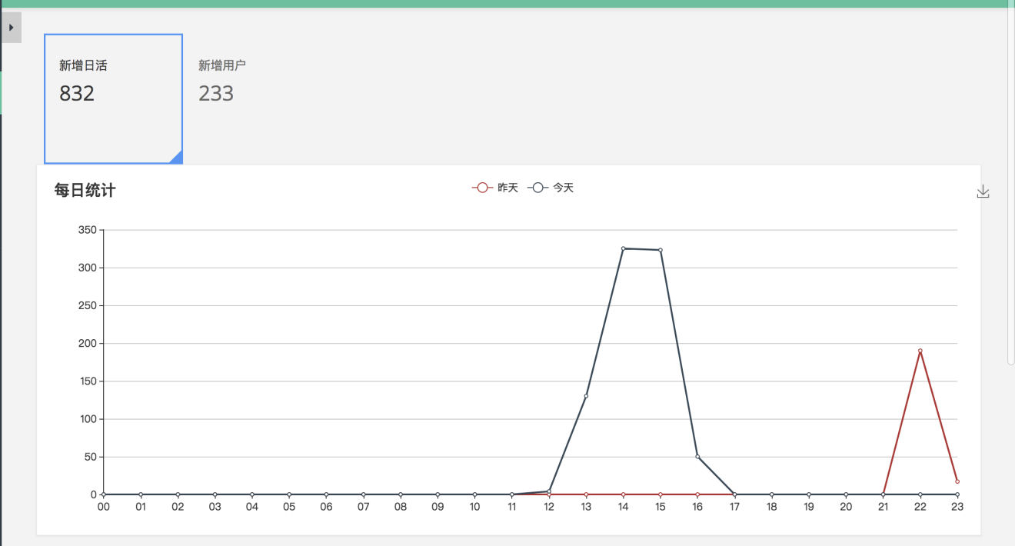

# 第 2 部分 业务数据处理

## 第 9 章 使用 Canal

前面解决了整个日志行为的采集到最终的展示.

从这这章开始, 来处理业务数据

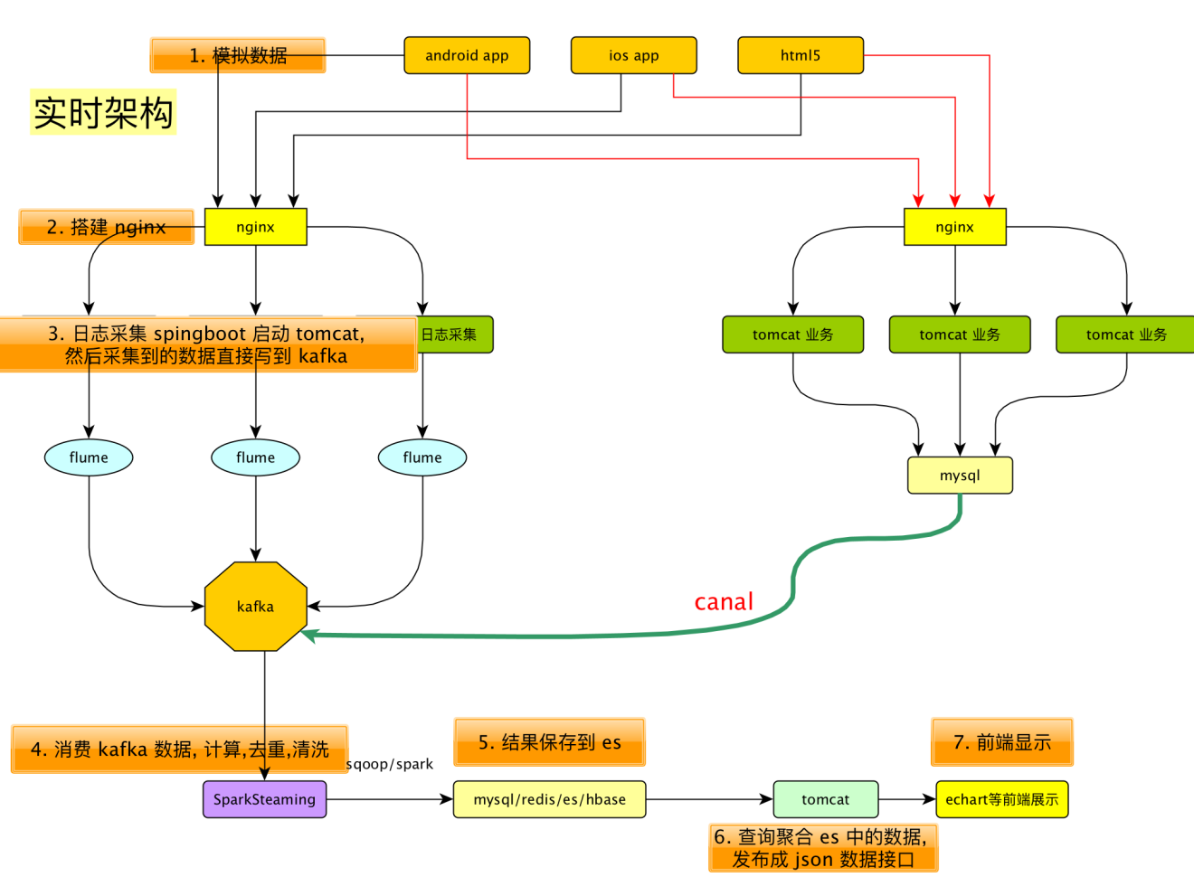

业务数据, 比如用户的订单,支付等操作会存储在 Mysql 中. 为便于 SparkStreaming 对这些业务数据实时分析处理, 这些数据一般也会再存储到 Kafka 中.

### 9.1 为什么需要 Canal

从 Mysql 到 Kafka 的过程中, 如果每次都是全表扫描进行数据的转移, 则非常耗时, 并且也会对 Mysql 造成性能的影响.

最好的办法是使用专门的工具能够实时的监控 Mysql 数据的变化.

Canal 就是一个我们想要的工具.

Canal 的作用就是实时同步 Mysql

### 9.2 Canal 工作原理

#### 9.2.1 Mysql 的主从复制

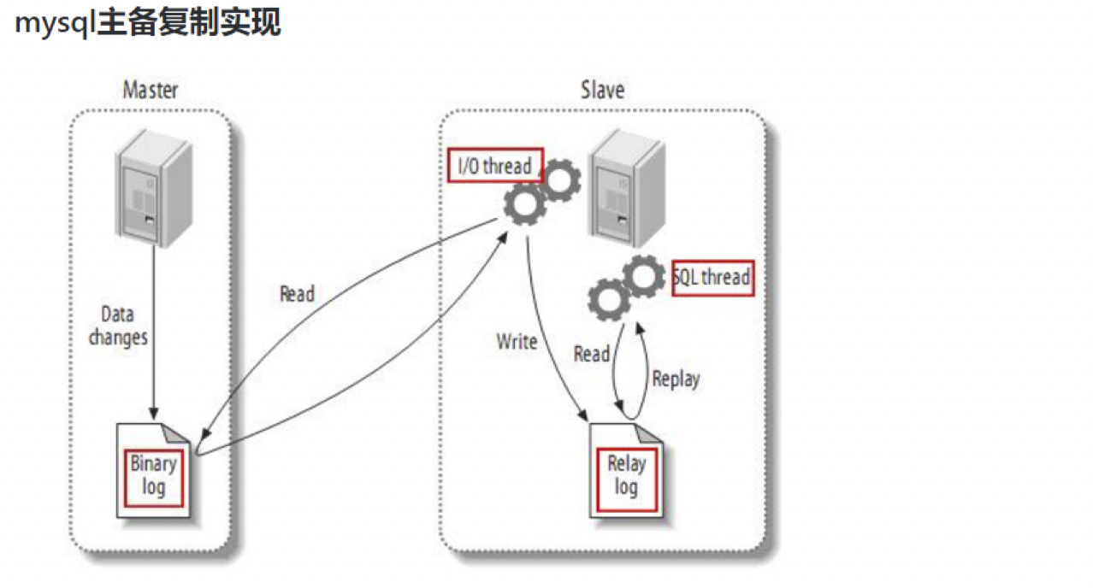

#### 9.2.3 Canal 的工作原理

Canal 的工作原理很简单， 就是把自己伪装成 slave，假装从 master 复制数据 。

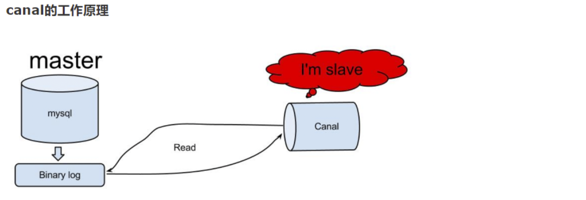

1. canal模拟mysql slave的交互协议，伪装自己为mysql slave，向mysql master发送dump协议
2. mysql master收到dump请求，开始推送 binary log 给 slave(也就是 canal)
3. canal 解析 binary log 对象(原始为 byte 流)

#### 9.2.4 Mysql 的 Binary log

MySQL 的二进制日志可以说是 MySQL 最重要的日志了，它记录了所有的 DDL 和DML (除了数据查询语句)语句，以事件形式记录，还包含语句所执行的消耗的时间，MySQL的二进制日志是事务安全型的。

一般来说开启 binlog 日志大概会有 1% 的性能损耗。 binlog日志有两个最重要的使用场景:

1. MySQL Replication 在 Master 端开启 binlog，Mster 把它的二进制日志传递给 slaves 来达到 master-slave 数据一致的目的。
2. 自然就是数据恢复了，通过使用 mysql binlog 工具来使恢复数据。

#### 9.2.5 binlog 格式

binlog 有 3 种格式: STATEMENT, ROW, MIXED

1. statement

语句级别, binlog 会记录每次执行的写操作的语句, 注意记录的是语句, slave 会自己重新执行写操作的语句, 从而达到与 master 的一致.

但是有可能会出现主从不一致的情况: 比如存储当前时间戳, 存储一个随机值等.

* 优点： 节省空间

 - 缺点： 有可能造成数据不一致。

1. row

行级， binlog 会记录每次操作后每行记录的变化。

* 优点：保持数据的绝对一致性。因为不管sql是什么，引用了什么函数，他只记录执行后的效果。

  - 缺点：占用较大空间。 如果一条语句执行之后导致很多行发生了变化, 则会产生很多条记录

1. mixed

  statement 的升级版，一定程度上解决了因为一些情况而造成的 statement模式不一致问题

    > 在某些情况下会按照 ROW的方式进行处理

1. 当函数中包含 UUID() 时；

     2. 包含 AUTO_INCREMENT 字段的表被更新时；

     3. 执行 INSERT DELAYED 语句时；

     4. 用 UDF 时；         - 优点：节省空间，同时兼顾了一定的一致性。

* 缺点：还有些极个别情况依旧会造成不一致，另外statement和mixed对于需要对binlog 的监控的情况都不方便。

由于 canal 是监控的数据的变化, 所以 binlog 的格式需要设置成 row 格式

### 9.3 配置 Mysql

#### 步骤 1: 赋权限

GRANT ALL PRIVILEGES ON *.* TO canal@'%' IDENTIFIED BY 'canal';

#### 步骤 2: 开启 binlog

打开文件/etc/my.cnf, 如果没有就创建一个

添加如下配置:

[mysqld]  
server-id= 1  
log-bin= mysql-bin  
binlog_format= row  
binlog-do-db= gmall

#### 步骤 3: 重启 mysql 使 binlog 生效

service mysql restart

#### 步骤 4: 检查 binlog 是否生效

进入 mysql

mysql> show variables like 'log_%';  
+----------------------------------------+--------------------------------+  
| Variable_name | Value |  
+----------------------------------------+--------------------------------+  
| log_bin | ON |  
| log_bin_basename | /var/lib/mysql/mysql-bin |  
| log_bin_index | /var/lib/mysql/mysql-bin.index |  
| log_bin_trust_function_creators | OFF |  
| log_bin_use_v1_row_events | OFF |  
| log_error | /var/lib/mysql/hadoop201.err |  
| log_output | FILE |  
| log_queries_not_using_indexes | OFF |  
| log_slave_updates | OFF |  
| log_slow_admin_statements | OFF |  
| log_slow_slave_statements | OFF |  
| log_throttle_queries_not_using_indexes | 0 |  
| log_warnings | 1 |  
+----------------------------------------+--------------------------------+

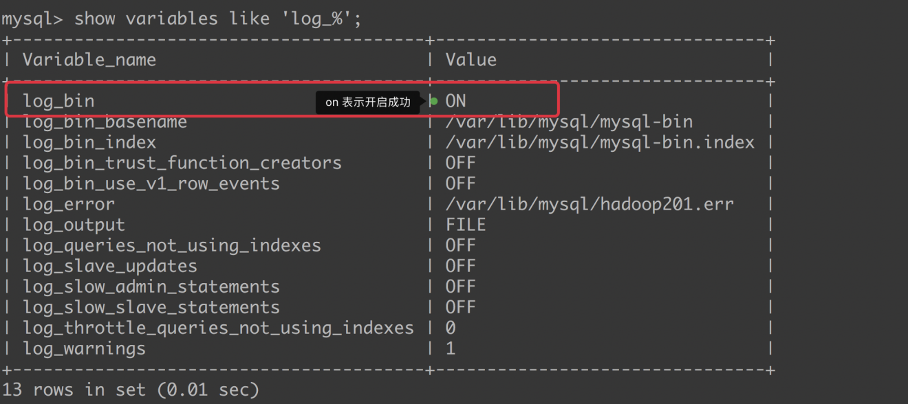



### 9.4 准备数据库数据

准备一些产品数据, 为了便于以后做测试

#### 步骤 1: 创建数据库

create database gmall DEFAULT CHARACTER SET utf8 COLLATE utf8_general_ci;

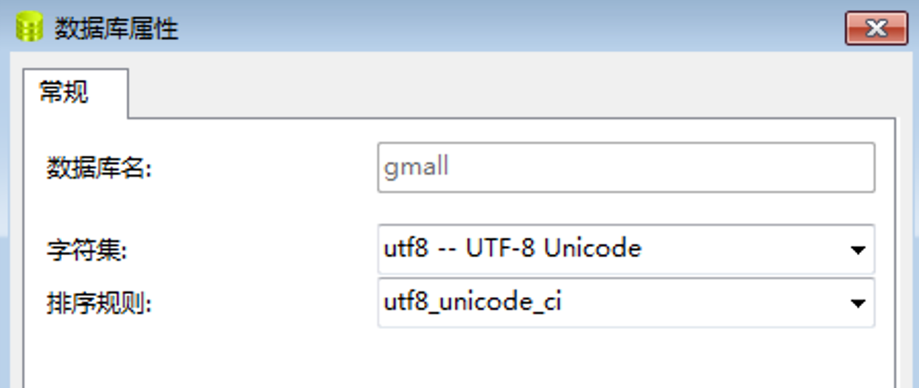

#### 步骤 2: 执行脚本, 建表和插入数据

[查看 ppt](http://www.zhenchao.cf/ppt/gmall.sql)

#### 步骤 3: 插入数据

步骤 2 中的 sql 脚本执行完毕之后, 部分表中已经插入了数据, 但是和订单相关的表中没有数据. 可以执行存储过程来插入数据.

# 日期 订单个数 用户数 是否删除以前的数据  
call init_data("2019-05-16", 10,2,false)

### 9.5 9.5 安装 canal 和启动

#### 步骤 1: 下载 Canal

wget https://github.com/alibaba/canal/releases/download/canal-1.1.2/canal.deployer-1.1.2.tar.gz

#### 步骤 2: 解压

mkdir /opt/module/canal  
tar -zxvf canal.deployer-1.1.2.tar.gz -C /opt/module/canal

#### 步骤 3: 配置

1. conf/canal.properties canal 的通用配置, 主要关注下canal.port, 默认是11111

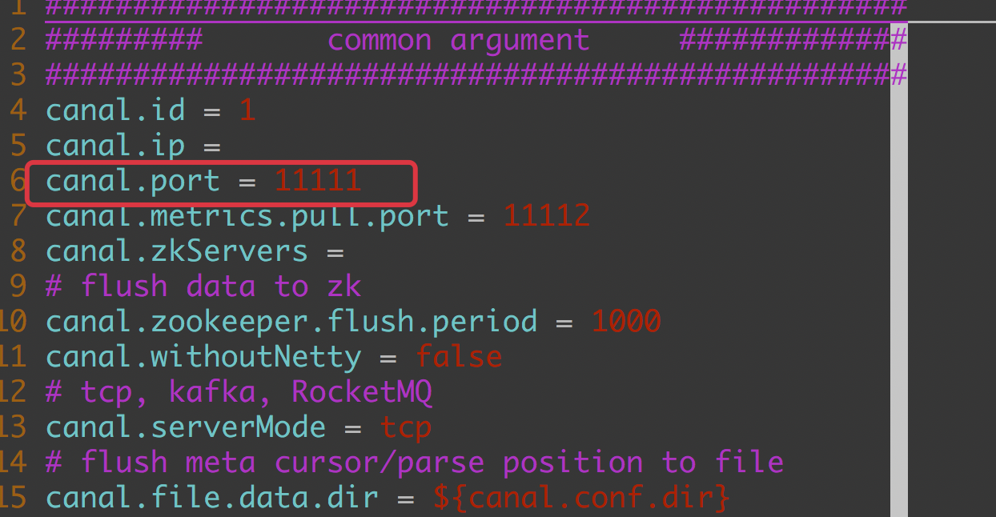

1. conf/example/instance.properties instance.properties是针对要追踪的 mysql 的实例配置

#################################################  
## mysql serverId , v1.0.26+ will autoGen  
# slaveId 必须配置, 不能和 mysql 的 id 重复  
canal.instance.mysql.slaveId=100  
  
# enable gtid use true/false  
canal.instance.gtidon=false  
  
# position info  
# mysql 的位置信息  
canal.instance.master.address=hadoop201:3306  
canal.instance.master.journal.name=  
canal.instance.master.position=  
canal.instance.master.timestamp=  
canal.instance.master.gtid=  
  
# rds oss binlog  
canal.instance.rds.accesskey=  
canal.instance.rds.secretkey=  
canal.instance.rds.instanceId=  
  
# table meta tsdb info  
canal.instance.tsdb.enable=true  
#canal.instance.tsdb.url=jdbc:mysql://127.0.0.1:3306/canal_tsdb  
#canal.instance.tsdb.dbUsername=canal  
#canal.instance.tsdb.dbPassword=canal  
  
#canal.instance.standby.address =  
#canal.instance.standby.journal.name =  
#canal.instance.standby.position =  
#canal.instance.standby.timestamp =  
#canal.instance.standby.gtid=  
  
# username/password  
# 用户名和密码  
canal.instance.dbUsername=root  
canal.instance.dbPassword=aaa  
canal.instance.connectionCharset = UTF-8  
canal.instance.defaultDatabaseName =  
# enable druid Decrypt database password  
canal.instance.enableDruid=false  
#canal.instance.pwdPublicKey=MFwwDQYJKoZIhvcNAQEBBQADSwAwSAJBALK4BUxdDltRRE5/zXpVEVPUgunvscYFtEip3pmLlhrWpacX7y7GCMo2/JM6LeHmiiNdH1FWgGCpUfircSwlWKUCAwEAAQ==  
  
# table regex  
canal.instance.filter.regex=.*\\..*  
# table black regex  
canal.instance.filter.black.regex=  
  
# mq config  
canal.mq.topic=example  
canal.mq.partition=0  
# hash partition config  
#canal.mq.partitionsNum=3  
#canal.mq.partitionHash=mytest.person:id,mytest.role:id  
#################################################

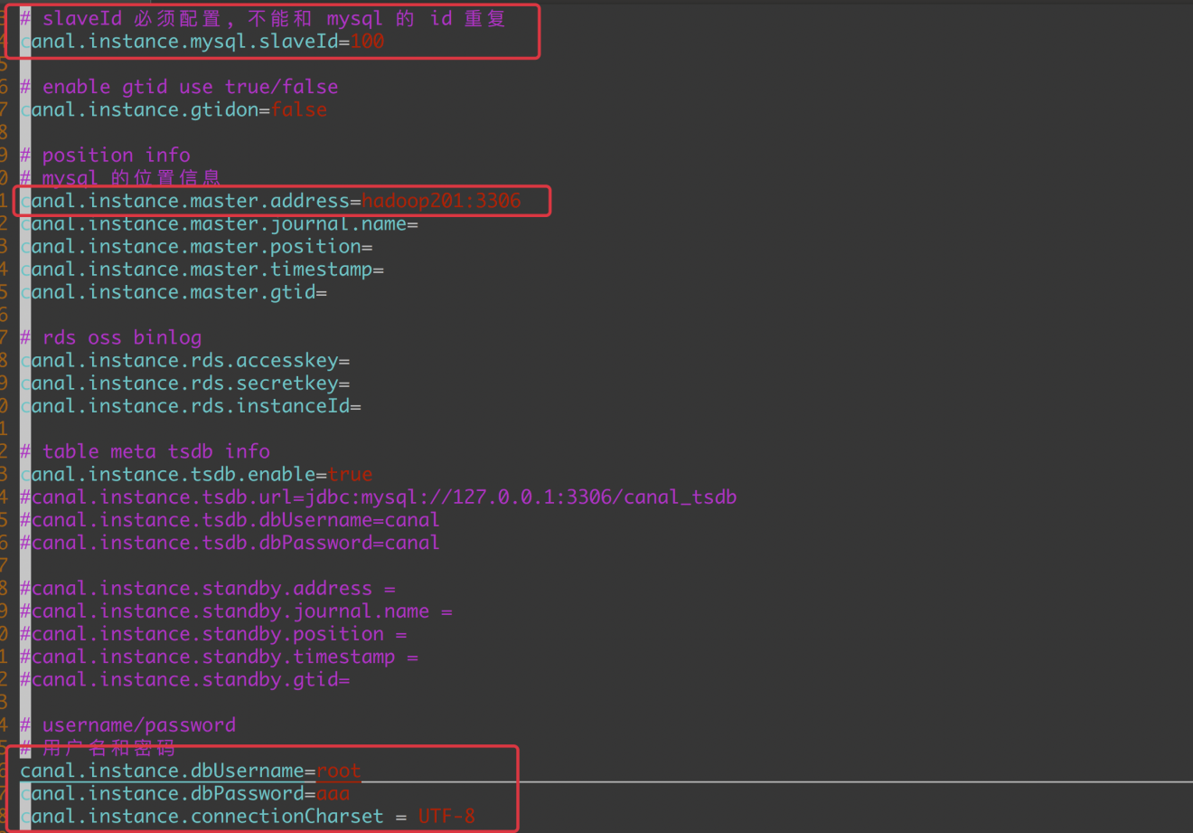

#### 步骤 4: 启动 canal

bin/startup.sh

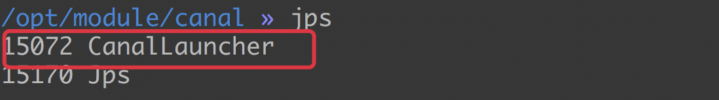

#### 步骤 5: 查看日志

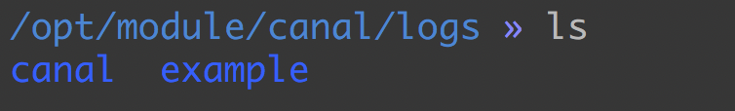

#### 步骤 6: 关闭 Canal

bin/stop.sh

## 第 10 章 从 Canal 读取数据到 Kafka

本章完成从 Canal 中读取数据, 然后发送的 Kafka 中.

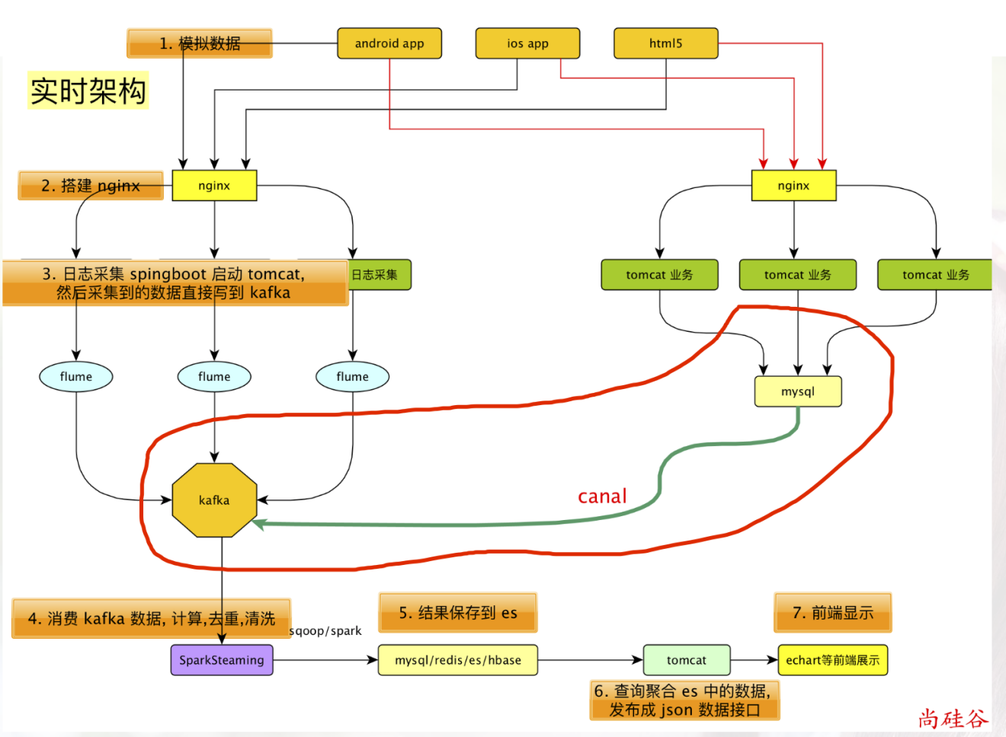

### 10.1 从 Canal 读取数据

创建子项目: gmall-canal

#### 10.1.1 添加依赖

<?xml version="1.0" encoding="UTF-8"?>  
<project xmlns="http://maven.apache.org/POM/4.0.0"  
 xmlns:xsi="http://www.w3.org/2001/XMLSchema-instance"  
 xsi:schemaLocation="http://maven.apache.org/POM/4.0.0 http://maven.apache.org/xsd/maven-4.0.0.xsd">  
 <parent>  
 <artifactId>gmall</artifactId>  
 <groupId>com.atguigu.dw</groupId>  
 <version>1.0-SNAPSHOT</version>  
 </parent>  
 <modelVersion>4.0.0</modelVersion>  
  
 <artifactId>gmall-canal</artifactId>  
 <dependencies>  
 <!-- https://mvnrepository.com/artifact/com.alibaba.otter/canal.client -->  
 <!--canal 客户端, 从 canal 服务器读取数据-->  
 <dependency>  
 <groupId>com.alibaba.otter</groupId>  
 <artifactId>canal.client</artifactId>  
 <version>1.1.2</version>  
 </dependency>  
 <!-- https://mvnrepository.com/artifact/org.apache.kafka/kafka-clients -->  
 <!-- kafka 客户端 -->  
 <dependency>  
 <groupId>org.apache.kafka</groupId>  
 <artifactId>kafka-clients</artifactId>  
 <version>0.11.0.0</version>  
 </dependency>  
 <dependency>  
 <groupId>com.atguigu.dw</groupId>  
 <artifactId>gmall-common</artifactId>  
 <version>1.0-SNAPSHOT</version>  
 </dependency>  
 </dependencies>  
   
</project>

#### 10.1.2 从 Canal 服务读取数据的客户端

package com.atguigu.dw.gamallcanal  
  
import java.net.InetSocketAddress  
  
import com.alibaba.otter.canal.client.{CanalConnector, CanalConnectors}  
import com.alibaba.otter.canal.protocol.CanalEntry.{EntryType, RowChange}  
import com.alibaba.otter.canal.protocol.{CanalEntry, Message}  
import com.atguigu.dw.gamallcanal.util.CanalHandler  
import com.google.protobuf.ByteString  
  
/**  
 * Author lzc  
 * Date 2019/5/17 3:22 PM  
 */  
object CanalClient {  
 def main(args: Array[String]): Unit = {  
 // 1. 创建能连接到 Canal 的连接器对象  
 val connector: CanalConnector = CanalConnectors.newSingleConnector(new InetSocketAddress("hadoop201", 11111), "example", "", "")  
 // 2. 连接到 Canal  
 connector.connect()  
 // 3. 监控指定的表的数据的变化  
 connector.subscribe("gmall.order_info")  
 while (true) {  
 // 4. 获取消息 (一个消息对应 多条sql 语句的执行)  
 val msg: Message = connector.get(100) // 一次最多获取 100 条 sql  
 // 5. 个消息对应多行数据发生了变化, 一个 entry 表示一条 sql 语句的执行  
 val entries: java.util.List[CanalEntry.Entry] = msg.getEntries  
 import scala.collection.JavaConversions._  
 if (entries.size() > 0) {  
 // 6. 遍历每行数据  
 for (entry <- entries) {  
 // 7. EntryType.ROWDATA 只对这样的 EntryType 做处理  
 if (entry.getEntryType == EntryType.ROWDATA) {  
 // 8. 获取到这行数据, 但是这种数据不是字符串, 所以要解析  
 val value: ByteString = entry.getStoreValue  
 val rowChange: RowChange = RowChange.parseFrom(value)  
 // 9.定义专门处理的工具类: 参数 1 表名, 参数 2 事件类型(插入, 删除等), 参数 3: 具体的数据  
 CanalHandler.handle(entry.getHeader.getTableName, rowChange.getEventType, rowChange.getRowDatasList)  
 }  
 }  
   
 } else {  
 println("没有抓取到数据...., 2s 之后重新抓取")  
 Thread.sleep(2000)  
 }  
 }  
   
 }  
}

#### 10.1.3 专门处理数据的工具类CanalHandler

package com.atguigu.dw.gamallcanal.util  
  
import java.util  
  
import com.alibaba.otter.canal.protocol.CanalEntry  
import com.alibaba.otter.canal.protocol.CanalEntry.{EventType, RowData}  
  
/**  
 * Author lzc  
 * Date 2019/5/17 4:09 PM  
 */  
object CanalHandler {  
 /**  
 * 处理从 canal 取来的数据  
 *  
 * @param tableName 表名  
 * @param eventType 事件类型  
 * @param rowDataList 数据类别  
 */  
 def handle(tableName: String, eventType: EventType, rowDataList: util.List[RowData]) = {  
 import scala.collection.JavaConversions._  
 if ("order_info" == tableName && eventType == EventType.INSERT && rowDataList.size() > 0) {  
 // 1. rowData 表示一行数据, 通过他得到每一列. 首先遍历每一行数据  
 for (rowData <- rowDataList) {  
 // 2. 得到每行中, 所有列组成的列表  
 val columnList: util.List[CanalEntry.Column] = rowData.getAfterColumnsList  
 for (column <- columnList) {  
 // 3. 得到列名和列值  
 println(column.getName + ":" + column.getValue)  
 }  
 }  
 }  
 }  
}

### 10.2 读取的数据发送到 Kafka

#### 10.2.1 实现 Kafka 生产者

package com.atguigu.dw.gamallcanal.util  
  
import java.util.Properties  
  
import org.apache.kafka.clients.producer.{KafkaProducer, ProducerRecord}  
  
/**  
 * Author lzc  
 * Date 2019/5/17 4:45 PM  
 */  
object MyKafkaSender {  
 val props = new Properties()  
 // Kafka服务端的主机名和端口号  
 props.put("bootstrap.servers", "hadoop201:9092,hadoop202:9092,hadoop203:9093")  
 // key序列化  
 props.put("key.serializer", "org.apache.kafka.common.serialization.StringSerializer")  
 // value序列化  
 props.put("value.serializer", "org.apache.kafka.common.serialization.StringSerializer")  
 val producer = new KafkaProducer[String, String](props)  
   
 def sendToKafka(topic: String, content: String) = {  
 producer.send(new ProducerRecord[String, String](topic, content))  
 }  
}

#### 10.2.2 使用生产者向 Kafka 生成数据

考虑到将来存储到 ES 中的数据是 Json 格式, 所以, 我们在 Kafka 存储的的时候也存储为 Json 格式的.

改写工具类: CanalHandler

package com.atguigu.dw.gamallcanal.util  
  
import java.util  
  
import com.alibaba.fastjson.JSONObject  
import com.alibaba.otter.canal.protocol.CanalEntry  
import com.alibaba.otter.canal.protocol.CanalEntry.{EventType, RowData}  
import com.atguigu.dw.gmall.common.constant.GmallConstant  
  
/**  
 * Author lzc  
 * Date 2019/5/17 4:09 PM  
 */  
object CanalHandler {  
 /**  
 * 处理从 canal 取来的数据  
 *  
 * @param tableName 表名  
 * @param eventType 事件类型  
 * @param rowDataList 数据类别  
 */  
 def handle(tableName: String, eventType: EventType, rowDataList: util.List[RowData]) = {  
 import scala.collection.JavaConversions._  
 if ("order_info" == tableName && eventType == EventType.INSERT && rowDataList.size() > 0) {  
 val obj: JSONObject = new JSONObject()  
 // 1. rowData 表示一行数据, 通过他得到每一列. 首先遍历每一行数据  
 for (rowData <- rowDataList) {  
 // 2. 得到每行中, 所有列组成的列表  
 val columnList: util.List[CanalEntry.Column] = rowData.getAfterColumnsList  
 for (column <- columnList) {  
 // 3. 得到列名和列值  
 // key下划线转成驼峰  
 val newColumn: String = CaseFormat.LOWER_UNDERSCORE.to(CaseFormat.LOWER_CAMEL, column.getName)  
 obj.put(newColumn, column.getValue)  
 }  
 }  
 // 4. 发送到 Kafka  
 MyKafkaSender.sendToKafka(GmallConstant.TOPIC_ORDER, obj.toJSONString)  
 }  
 }  
}

## 第 11 章 从 Kafka 读取订单数据并写入到 ES

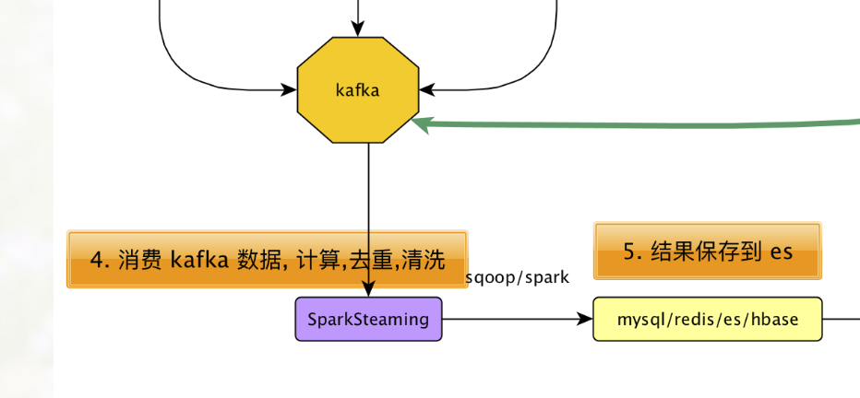

### 11.1 从 Kafka 读取数据

在模块gmall-realtime中新建OrderApp.scala

package com.atguigu.dw.gmall.realtime.app  
  
import com.atguigu.dw.gmall.common.constant.GmallConstant  
import com.atguigu.dw.gmall.realtime.util.MyKafkaUtil  
import org.apache.spark.SparkConf  
import org.apache.spark.streaming.dstream.InputDStream  
import org.apache.spark.streaming.{Seconds, StreamingContext}  
  
/**  
 * Author lzc  
 * Date 2019/5/17 5:31 PM  
 */  
object OrderApp {  
 def main(args: Array[String]): Unit = {  
 val conf: SparkConf = new SparkConf().setMaster("local[*]").setAppName("OrderApp")  
 val ssc = new StreamingContext(conf, Seconds(2))  
 val inputDSteam: InputDStream[(String, String)] = MyKafkaUtil.getKafkaStream(ssc, GmallConstant.TOPIC_ORDER)  
 inputDSteam.print(20)  
 ssc.start()  
 ssc.awaitTermination()  
   
 }  
}

### 11.2 写入数据到 Phoenix

#### 11.2.1 在 Phoenix 创建表

create table gmall_order_info (  
 id varchar primary key,  
 province_id varchar,  
 consignee varchar,  
 order_comment varchar,  
 consignee_tel varchar,  
 order_status varchar,  
 payment_way varchar,  
 user_id varchar,  
 img_url varchar,  
 total_amount decimal,   
 expire_time varchar,  
 delivery_address varchar,  
 create_time varchar,  
 operate_time varchar,  
 tracking_no varchar,  
 parent_order_id varchar,  
 out_trade_no varchar,  
 trade_body varchar,  
 create_date varchar,  
 create_hour varchar)

#### 11.2.2 写数据到 ES

OrderInfo.scala

case class OrderInfo(id: String,  
 province_id: String,  
 var consignee: String,  
 order_comment: String,  
 var consignee_tel: String,  
 order_status: String,  
 payment_way: String,  
 user_id: String,  
 img_url: String,  
 total_amount: Double,  
 expire_time: String,  
 delivery_address: String,  
 create_time: String,  
 operate_time: String,  
 tracking_no: String,  
 parent_order_id: String,  
 out_trade_no: String,  
 trade_body: String,  
 var create_date: String,  
 var create_hour: String)

OrderApp

import java.text.SimpleDateFormat  
  
import com.alibaba.fastjson.JSON  
import com.atguigu.gmall0225.common.util.GmallConstant  
import com.atguigu.gmall0225.realtime.bean.OrderInfo  
import com.atguigu.gmall0225.realtime.util.MyKafkaUtil  
import org.apache.spark.SparkConf  
import org.apache.spark.streaming.dstream.{DStream, InputDStream}  
import org.apache.spark.streaming.{Seconds, StreamingContext}  
  
object OrderApp {  
 def main(args: Array[String]): Unit = {  
   
 //1 . 从kafka消费数据  
 val conf = new SparkConf().setMaster("local[2]").setAppName("OrderApp")  
 val ssc = new StreamingContext(conf, Seconds(2))  
 val sourceDStream: InputDStream[(String, String)] = MyKafkaUtil.getKafkaStream(ssc, GmallConstant.TOPIC_ORDER)  
 val orerInfoDStream: DStream[OrderInfo] = sourceDStream.map { // 对数据格式做调整  
 case (_, value) => {  
 val orderInfo = JSON.parseObject(value, classOf[OrderInfo]) // 李小名 => 李**  
 orderInfo.consignee = orderInfo.consignee.substring(0, 1) + "**" // 李小名 => 李**  
 orderInfo.consignee_tel = orderInfo.consignee_tel.substring(0, 3) +  
 "****" + orderInfo.consignee_tel.substring(7, 11)  
   
 // 计算 createDate 和 createHour  
 val date = new SimpleDateFormat("yyyy-MM-dd HH:mm:ss").parse(orderInfo.create_time)  
 orderInfo.create_date = new SimpleDateFormat("yyyy-MM-dd").format(date)  
 orderInfo.create_hour = new SimpleDateFormat("HH").format(date)  
 orderInfo  
 }  
 }  
   
 //2. 把数据写入到 Phoenix  
 import org.apache.phoenix.spark._  
 orerInfoDStream.foreachRDD(rdd => {  
 rdd.saveToPhoenix(  
 "GMALL_ORDER_INFO",  
 Seq("ID", "PROVINCE_ID", "CONSIGNEE", "ORDER_COMMENT", "CONSIGNEE_TEL", "ORDER_STATUS", "PAYMENT_WAY", "USER_ID", "IMG_URL", "TOTAL_AMOUNT", "EXPIRE_TIME", "DELIVERY_ADDRESS", "CREATE_TIME", "OPERATE_TIME", "TRACKING_NO", "PARENT_ORDER_ID", "OUT_TRADE_NO", "TRADE_BODY", "CREATE_DATE", "CREATE_HOUR"),  
 zkUrl = Some("hadoop201,hadoop202,hadoop203:2181"))  
 })  
 orerInfoDStream.print  
 ssc.start()  
 ssc.awaitTermination()  
   
 }  
}

## 第 12 章 发布数据(旧)

计算指标:



### 12.1 查询 DSL 语句

#### 交易总额

GET gmall_order/_search  
{  
 "query": {  
 "bool": {  
 "filter": {  
 "term": {  
 "createDate": "2019-05-17"  
 }  
 }  
 }  
 }  
 , "aggs": {  
 "sum_totalAmount": {  
 "sum": {  
 "field": "totalAmount"  
 }  
   
 }  
 }  
}

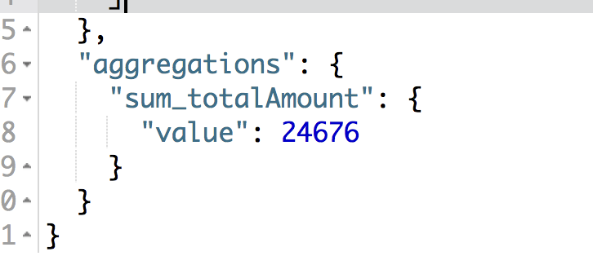

#### 交易额小时明细

GET gmall_order/_search  
{  
 "query": {  
 "bool": {  
 "filter": {  
 "term": {  
 "createDate": "2019-05-17"  
 }  
 }  
 }  
 }  
 , "aggs": {  
 "groupby_createHour": {  
 "terms": {  
 "field": "createHour",  
 "size": 24  
 }  
 , "aggs": {  
 "sum_totalAmount": {  
 "sum": {  
 "field": "totalAmount"  
 }  
 }  
 }  
 }  
   
 }  
}

### 12.2 开发对外接口

#### 12.2.1 在PublisherService中添加方法

/**  
 * 获取指定日期订单的销售额  
 * @param day  
 * @return  
 */  
def getOrderTotalAmount(day: String): Double  
  
/**  
 * 获取指定日期每个小时的销售额  
 * @param day  
 * @return  
 */  
def getOrderHourTotalAmount(day: String): Map[String, Double]

#### 12.2.2 在PublisherServiceImp中实现新增的方法

/**  
 * 获取指定日期订单的销售额  
 *  
 * @param day  
 * @return  
 */  
 override def getOrderTotalAmount(day: String): Double = {  
 val queryDSL =  
 s"""  
 |{  
 | "query": {  
 | "bool": {  
 | "filter": {  
 | "term": {  
 | "createDate": "$day"  
 | }  
 | }  
 | }  
 | }  
 | , "aggs": {  
 | "sum_totalAmount": {  
 | "sum": {  
 | "field": "totalAmount"  
 | }  
 |  
 | }  
 | }  
 |}  
 """.stripMargin  
   
 val search: Search = new Search.Builder(queryDSL)  
 .addIndex(GmallConstant.ES_INDEX_ORDER)  
 .addType("_doc").build()  
   
 val result: SearchResult = jestClient.execute(search)  
 result.getAggregations.getSumAggregation("sum_totalAmount").getSum  
 }  
   
 /**  
 * 获取指定日期每个小时的销售额  
 *  
 * @param day  
 * @return  
 */  
 override def getOrderHourTotalAmount(day: String): Map[String, Double] = {  
 val searchDSL: String =  
 s"""  
 |{  
 | "query": {  
 | "bool": {  
 | "filter": {  
 | "term": {  
 | "createDate": "$day"  
 | }  
 | }  
 | }  
 | }  
 | , "aggs": {  
 | "groupby_createHour": {  
 | "terms": {  
 | "field": "createHour",  
 | "size": 24  
 | }  
 | , "aggs": {  
 | "sum_totalAmount": {  
 | "sum": {  
 | "field": "totalAmount"  
 | }  
 | }  
 | }  
 | }  
 | }  
 |}  
 """.stripMargin  
   
 val search: Search = new Search.Builder(searchDSL)  
 .addIndex(GmallConstant.ES_INDEX_ORDER)  
 .addType("_doc")  
 .build()  
 val result: SearchResult = jestClient.execute(search)  
 // 得到聚合后的结果  
 val buckets: util.List[TermsAggregation#Entry] =  
 result.getAggregations.getTermsAggregation("groupby_createHour").getBuckets  
 val hour2TotalAmount: mutable.Map[String, Double] = mutable.Map[String, Double]()  
 import scala.collection.JavaConversions._  
 for (bucket <- buckets) {  
 hour2TotalAmount += bucket.getKey -> bucket.getSumAggregation("sum_totalAmount").getSum  
 }  
 hour2TotalAmount.toMap  
 }

#### 12.2.3 PublisherControler

注意观察新增的就可以了

package com.atguigu.dw.gmallpublisher.controller  
  
import java.text.SimpleDateFormat  
import java.util.Date  
  
import com.atguigu.dw.gmallpublisher.service.PublisherService  
import org.apache.commons.lang.time.DateUtils  
import org.json4s.jackson.JsonMethods  
import org.springframework.beans.factory.annotation.Autowired  
import org.springframework.web.bind.annotation.{GetMapping, RequestParam, RestController}  
  
import scala.collection.mutable  
  
  
/*  
日活:  
 http://hadoop201:8070/realtime-total?date=2019-05-15  
   
 [  
 {"id":"dau","name":"新增日活","value":1200},  
 {"id":"new_mid","name":"新增用户","value":233}  
 ]  
*/  
/*  
明细:  
 http://hadoop201:8070/realtime-hour?id=dau&&date=2019-05-15  
   
 {  
 "yesterday":{"钟点":数量, "钟点":数量, ...},  
 "today":{"钟点":数量, "钟点":数量, ...}  
 }  
*/  
  
@RestController  
class PublisherController {  
 @Autowired  
 var publisherService: PublisherService = _  
   
 @GetMapping(Array("realtime-total"))  
 def getRealTimeTotal(@RequestParam("date") date: String): String = {  
 val total: Long = publisherService.getDauTotal(date)  
 val totalAmount: Double = publisherService.getOrderTotalAmount(date)  
   
 val result =  
 s"""  
 |[  
 | {"id":"dau","name":"新增日活","value":$total},  
 | {"id":"new_mid","name":"新增用户","value":233},  
 | {"id":"order_amount","name":"新增交易额","value":${totalAmount}}  
 |]  
 """.stripMargin  
 result  
 }  
   
 @GetMapping(Array("realtime-hour"))  
 def getRealTimeHour(@RequestParam("id") id: String, @RequestParam("date") date: String) = {  
 if (id == "dau") {  
 val todayMap: Map[String, Long] = publisherService.getDauHour2countMap(date)  
 val yesterdayMap: Map[String, Long] = publisherService.getDauHour2countMap(date2Yesterday(date))  
   
 val resultMap: mutable.Map[String, Map[String, Long]] = mutable.Map[String, Map[String, Long]]()  
 resultMap += "today" -> todayMap  
 resultMap += "yesterday" -> yesterdayMap  
 println(resultMap)  
 // 转变成 json 格式字符串输出  
 import org.json4s.JsonDSL._  
 JsonMethods.compact(JsonMethods.render(resultMap))  
 } else if (id == "order_amount") {  
 val todayMap: Map[String, Double] = publisherService.getOrderHourTotalAmount(date)  
 val yesterdayMap: Map[String, Double] = publisherService.getOrderHourTotalAmount(date2Yesterday(date))  
   
 val resultMap: mutable.Map[String, Map[String, Double]] = mutable.Map[String, Map[String, Double]]()  
 resultMap += "today" -> todayMap  
 resultMap += "yesterday" -> yesterdayMap  
 println(resultMap)  
 // 转变成 json 格式字符串输出  
 import org.json4s.JsonDSL._  
 JsonMethods.compact(JsonMethods.render(resultMap))  
 } else {  
 null  
 }  
 }  
   
 private val dateFormat = new SimpleDateFormat("yyyy-MM-dd")  
   
 // 通过今天计算出来昨天  
 private def date2Yesterday(date: String): String = {  
 val today: Date = dateFormat.parse(date)  
 val yesterday: Date = DateUtils.addDays(today, -1)  
 dateFormat.format(yesterday)  
 }  
}

### 12.3 图形化展示

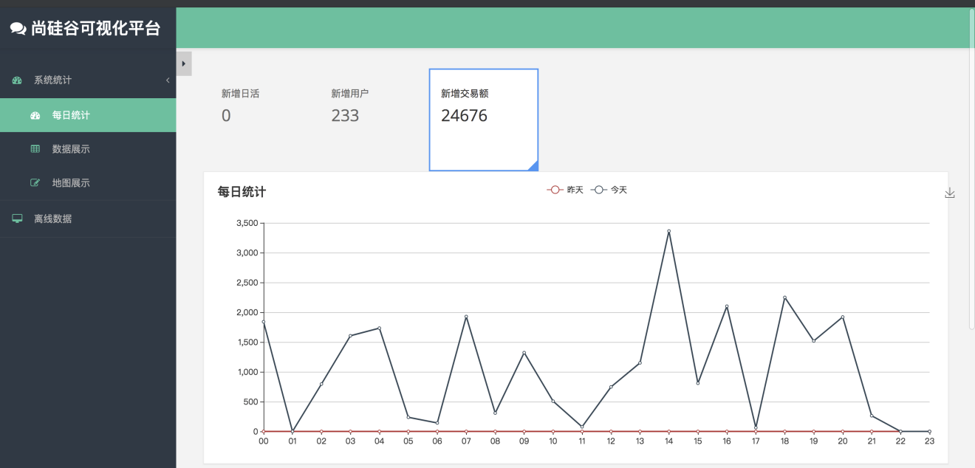

## 第 12 章 数据接口发布(新)

### 12.1 提供的接口和返回的数据

#### 12.1.1 对外提供的接口

##### 销售额总数

接口其实还是前面的接口, 只是返回值多了个销售额总数

http://localhost:8070/realtime-total?date=2019-08-28

##### 销售额分时统计

与前面的接口相比, id 的值发生了变化

http://localhost:8070/realtime-hour?id=order_amount&date=2019-02-01

#### 12.1.2 返回的数据格式

##### 总数

[{"id":"dau","name":"新增日活","value":1200},  
{"id":"new_mid","name":"新增设备","value":233 },  
{"id":"order_amount","name":"新增交易额","value":1000.2 }]

##### 分时统计

{"yesterday":{"11":383,"12":123,"17":88,"19":200 },  
"today":{"12":38,"13":1233,"17":123,"19":688 }}

### 12.2 代码部分

代码仍然部署在前面的 publisher 模块中.

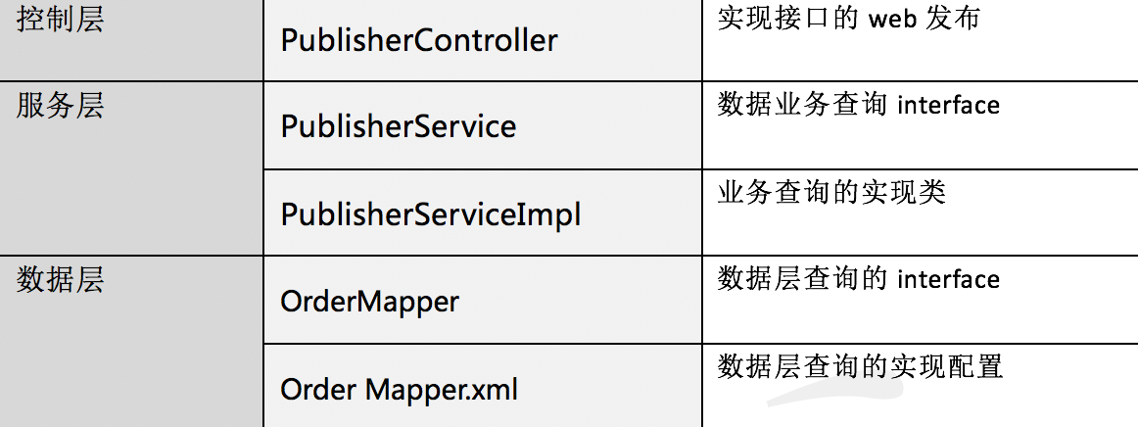

#### 12.2.1 数据层

一般一个表对应着一个类.

##### 12.2.1.1 数据层的mapper接口

import java.util.List;  
import java.util.Map;  
  
public interface OrderMapper {  
  
 /**  
 * 获取订单总的销售额  
 *  
 * @param date  
 * @return  
 */  
 double getOrderAmountTotal(String date);  
  
 /**  
 * 获取每小时的销售额明细  
 *  
 * @param date  
 * @return  
 */  
 List<Map> getOrderAmountHour(String date);  
  
}

##### 12.2.1.2 数据层的 sql

<?xml version="1.0" encoding="UTF-8" ?>  
<!DOCTYPE mapper SYSTEM "http://mybatis.org/dtd/mybatis-3-mapper.dtd" >  
<!--namespace 对应前面定义的接口-->  
<mapper namespace="com.atguigu.gmall0225publisher2.mapper.OrderMapper">  
 <!--对应前面接口中的方法, 标签内写响应的查询语句, 查询的接口会赋值给这个方法的返回值-->  
 <select id="getOrderAmountTotal" resultType="java.lang.Double">  
 select sum(total_amount) sum from gmall_order_info where create_date=#{date}  
 </select>  
  
 <!--分时明细-->  
 <select id="getOrderAmountHour" resultMap="orderAmountHourList">  
 select create_hour, sum(total_amount) sum from gmall_order_info where create_date=#{date} group by create_hour  
 </select>  
 <resultMap id="orderAmountHourList" type="java.util.Map" autoMapping="true">  
  
 </resultMap>  
  
</mapper>

#### 12.2.2 服务层

##### 接口

import java.util.List;  
import java.util.Map;  
  
public interface PublisherService {  
 /*  
 查询总数  
 */  
 long getDauTotal(String date);  
 /*  
 查询小时明细  
  
 相比数据层, 我们把数据结构做下调整, 更方便使用  
 */  
 Map getDauHour(String date);  
  
 // 以下为新增  
 /**  
 * 销售额总数  
 * @param date  
 * @return  
 */  
 double getOrderAmountTotal(String date);  
  
 /**  
 * 获取销售额小时明细  
 * @param date  
 * @return  
 */  
 Map getOrderAmountHour(String date);  
}

##### 实现

import com.atguigu.gmall0225publisher2.mapper.DauMapper;  
import com.atguigu.gmall0225publisher2.mapper.OrderMapper;  
import org.apache.commons.collections.map.HashedMap;  
import org.springframework.beans.factory.annotation.Autowired;  
import org.springframework.stereotype.Service;  
  
import java.math.BigDecimal;  
import java.time.LocalDate;  
import java.util.HashMap;  
import java.util.List;  
import java.util.Map;  
  
/**  
 * @Author lzc  
 * @Date 2019/8/27 4:03 PM  
 */  
@Service // 必须添加 Service 注解  
public class PublisherServiceImpl implements PublisherService {  
 /*自动注入 DauMapper 对象*/  
 @Autowired  
 DauMapper dauMapper;  
  
  
 @Override  
 public long getDauTotal(String date) {  
 return dauMapper.getDauTotal(date);  
 }  
  
 @Override  
 public Map getDauHour(String date) {  
 List<Map> dauHourList = dauMapper.getDauHour(date);  
  
 Map dauHourMap = new HashedMap();  
 for (Map map : dauHourList) {  
 String hour = (String)map.get("LOGHOUR");  
 Long count = (Long) map.get("COUNT");  
 dauHourMap.put(hour, count);  
 }  
  
 return dauHourMap;  
 }  
  
 // 以下为新增  
 @Autowired  
 OrderMapper orderMapper;  
 @Override  
 public double getOrderAmountTotal(String date) {  
 return orderMapper.getOrderAmountTotal(date);  
 }  
  
 @Override  
 public Map getOrderAmountHour(String date) {  
 List<Map> orderAmountHour = orderMapper.getOrderAmountHour(date);  
  
 Map<String, BigDecimal> orderHourAmountMap = new HashMap<>();  
 for (Map map : orderAmountHour) {  
 String hour = (String) map.get("CREATE_HOUR");  
 BigDecimal amount = (BigDecimal)map.get("SUM");  
 orderHourAmountMap.put(hour, amount);  
 }  
  
 return orderHourAmountMap;  
 }  
}

#### 12.2.3 控制层

import com.alibaba.fastjson.JSON;  
import com.atguigu.gmall0225publisher2.service.PublisherService;  
import org.springframework.beans.factory.annotation.Autowired;  
import org.springframework.web.bind.annotation.GetMapping;  
import org.springframework.web.bind.annotation.RequestParam;  
import org.springframework.web.bind.annotation.RestController;  
  
import java.time.LocalDate;  
import java.util.ArrayList;  
import java.util.HashMap;  
import java.util.List;  
import java.util.Map;  
  
/**  
 * @Author lzc  
 * @Date 2019/8/27 4:06 PM  
 */  
@RestController  
public class PublisherController {  
 @Autowired  
 PublisherService publisherService;  
  
 @GetMapping("realtime-total")  
 public String getRealtimeTotal(@RequestParam("date") String date) {  
 List<Map> totalList = new ArrayList<>();  
  
 Map dauMap = new HashMap<>();  
 dauMap.put("id", "dau");  
 dauMap.put("name", "新增日活");  
 dauMap.put("value", publisherService.getDauTotal(date));  
 totalList.add(dauMap);  
  
 Map midMap = new HashMap<>();  
 midMap.put("id", "new_mid");  
 midMap.put("name", "新增设备");  
 midMap.put("value", "1000");  
 totalList.add(midMap);  
  
 Map orderAmountMap = new HashMap();  
 orderAmountMap.put("id", "order_amount");  
 orderAmountMap.put("name", "新增交易额");  
 orderAmountMap.put("value", publisherService.getOrderAmountTotal(date));  
 totalList.add(orderAmountMap);  
  
 return JSON.toJSONString(totalList);  
 }  
  
 @GetMapping("realtime-hour")  
 public String getRealtimeHour(@RequestParam("id") String id, @RequestParam("date") String date) {  
 if ("dau".equals(id)) {  
 Map todayDauHourMap = publisherService.getDauHour(date);  
 Map yesterdayDauHourMap = publisherService.getDauHour(date2Yesterday(date));  
  
 Map<String, Map> hourMap = new HashMap<>();  
 hourMap.put("today", todayDauHourMap);  
 hourMap.put("yesterday", yesterdayDauHourMap);  
 return JSON.toJSONString(hourMap);  
 } else if ("order_amount".equals(id)) {  
 Map todayOrderAmountHourMap = publisherService.getOrderAmountHour(date);  
 Map yesterdayOrderAmountHourMap = publisherService.getOrderAmountHour(date2Yesterday(date));  
  
 Map<String, Map> hourMap = new HashMap<>();  
 hourMap.put("today", todayOrderAmountHourMap);  
 hourMap.put("yesterday", yesterdayOrderAmountHourMap);  
 return JSON.toJSONString(hourMap);  
 }  
 return null;  
 }  
  
  
 /**  
 * 根据传入的日期转换成昨天  
 *  
 * @param date  
 * @return  
 */  
 public String date2Yesterday(String date) {  
 return LocalDate.parse(date).minusDays(1).toString();  
 }  
  
}

### 12.3 索引优化

create local index IDX_GMALL_ORDER_CREATE_DATE_HOUR on gmall_order_info(create_date,create_hour )

### 12.3 图形化展示

# 第 3 部分 灵活查询

## 第 13 章 灵活查询用户的购买行为

根据条件来灵活分析用户的购买行为.

数仓中存储了大量的明细数据，但是 hive 存储的数仓计算必须经过 MapReduce ，所以即时交互性非常糟糕。为了方便数据分析人员查看信息，数据平台需要提供一个能够根据文字及选项等条件，进行灵活分析判断的数据功能。

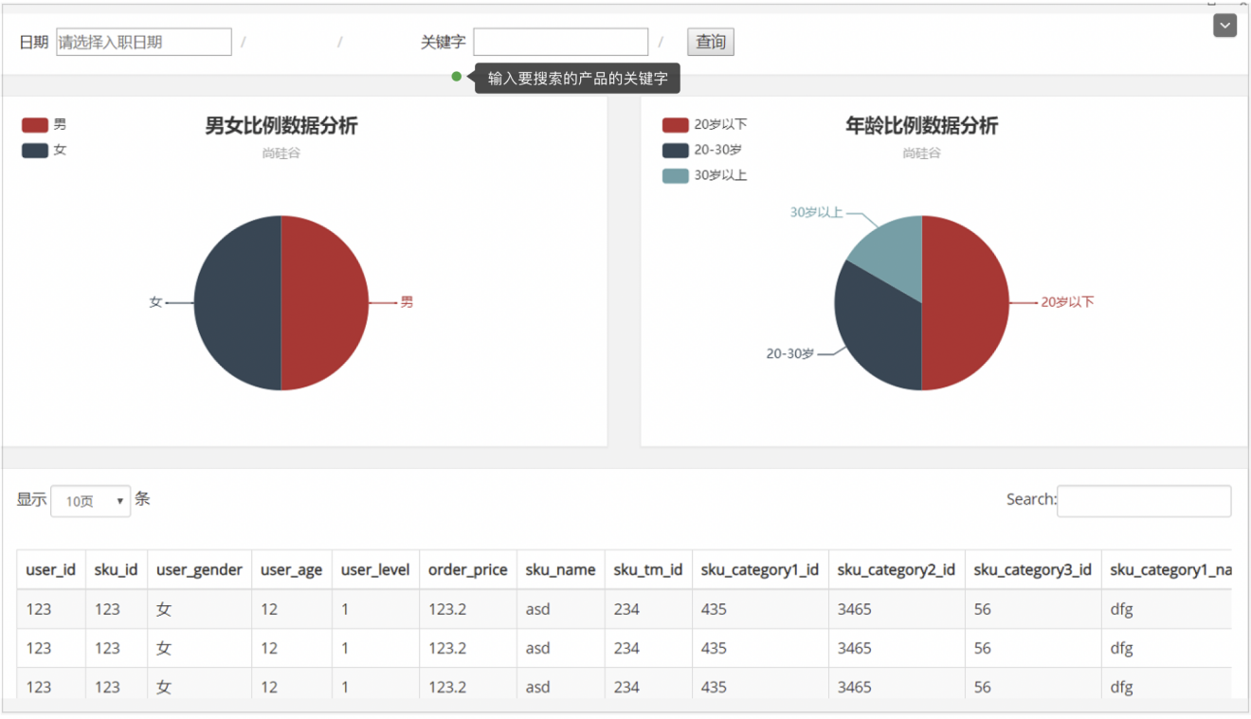

### 13.1 思路分析

数据存储在哪里?

~~1. redis: 交互性能好, 但是不能做聚合~~

~~2. hbase: 交互新能向可, 无法做分析聚合~~

~~3. hive: 可以分析聚合, 但是交互性能差~~

~~4. mysql: 交互性能好, 可以分析聚合, 但是数量大的时候撑不住~~

1. ES: 交互性能好, 能分析聚合, 支持大数据量, 唯一的缺陷: 不能多表 join

所以我们使用 ES 来存储我们的数据!

ES 中的数据来自哪里?

有 2 部分来源:

1. T+1 数据(离线数据)一般来源于数仓
2. T+0 的数据(实时数据)一般来源于 Mysql

#### T+1 的数据又来源于数仓的哪一层

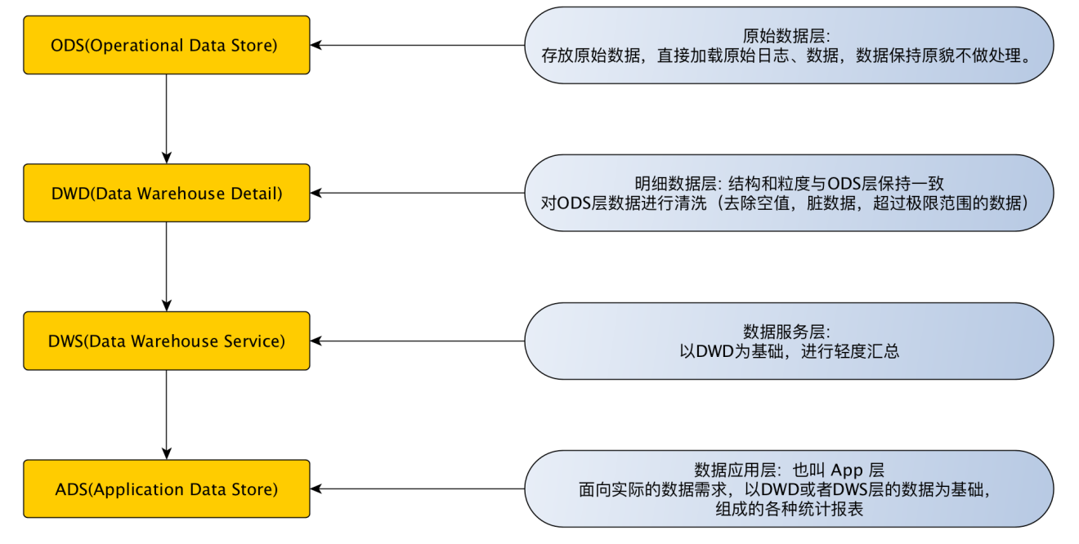

由于 ES 的数据需要明细, 并且自己还没有 join 的功能, 所以应该从 DWS 层获取数据.

通过 SparkSql 把数据存入到 ES 中

#### T+0 的数据怎么读

mysql -> Canal -> kafka -> SparkStreaming -> ES

但是这里有一个问题, Canal 获取到数据是一个表一个表的, 但是 ES 需要的是宽表数据, 怎么解决这个问题?

企业通常的做法: Canal 获取到一条数据之后, 再去反查 Mysql, 把信息给补全了, 然后再把相当于宽表的一条数据集存储到 Kafka 中.

在课堂上, 我们只处理 T+1 的数据, 没有处理 T+0的数据.

### 13.2 T+1 业务数据的数据流程

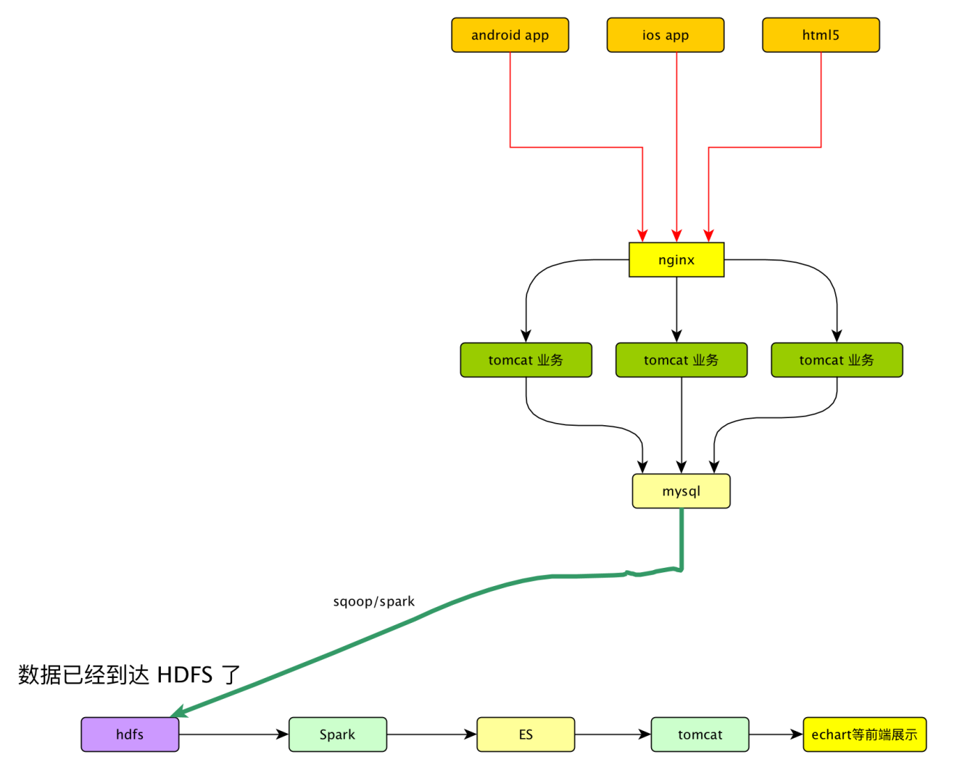

基于前面的数仓项目, 数据已经有了并且已经到到了 HDFS.

我我们在这里需要做的就是使用 Spark 把宽表数据从 HDFS 导入到 ES, 然后提供对外的查询接口.

为为数仓数据准备

如果数仓中已经有对应的数据可以跳过.

我们需要的是用户购买行为的宽表

#### 3.2.1 准备 ODS 层

##### 步骤 1: 在 mysql 中生成数据

# 插入 2019-05-20 日的数据, 10000 条数据 , 200 个用户, 并且删除原来的数据  
CALL init_data('2019-05-20',10000,200,TRUE);

##### 步骤 2: 查看数据是否生成成功

##### 步骤 3: 使用 sqoop 导入数据到 HDFS

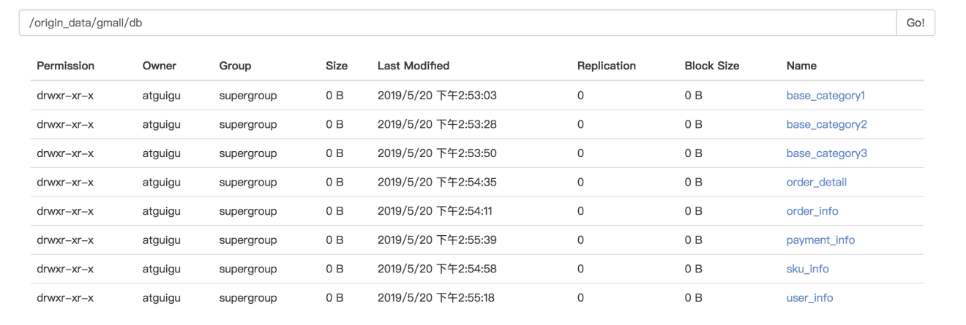

#!/bin/bash  
  
db_date=$2  
echo $db_date  
db_name=gmall  
  
import_data() {  
 /opt/module/sqoop-1.4.6/bin/sqoop import \  
 --connect jdbc:mysql://hadoop201:3306/$db_name \  
 --username root \  
 --password aaa \  
 --target-dir /origin_data/$db_name/db/$1/$db_date \  
 --delete-target-dir \  
 --num-mappers 1 \  
 --fields-terminated-by "\t" \  
 --query "$2"' and $CONDITIONS;'  
}  
  
import_sku_info(){  
 import_data "sku_info" "select  
id, spu_id, price, sku_name, sku_desc, weight, tm_id,  
category3_id, create_time  
 from sku_info where 1=1"  
}  
  
import_user_info(){  
 import_data "user_info" "select  
id, name, birthday, gender, email, user_level,  
create_time  
from user_info where 1=1"  
}  
  
import_base_category1(){  
 import_data "base_category1" "select  
id, name from base_category1 where 1=1"  
}  
  
import_base_category2(){  
 import_data "base_category2" "select  
id, name, category1_id from base_category2 where 1=1"  
}  
  
import_base_category3(){  
 import_data "base_category3" "select id, name, category2_id from base_category3 where 1=1"  
}  
  
import_order_detail(){  
 import_data "order_detail" "select  
 od.id,  
 order_id,  
 user_id,  
 sku_id,  
 sku_name,  
 order_price,  
 sku_num,  
 o.create_time  
 from order_info o, order_detail od  
 where o.id=od.order_id  
 and DATE_FORMAT(create_time,'%Y-%m-%d')='$db_date'"  
}  
  
import_payment_info(){  
 import_data "payment_info" "select  
 id,  
 out_trade_no,  
 order_id,  
 user_id,  
 alipay_trade_no,  
 total_amount,  
 subject,  
 payment_type,  
 payment_time  
 from payment_info  
 where DATE_FORMAT(payment_time,'%Y-%m-%d')='$db_date'"  
}  
  
import_order_info(){  
 import_data "order_info" "select  
 id,  
 total_amount,  
 order_status,  
 user_id,  
 payment_way,  
 out_trade_no,  
 create_time,  
 operate_time  
 from order_info  
 where (DATE_FORMAT(create_time,'%Y-%m-%d')='$db_date' or DATE_FORMAT(operate_time,'%Y-%m-%d')='$db_date')"  
}  
  
case $1 in  
 "base_category1")  
 import_base_category1  
;;  
 "base_category2")  
 import_base_category2  
;;  
 "base_category3")  
 import_base_category3  
;;  
 "order_info")  
 import_order_info  
;;  
 "order_detail")  
 import_order_detail  
;;  
 "sku_info")  
 import_sku_info  
;;  
 "user_info")  
 import_user_info  
;;  
 "payment_info")  
 import_payment_info  
;;  
 "all")  
 import_base_category1  
 import_base_category2  
 import_base_category3  
 import_order_info  
 import_order_detail  
 import_sku_info  
 import_user_info  
 import_payment_info  
;;  
esac

##### 步骤 4: 为ODS 层创建表

完全仿照业务数据库中的表字段，一模一样的创建ODS层对应表。

drop table if exists ods_order_info;  
create external table ods_order_info (  
 `id` string COMMENT '订单编号',  
 `total_amount` decimal(10,2) COMMENT '订单金额',  
 `order_status` string COMMENT '订单状态',  
 `user_id` string COMMENT '用户id',  
 `payment_way` string COMMENT '支付方式',  
 `out_trade_no` string COMMENT '支付流水号',  
 `create_time` string COMMENT '创建时间',  
 `operate_time` string COMMENT '操作时间'  
) COMMENT '订单表'  
  
PARTITIONED BY (`dt` string)  
row format delimited fields terminated by '\t'  
location '/warehouse/gmall/ods/ods_order_info/';  
  
drop table if exists ods_order_detail;  
create external table ods_order_detail(  
 `id` string COMMENT '订单编号',  
 `order_id` string COMMENT '订单号',  
 `user_id` string COMMENT '用户id',  
 `sku_id` string COMMENT '商品id',  
 `sku_name` string COMMENT '商品名称',  
 `order_price` string COMMENT '商品价格',  
 `sku_num` string COMMENT '商品数量',  
 `create_time` string COMMENT '创建时间'  
) COMMENT '订单明细表'  
PARTITIONED BY (`dt` string)  
row format delimited fields terminated by '\t'  
location '/warehouse/gmall/ods/ods_order_detail/';  
  
drop table if exists ods_sku_info;  
create external table ods_sku_info(  
 `id` string COMMENT 'skuId',  
 `spu_id` string COMMENT 'spuid',  
 `price` decimal(10,2) COMMENT '价格',  
 `sku_name` string COMMENT '商品名称',  
 `sku_desc` string COMMENT '商品描述',  
 `weight` string COMMENT '重量',  
 `tm_id` string COMMENT '品牌id',  
 `category3_id` string COMMENT '品类id',  
 `create_time` string COMMENT '创建时间'  
) COMMENT '商品表'  
PARTITIONED BY (`dt` string)  
row format delimited fields terminated by '\t'  
location '/warehouse/gmall/ods/ods_sku_info/';  
  
drop table if exists ods_user_info;  
create external table ods_user_info(  
 `id` string COMMENT '用户id',  
 `name` string COMMENT '姓名',  
 `birthday` string COMMENT '生日',  
 `gender` string COMMENT '性别',  
 `email` string COMMENT '邮箱',  
 `user_level` string COMMENT '用户等级',  
 `create_time` string COMMENT '创建时间'  
) COMMENT '用户信息'  
PARTITIONED BY (`dt` string)  
row format delimited fields terminated by '\t'  
location '/warehouse/gmall/ods/ods_user_info/';  
  
drop table if exists ods_base_category1;  
create external table ods_base_category1(  
 `id` string COMMENT 'id',  
 `name` string COMMENT '名称'  
) COMMENT '商品一级分类'  
PARTITIONED BY (`dt` string)  
row format delimited fields terminated by '\t'  
location '/warehouse/gmall/ods/ods_base_category1/';  
  
drop table if exists ods_base_category2;  
create external table ods_base_category2(  
 `id` string COMMENT ' id',  
 `name` string COMMENT '名称',  
 category1_id string COMMENT '一级品类id'  
) COMMENT '商品二级分类'  
PARTITIONED BY (`dt` string)  
row format delimited fields terminated by '\t'  
location '/warehouse/gmall/ods/ods_base_category2/';  
  
drop table if exists ods_base_category3;  
create external table ods_base_category3(  
 `id` string COMMENT ' id',  
 `name` string COMMENT '名称',  
 category2_id string COMMENT '二级品类id'  
) COMMENT '商品三级分类'  
PARTITIONED BY (`dt` string)  
row format delimited fields terminated by '\t'  
location '/warehouse/gmall/ods/ods_base_category3/';  
  
drop table if exists ods_payment_info;  
create external table ods_payment_info(  
 `id` bigint COMMENT '编号',  
 `out_trade_no` string COMMENT '对外业务编号',  
 `order_id` string COMMENT '订单编号',  
 `user_id` string COMMENT '用户编号',  
 `alipay_trade_no` string COMMENT '支付宝交易流水编号',  
 `total_amount` decimal(16,2) COMMENT '支付金额',  
 `subject` string COMMENT '交易内容',  
 `payment_type` string COMMENT '支付类型',  
 `payment_time` string COMMENT '支付时间'  
) COMMENT '支付流水表'  
PARTITIONED BY (`dt` string)  
row format delimited fields terminated by '\t'  
location '/warehouse/gmall/ods/ods_payment_info/';

##### 步骤 5: 确认表创建成功

##### 步骤 6: 导入数据到 ODS 层

脚本:ods_db.sh

#!/bin/bash  
  
APP=gmall  
hive=/opt/module/hive-1.2.1/bin/hive  
  
# 如果是输入的日期按照取输入日期；如果没输入日期取当前时间的前一天  
if [ -n "$1" ] ;then  
 do_date=$1  
else   
 do_date=`date -d "-1 day" +%F`  
fi  
  
sql="   
load data inpath '/origin_data/$APP/db/order_info/$do_date' OVERWRITE into table "$APP".ods_order_info partition(dt='$do_date');  
  
load data inpath '/origin_data/$APP/db/order_detail/$do_date' OVERWRITE into table "$APP".ods_order_detail partition(dt='$do_date');  
  
load data inpath '/origin_data/$APP/db/sku_info/$do_date' OVERWRITE into table "$APP".ods_sku_info partition(dt='$do_date');  
  
load data inpath '/origin_data/$APP/db/user_info/$do_date' OVERWRITE into table "$APP".ods_user_info partition(dt='$do_date');  
  
load data inpath '/origin_data/$APP/db/payment_info/$do_date' OVERWRITE into table "$APP".ods_payment_info partition(dt='$do_date');  
  
load data inpath '/origin_data/$APP/db/base_category1/$do_date' OVERWRITE into table "$APP".ods_base_category1 partition(dt='$do_date');  
  
load data inpath '/origin_data/$APP/db/base_category2/$do_date' OVERWRITE into table "$APP".ods_base_category2 partition(dt='$do_date');  
  
load data inpath '/origin_data/$APP/db/base_category3/$do_date' OVERWRITE into table "$APP".ods_base_category3 partition(dt='$do_date');   
"  
$hive -e "$sql"

执行导入脚本:

ods_db.sh 2019-05-20

##### 步骤 7: 确认数据导入成功

select * from ods_order_info where dt='2019-05-20';

#### 13.2.2 准备 DWD 层

##### 步骤 1: 建表

订单表, 订单详情表, 用户表, 支付流水表

drop table if exists dwd_order_info;  
create external table dwd_order_info (  
 `id` string COMMENT '',  
 `total_amount` decimal(10,2) COMMENT '',  
 `order_status` string COMMENT ' 1 2 3 4 5',  
 `user_id` string COMMENT 'id',  
 `payment_way` string COMMENT '',  
 `out_trade_no` string COMMENT '',  
 `create_time` string COMMENT '',  
 `operate_time` string COMMENT ''  
)   
PARTITIONED BY (`dt` string)  
stored as parquet  
location '/warehouse/gmall/dwd/dwd_order_info/'  
tblproperties ("parquet.compression"="snappy");  
  
drop table if exists dwd_order_detail;  
create external table dwd_order_detail(   
 `id` string COMMENT '',  
 `order_id` decimal(10,2) COMMENT '',   
 `user_id` string COMMENT 'id',  
 `sku_id` string COMMENT 'id',  
 `sku_name` string COMMENT '',  
 `order_price` string COMMENT '',  
 `sku_num` string COMMENT '',  
 `create_time` string COMMENT ''  
)  
PARTITIONED BY (`dt` string)  
stored as parquet  
location '/warehouse/gmall/dwd/dwd_order_detail/'  
tblproperties ("parquet.compression"="snappy");  
  
drop table if exists dwd_user_info;  
create external table dwd_user_info(   
 `id` string COMMENT 'id',  
 `name` string COMMENT '',   
 `birthday` string COMMENT '',  
 `gender` string COMMENT '',  
 `email` string COMMENT '',  
 `user_level` string COMMENT '',  
 `create_time` string COMMENT ''  
)   
PARTITIONED BY (`dt` string)  
stored as parquet  
location '/warehouse/gmall/dwd/dwd_user_info/'  
tblproperties ("parquet.compression"="snappy");  
  
drop table if exists dwd_payment_info;  
create external table dwd_payment_info(  
 `id` bigint COMMENT '',  
 `out_trade_no` string COMMENT '',  
 `order_id` string COMMENT '',  
 `user_id` string COMMENT '',  
 `alipay_trade_no` string COMMENT '',  
 `total_amount` decimal(16,2) COMMENT '',  
 `subject` string COMMENT '',  
 `payment_type` string COMMENT '',  
 `payment_time` string COMMENT ''  
)   
PARTITIONED BY (`dt` string)  
stored as parquet  
location '/warehouse/gmall/dwd/dwd_payment_info/'  
tblproperties ("parquet.compression"="snappy");

##### 步骤 2: 创建商品表(增加分类)

drop table if exists dwd_sku_info;  
create external table dwd_sku_info(  
 `id` string COMMENT 'skuId',  
 `spu_id` string COMMENT 'spuid',  
 `price` decimal(10,2) COMMENT '',  
 `sku_name` string COMMENT '',  
 `sku_desc` string COMMENT '',  
 `weight` string COMMENT '',  
 `tm_id` string COMMENT 'id',  
 `category3_id` string COMMENT '1id',  
 `category2_id` string COMMENT '2id',  
 `category1_id` string COMMENT '3id',  
 `category3_name` string COMMENT '3',  
 `category2_name` string COMMENT '2',  
 `category1_name` string COMMENT '1',  
 `create_time` string COMMENT ''  
)   
PARTITIONED BY (`dt` string)  
stored as parquet  
location '/warehouse/gmall/dwd/dwd_sku_info/'  
tblproperties ("parquet.compression"="snappy");

##### 步骤 3: 导入数据到 DWD 层

脚本: dwd_db.sh

#!/bin/bash  
  
# 定义变量方便修改  
APP=gmall  
hive=/opt/module/hive-1.2.1/bin/hive  
  
# 如果是输入的日期按照取输入日期；如果没输入日期取当前时间的前一天  
if [ -n "$1" ] ;then  
 do_date=$1  
else   
 do_date=`date -d "-1 day" +%F`   
fi   
  
sql="  
  
set hive.exec.dynamic.partition.mode=nonstrict;  
  
insert overwrite table "$APP".dwd_order_info partition(dt)  
select * from "$APP".ods_order_info   
where dt='$do_date' and id is not null;  
   
insert overwrite table "$APP".dwd_order_detail partition(dt)  
select * from "$APP".ods_order_detail   
where dt='$do_date' and id is not null;  
  
insert overwrite table "$APP".dwd_user_info partition(dt)  
select * from "$APP".ods_user_info  
where dt='$do_date' and id is not null;  
   
insert overwrite table "$APP".dwd_payment_info partition(dt)  
select * from "$APP".ods_payment_info  
where dt='$do_date' and id is not null;  
  
insert overwrite table "$APP".dwd_sku_info partition(dt)  
select   
 sku.id,  
 sku.spu_id,  
 sku.price,  
 sku.sku_name,  
 sku.sku_desc,  
 sku.weight,  
 sku.tm_id,  
 sku.category3_id,  
 c2.id category2_id,  
 c1.id category1_id,  
 c3.name category3_name,  
 c2.name category2_name,  
 c1.name category1_name,  
 sku.create_time,  
 sku.dt  
from  
 "$APP".ods_sku_info sku  
join "$APP".ods_base_category3 c3 on sku.category3_id=c3.id   
 join "$APP".ods_base_category2 c2 on c3.category2_id=c2.id   
 join "$APP".ods_base_category1 c1 on c2.category1_id=c1.id   
where sku.dt='$do_date' and c2.dt='$do_date'  
and c3.dt='$do_date' and c1.dt='$do_date'  
and sku.id is not null;  
"  
  
$hive -e "$sql"

导入:

dwd_db.sh 2019-05-20

#### 13.2.3 准备 DWS 层

用户购买商品明细表(宽表)

##### 步骤 1: 创建用户购买商品明细表

drop table if exists dws_sale_detail_daycount;  
create external table dws_sale_detail_daycount  
(   
 user_id string comment '用户 id',  
 sku_id string comment '商品 Id',  
 user_gender string comment '用户性别',  
 user_age string comment '用户年龄',  
 user_level string comment '用户等级',  
 order_price decimal(10,2) comment '商品价格',  
 sku_name string comment '商品名称',  
 sku_tm_id string comment '品牌id',  
 sku_category3_id string comment '商品三级品类id',  
 sku_category2_id string comment '商品二级品类id',  
 sku_category1_id string comment '商品一级品类id',  
 sku_category3_name string comment '商品三级品类名称',  
 sku_category2_name string comment '商品二级品类名称',  
 sku_category1_name string comment '商品一级品类名称',  
 spu_id string comment '商品 spu',  
 sku_num int comment '购买个数',  
 order_count string comment '当日下单单数',  
 order_amount string comment '当日下单金额'  
) COMMENT '用户购买商品明细表'  
PARTITIONED BY (`dt` string)  
stored as parquet  
location '/warehouse/gmall/dws/dws_user_sale_detail_daycount/'  
tblproperties ("parquet.compression"="snappy");

##### 步骤 2: 向用户购买商品明细表导入数据

#!/bin/bash  
  
# 定义变量方便修改  
APP=gmall  
hive=/opt/module/hive-1.2.1/bin/hive  
  
# 如果是输入的日期按照取输入日期；如果没输入日期取当前时间的前一天  
if [ -n "$1" ] ;then  
 do_date=$1  
else   
 do_date=`date -d "-1 day" +%F`   
fi   
  
sql="  
  
set hive.exec.dynamic.partition.mode=nonstrict;  
  
with  
tmp_detail as  
(  
 select   
 user_id,  
 sku_id,   
 sum(sku_num) sku_num,   
 count(*) order_count,   
 sum(od.order_price*sku_num) order_amount  
 from "$APP".dwd_order_detail od  
 where od.dt='$do_date'  
 group by user_id, sku_id  
)   
insert overwrite table "$APP".dws_sale_detail_daycount partition(dt='$do_date')  
select   
 tmp_detail.user_id,  
 tmp_detail.sku_id,  
 u.gender,  
 months_between('$do_date', u.birthday)/12 age,   
 u.user_level,  
 price,  
 sku_name,  
 tm_id,  
 category3_id,  
 category2_id,  
 category1_id,  
 category3_name,  
 category2_name,  
 category1_name,  
 spu_id,  
 tmp_detail.sku_num,  
 tmp_detail.order_count,  
 tmp_detail.order_amount   
from tmp_detail   
left join "$APP".dwd_user_info u   
on tmp_detail.user_id=u.id and u.dt='$do_date'  
left join "$APP".dwd_sku_info s on tmp_detail.sku_id =s.id and s.dt='$do_date';  
"  
$hive -e "$sql"

执行脚本:

dws_sale.sh 2019-05-20

##### 步骤 3: 查看数据

select * from dws_sale_detail_daycount where dt='2019-05-20'

## 第 14 章 数仓中数据导入到 ES

我们使用 SparkSql 来读取 Hive 中的数据, 然后把读到的数据写入到 ES 中.

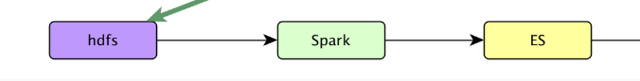

### 14.1 创建 idea 模块

模块名: gmall-dw2es

#### 14.1.1 导入依赖:

<dependencies>  
 <dependency>  
 <groupId>com.atguigu.dw</groupId>  
 <artifactId>gmall-common</artifactId>  
 <version>1.0-SNAPSHOT</version>  
 </dependency>  
  
 <dependency>  
 <groupId>org.apache.spark</groupId>  
 <artifactId>spark-core_2.11</artifactId>  
 </dependency>  
  
 <dependency>  
 <groupId>org.apache.spark</groupId>  
 <artifactId>spark-hive_2.11</artifactId>  
 </dependency>  
 <dependency>  
 <groupId>org.apache.spark</groupId>  
 <artifactId>spark-sql_2.11</artifactId>  
 </dependency>  
  
 <dependency>  
 <groupId>mysql</groupId>  
 <artifactId>mysql-connector-java</artifactId>  
 <version>5.1.27</version>  
 </dependency>  
</dependencies>

#### 14.1.2 copy hie-site.xml 的内容

在resources目录中添加hive-site.xml从而可以让 SparkSql 来找到我们的仓库.

<?xml version="1.0"?>  
<?xml-stylesheet type="text/xsl" href="configuration.xsl"?>  
<configuration>  
 <property>  
 <name>javax.jdo.option.ConnectionURL</name>  
 <value>jdbc:mysql://hadoop201:3306/metastore?createDatabaseIfNotExist=true</value>  
 <description>JDBC connect string for a JDBC metastore</description>  
 </property>  
  
 <property>  
 <name>javax.jdo.option.ConnectionDriverName</name>  
 <value>com.mysql.jdbc.Driver</value>  
 <description>Driver class name for a JDBC metastore</description>  
 </property>  
  
 <property>  
 <name>javax.jdo.option.ConnectionUserName</name>  
 <value>root</value>  
 <description>username to use against metastore database</description>  
 </property>  
  
 <property>  
 <name>javax.jdo.option.ConnectionPassword</name>  
 <value>aaa</value>  
 <description>password to use against metastore database</description>  
 </property>  
 <!-- zookeeper 地址-->  
 <property>  
 <name>hive.zookeeper.quorum</name>  
 <value>hadoop201,hadoop202,hadoop203</value>  
 <description>The list of ZooKeeper servers to talk to. This is only needed for read/write locks.</description>  
 </property>  
 <!-- zookeeper 端口号 -->  
 <property>  
 <name>hive.zookeeper.client.port</name>  
 <value>2181</value>  
 <description>The port of ZooKeeper servers to talk to. This is only needed for read/write locks.</description>  
 </property>  
</configuration>

### 14.2 完成从 dw 到 es 的业务代码

利用 SparkSql 从 Hive 中查询到数据, 然后写入到 ES 中.

#### 14.2.2 在 ES 中为宽表创建索引

PUT gmall_sale_detail  
{  
 "mappings": {  
 "_doc":{  
 "properties":{  
 "user_id":{  
 "type":"keyword"  
 },  
 "sku_id":{  
 "type":"keyword"  
 },  
 "user_gender":{  
 "type":"keyword"  
 },  
 "user_age":{  
 "type":"short"  
 },  
 "user_level":{  
 "type":"keyword"  
 },  
 "sku_price":{  
 "type":"double"   
 },  
 "sku_name":{  
 "type":"text",  
 "analyzer": "ik_max_word"  
 },  
 "sku_tm_id ":{  
 "type":"keyword"  
 },  
 "sku_category3_id":{  
 "type":"keyword"  
 },  
 "sku_category2_id":{  
 "type":"keyword"  
 },  
 "sku_category1_id":{  
 "type":"keyword"  
 },  
 "sku_category3_name":{  
 "type":"text",  
 "analyzer": "ik_max_word"  
 },  
 "sku_category2_name":{  
 "type":"text",  
 "analyzer": "ik_max_word"  
 },  
 "sku_category1_name":{  
 "type":"text",  
 "analyzer": "ik_max_word"  
 },  
 "spu_id":{  
 "type":"keyword"  
 },  
 "sku_num":{  
 "type":"long"  
 },  
 "order_count":{  
 "type":"long"  
 },  
 "order_amount":{  
 "type":"long"  
 },  
 "dt":{  
 "type":"keyword"  
 }   
 }  
 }  
 }  
}

#### 14.2.2 创建SaleDetailDayCount

创建 bean 类com.atguigu.dw.gmalldw2es.bean.SaleDetailDayCount用来封装宽表的数据

package com.atguigu.dw.gmalldw2es.bean  
  
  
case class SaleDetailDayCount(user_id: String,  
 sku_id: String,  
 user_gender: String,  
 user_age: Int,  
 user_level: String,  
 order_price: Double,  
 sku_name: String,  
 sku_tm_id: String,  
 sku_category1_id: String,  
 sku_category2_id: String,  
 sku_category3_id: String,  
 sku_category1_name: String,  
 sku_category2_name: String,  
 sku_category3_name: String,  
 spu_id: String,  
 sku_num: Long,  
 order_count: Long,  
 order_amount: Double,  
 var dt: String)

#### 14.2.3 创建SaleDetailApp

package com.atguigu.dw.gmalldw2es.app  
  
import com.atguigu.dw.gmall.common.util.MyESUtil  
import com.atguigu.dw.gmalldw2es.bean.SaleDetailDayCount  
import org.apache.spark.sql.{Dataset, SparkSession}  
  
/**  
 * Author lzc  
 * Date 2019/5/21 6:10 PM  
 */  
object SaleDetailApp {  
 def main(args: Array[String]): Unit = {  
 // 获取要查询的日期  
 val date = if (args.length > 0) args(0) else "2019-05-20"  
 val spark: SparkSession = SparkSession  
 .builder()  
 .master("local[*]")  
 .appName("SaleDetailApp")  
 .enableHiveSupport()  
 .getOrCreate()  
 import spark.implicits._  
 val sql =  
 s"""  
 |select  
 | user_id,  
 | sku_id,  
 | user_gender,  
 | cast(user_age as int) user_age,  
 | user_level,  
 | cast(order_price as double) order_price,  
 | sku_name,  
 | sku_tm_id,  
 | sku_category3_id,  
 | sku_category2_id,  
 | sku_category1_id,  
 | sku_category3_name,  
 | sku_category2_name,  
 | sku_category1_name,  
 | spu_id,  
 | sku_num,  
 | cast(order_count as bigint) order_count,  
 | cast(order_amount as double) order_amount,  
 | dt  
 |from dws_sale_detail_daycount  
 |where dt='$date'  
 """.stripMargin  
 spark.sql("use gmall")  
 val ds: Dataset[SaleDetailDayCount] = spark.sql(sql).as[SaleDetailDayCount]  
 ds.foreachPartition(it => {  
 MyESUtil.insertBulk("gmall_sale_detail", it.toList)  
 })  
   
 spark.stop()  
 }  
}

## 第 15 章 发布灵活查询用到的数据

1. 发布接口:

* http://localhost:8070/sale_detail?date=2019-05-20&&startpage=1&&size=5&&keyword=手机小米
* 说明: startpage表示开始页数, size表示每页查询的明细数量

1. 返回的数据格式

* {  
   "total": 62,  
   "stat": [{  
   "options": [{  
   "name": "20岁以下",  
   "value": 0.0  
   }, {  
   "name": "20岁到30岁",  
   "value": 25.8  
   }, {  
   "name": "30岁及30岁以上",  
   "value": 74.2  
   }],  
   "title": "用户年龄占比"  
   }, {  
   "options": [{  
   "name": "男",  
   "value": 38.7  
   }, {  
   "name": "女",  
   "value": 61.3  
   }],  
   "title": "用户性别占比"  
   }],  
   "detail": [{  
   "user_id": "9",  
   "sku_id": "8",  
   "user_gender": "M",  
   "user_age": 49.0,  
   "user_level": "1",  
   "sku_price": 8900.0,  
   "sku_name": "Apple iPhone XS Max (A2104) 256GB 深空灰色 移动联通电信4G手机 双卡双待",  
   "sku_tm_id": "86",  
   "sku_category1_id": "2",  
   "sku_category2_id": "13",  
   "sku_category3_id": "61",  
   "sku_category1_name": "手机",  
   "sku_category2_name": "手机通讯",  
   "sku_category3_name": "手机",  
   "spu_id": "1",  
   "sku_num": 6.0,  
   "order_count": 2.0,  
   "order_amount": 53400.0,  
   "dt": "2019-05-20",  
   "es_metadata_id": "wPdM7GgBQMmfy2BJr4YT"  
   }, {  
   "user_id": "5",  
   "sku_id": "8",  
   "user_gender": "F",  
   "user_age": 36.0,  
   "user_level": "4",  
   "sku_price": 8900.0,  
   "sku_name": "Apple iPhone XS Max (A2104) 256GB 深空灰色 移动联通电信4G手机 双卡双待",  
   "sku_tm_id": "86",  
   "sku_category1_id": "2",  
   "sku_category2_id": "13",  
   "sku_category3_id": "61",  
   "sku_category1_name": "手机",  
   "sku_category2_name": "手机通讯",  
   "sku_category3_name": "手机",  
   "spu_id": "1",  
   "sku_num": 5.0,  
   "order_count": 1.0,  
   "order_amount": 44500.0,  
   "dt": "2019-05-20",  
   "es_metadata_id": "wvdM7GgBQMmfy2BJr4YT"  
   }, {  
   "user_id": "19",  
   "sku_id": "8",  
   "user_gender": "F",  
   "user_age": 43.0,  
   "user_level": "5",  
   "sku_price": 8900.0,  
   "sku_name": "Apple iPhone XS Max (A2104) 256GB 深空灰色 移动联通电信4G手机 双卡双待",  
   "sku_tm_id": "86",  
   "sku_category1_id": "2",  
   "sku_category2_id": "13",  
   "sku_category3_id": "61",  
   "sku_category1_name": "手机",  
   "sku_category2_name": "手机通讯",  
   "sku_category3_name": "手机",  
   "spu_id": "1",  
   "sku_num": 7.0,  
   "order_count": 2.0,  
   "order_amount": 62300.0,  
   "dt": "2019-05-20",  
   "es_metadata_id": "xvdM7GgBQMmfy2BJr4YU"  
   }, {  
   "user_id": "15",  
   "sku_id": "8",  
   "user_gender": "M",  
   "user_age": 66.0,  
   "user_level": "4",  
   "sku_price": 8900.0,  
   "sku_name": "Apple iPhone XS Max (A2104) 256GB 深空灰色 移动联通电信4G手机 双卡双待",  
   "sku_tm_id": "86",  
   "sku_category1_id": "2",  
   "sku_category2_id": "13",  
   "sku_category3_id": "61",  
   "sku_category1_name": "手机",  
   "sku_category2_name": "手机通讯",  
   "sku_category3_name": "手机",  
   "spu_id": "1",  
   "sku_num": 3.0,  
   "order_count": 1.0,  
   "order_amount": 26700.0,  
   "dt": "2019-05-20",  
   "es_metadata_id": "xvdM7GgBQMmfy2BJr4YU"  
   }]  
  }

1. 要做的报表:
2. 购买的男女比例

这个比较容易统计, 在查询的直接按照男女分组即可统计出来 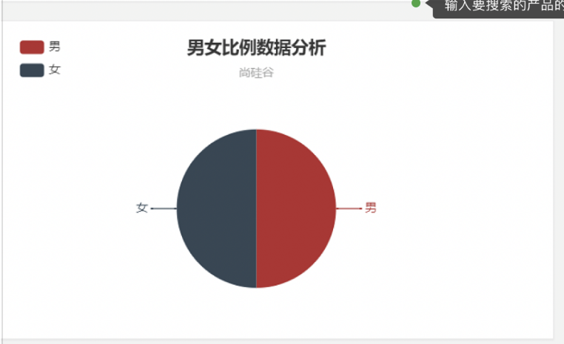

1. 购买明细

每次查询都会自带明细, 也是比较容易得到 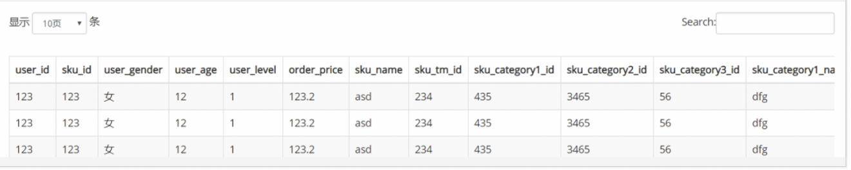

1. 年龄段分布

这个查询相对比较麻烦, es 只能把每个年龄的购买统计出来, 但是无法统计出来 20-39 这个10 个年龄的数据, 我们可以在代码中来统计这个 10 个年龄的数据

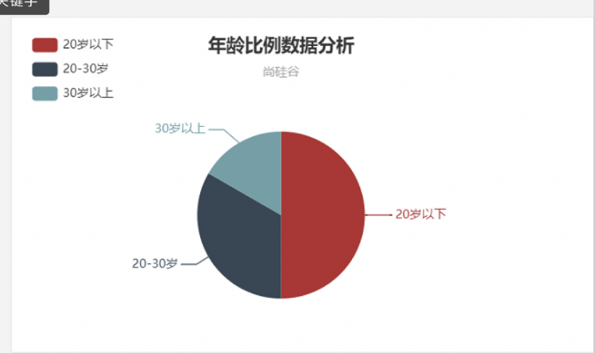

### 15.1 在 gmall-publish 子模块中读取 ES 中数据

#### 15.1.1 在PublisherService中添加方法

package com.atguigu.dw.gmallpublisher.service  
  
trait PublisherService {  
 /**  
 * 根据需要的聚合字段得到销售明细和聚合结构  
 *  
 * @param date 要查询的日期  
 * @param keyword 要查询关键字  
 * @param startPage 开始页面  
 * @param size 每页显示多少条记录  
 * @param aggField 要聚合的字段  
 * @param aggSize 聚合后最多多少条记录  
 * @return 1. 总数 2. 聚合结果 3. 明细  
 * {  
 * "total": 100,  
 * "stat" : [  
 * {  
 * // 年龄段比例  
 * },  
 * {  
 * // 男女比例  
 * }  
 * ],  
 * "detail": {  
 * // 明细  
 * }  
 * }  
 */  
 def getSaleDetailAndAggResultByAggField(date: String,  
 keyword: String,  
 startPage: Int,  
 size: Int,  
 aggField: String,  
 aggSize: Int): Map[String, Any]  
}

#### 15.1.2 在PublisherServiceImp中实现上述方法

override def getSaleDetailAndAggResultByAggField(date: String, keyword: String, startPage: Int, size: Int, aggField: String, aggSize: Int): Map[String, Any] = {  
 // 统计每个年龄购买情况  
 val searchDSL =  
 s"""  
 |{  
 | "from": ${(startPage - 1) * size},  
 | "size": $size,  
 | "query": {  
 | "bool": {  
 | "filter": {  
 | "term": {  
 | "dt": "$date"  
 | }  
 | }  
 | , "must": [  
 | {"match": {  
 | "sku_name": {  
 | "query": "$keyword",  
 | "operator": "and"  
 | }  
 | }}  
 | ]  
 | }  
 | }  
 | , "aggs": {  
 | "groupby_$aggField": {  
 | "terms": {  
 | "field": "user_$aggField",  
 | "size": $aggSize  
 | }  
 | }  
 | }  
 |}  
 """.stripMargin  
   
 val search: Search = new Search.Builder(searchDSL)  
 .addIndex("gmall_sale_detail")  
 .addType("_doc")  
 .build()  
   
 val client: JestClient = MyESUtil.getClient()  
 val result: SearchResult = client.execute(search)  
   
 // 1. 得到总数  
 val total: Integer = result.getTotal  
 // 2. 得到明细 (scala 集合)  
 val detailList = List[Map[String, Any]]() // 存储明细  
 val hits: util.List[SearchResult#Hit[util.HashMap[String, Any], Void]] = result.getHits(classOf[util.HashMap[String, Any]])  
 import scala.collection.JavaConversions._ // 要是使用 scala 的遍历凡是, 需要隐式转换  
 for (hit <- hits) {  
 val source: util.HashMap[String, Any] = hit.source  
 detailList.add(source.toMap)  
 }  
 // 3. 得到聚合结果  
 var aggMap = Map[String, Long]() // 存储聚合结果  
 val buckets = result.getAggregations.getTermsAggregation(s"groupby_$aggField").getBuckets  
 for (bucket <- buckets) {  
 aggMap += bucket.getKey -> bucket.getCount()  
 }  
   
 // 返回最终结果  
 Map("total" -> total, "aggMap" -> aggMap, "detail" -> detailList)  
}

### 15.2 在 Controller 中年添加对外访问接口

#### 15.2.1 添加封装数据的 bean 类

package com.atguigu.dw.gmallpublisher.bean  
  
import org.json4s.JValue  
  
/**  
 * 封装饼图中的数据  
 * 代表一张饼图  
 */  
case class Stat(title: String, options: List[Opt])  
  
/**  
 * 表示结果中的一个选项  
 * 男 0.1 ...  
 * *  
 * 20-20岁 0.2  
 */  
case class Opt(name: String, value: String)  
  
/**  
 * 封装返回给前端的所有数据  
 */  
case class SaleInfo(total: Int, stats: List[Stat], detail: List[Map[String, Any]])

#### 15.2.2 在 Controller 中添加方法

/*  
接口: http://localhost:8070/sale_detail?date=2019-05-20&&startpage=1&&size=5&&keyword=手机小米  
  
 */  
@GetMapping(Array("sale_detail"))  
def saleDetail(@RequestParam("date") date: String,  
 @RequestParam("startpage") startPage: Int,  
 @RequestParam("size") pageSize: Int,  
 @RequestParam("keyword") keyword: String) = {  
 val formater = new DecimalFormat(".00")  
   
 // 按照性别统计  
 val saleDetailMapByGender: Map[String, Any] = publisherService.getSaleDetailAndAggResultByAggField(date, keyword, startPage, pageSize, "user_gender", 2)  
 val total: Integer = saleDetailMapByGender("total").asInstanceOf[Integer]  
 val genderMap: Map[String, Long] = saleDetailMapByGender("aggMap").asInstanceOf[Map[String, Long]]  
 val maleCount: Long = genderMap("M")  
 val femalCount: Long = genderMap("F")  
 // 个数变比例, F M 变 男 女 用户性别占比  
 val genderOpts = List[Opt](  
 Opt("total", total.toString),  
 Opt("男", formater.format(maleCount.toDouble / total)),  
 Opt("女", formater.format(femalCount.toDouble / total))  
 )  
 // 性别图片的数据  
 val genderStat = Stat("用户性别占比", genderOpts)  
   
 // 按照年龄统计  
 val saleDetailMapByAge: Map[String, Any] = publisherService.getSaleDetailAndAggResultByAggField(date, keyword, startPage, pageSize, "user_age", 100)  
 // 分别计算每个年龄段的人数  
 val ageMap: Map[String, Long] = saleDetailMapByAge("aggMap").asInstanceOf[Map[String, Long]]  
 val ageOpts = ageMap.groupBy {  
 case (age, _) =>  
 val intAge = age.toInt  
 if (intAge < 20) "20岁以下"  
 else if (intAge >= 20 && intAge <= 30) "20岁到30岁"  
 else "30岁以上"  
 }.map {  
 case (age2age, map) =>  
 (age2age, (0L /: map) (_ + _._2))  
 }.map {  
 case (age2age, count) =>  
 (age2age, formater.format(count.toDouble / total))  
 }.toList.map {  
 case (age2age, rate) =>  
 Opt(age2age, rate)  
 }  
   
 // 年龄段图表的数据  
 val ageStat = Stat("用户年龄占比", ageOpts)  
   
 // 详表  
 val detailList: List[Map[String, Any]] = saleDetailMapByAge("detail").asInstanceOf[List[Map[String, Any]]]  
 val saleInfo = SaleInfo(total, List(genderStat, ageStat), detailList)  
 // 返回给前端数据  
 import org.json4s.jackson.Serialization.write // 序列化方法  
 implicit val formats = DefaultFormats  
 write(saleInfo)  
}

## 第 16 章 可视化展示

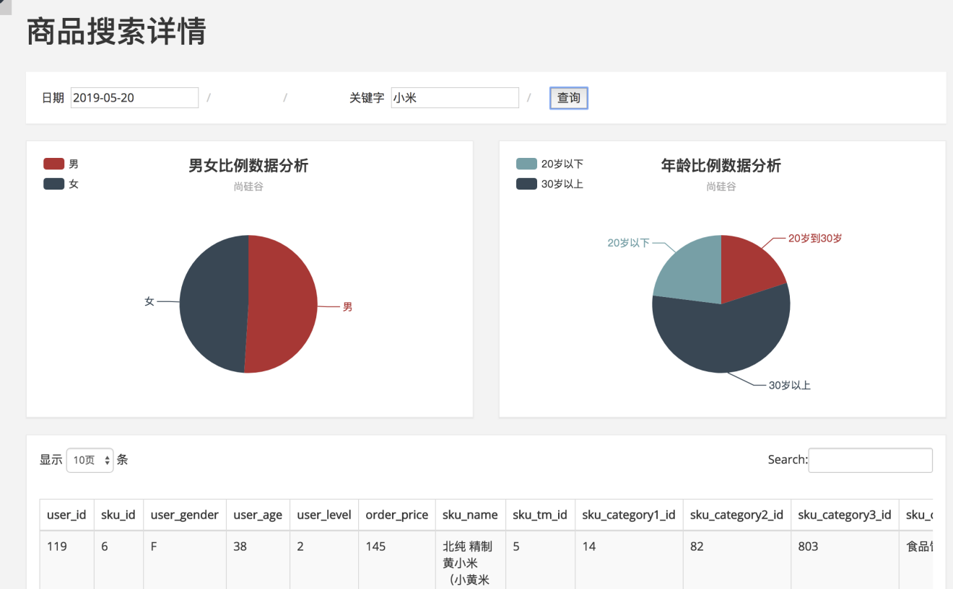

# 第 3 部分 实时预警

## 第 1 章 需求分析

### 1.1 简介

实时预警，是一种经常出现在实时计算中的业务类型。根据日志数据中系统报错异常，或者用户行为异常的检测，产生对应预警日志。

预警日志通过图形化界面的展示，可以提醒监控方，需要及时核查问题，并采取应对措施。

### 1.2 需求说明

需求：同一设备，5分钟内三次及以上用不同账号登录并领取优惠劵，并且在登录到领劵过程中没有浏览商品。同时达到以上要求则产生一条预警日志。 同一设备，每分钟只记录一次预警。

## 第 2 章 整体流程设计

### 2.1 整体框架流程

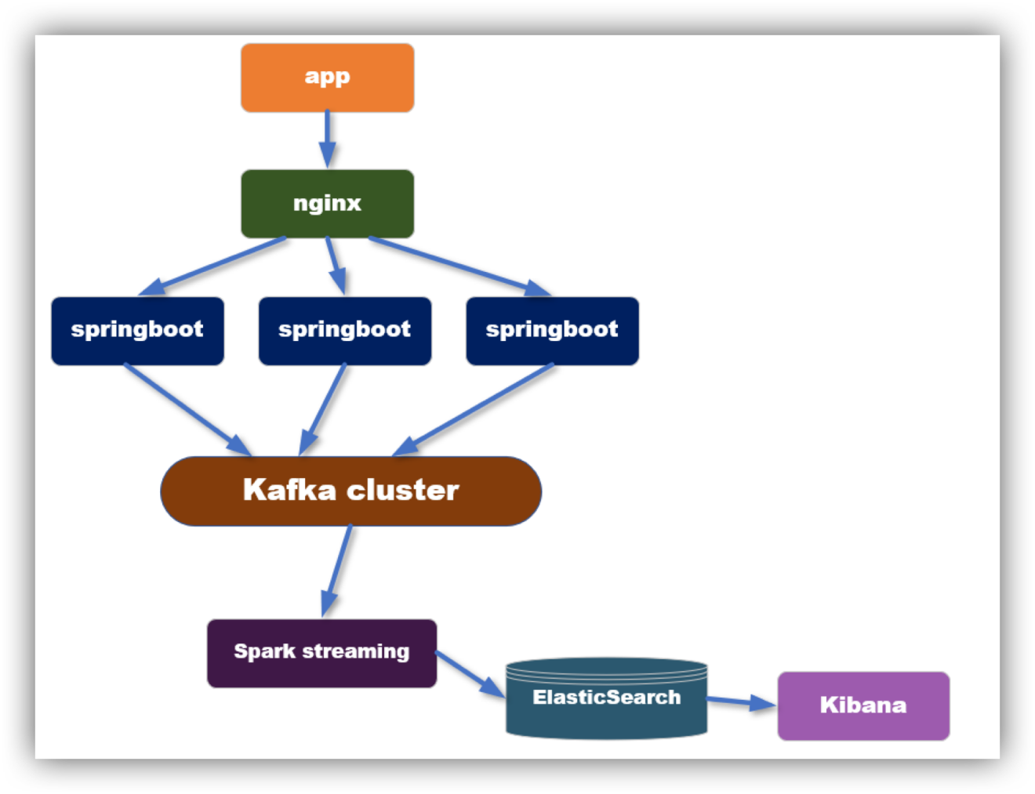

### 2.2 整体开发思路

1. 从kafka中消费数据，根据条件进行过滤筛选，生成预警日志。
2. 预警日志保存到ElasticSearch中
3. 利用Kibana 快速搭建可视化图形界面

## 第 3 章 实时计算模块

### 3.1 预警条件分析

1. 同一设备(按照设备分组)
2. 5分钟内(window)
3. 三个不同账号登录
4. 领取优惠券
5. 并且没有浏览商品
6. 同一设备每分钟只预警一次(同一设备, 每分钟只向 es 写一次记录)

### 3.2 数据处理流程图

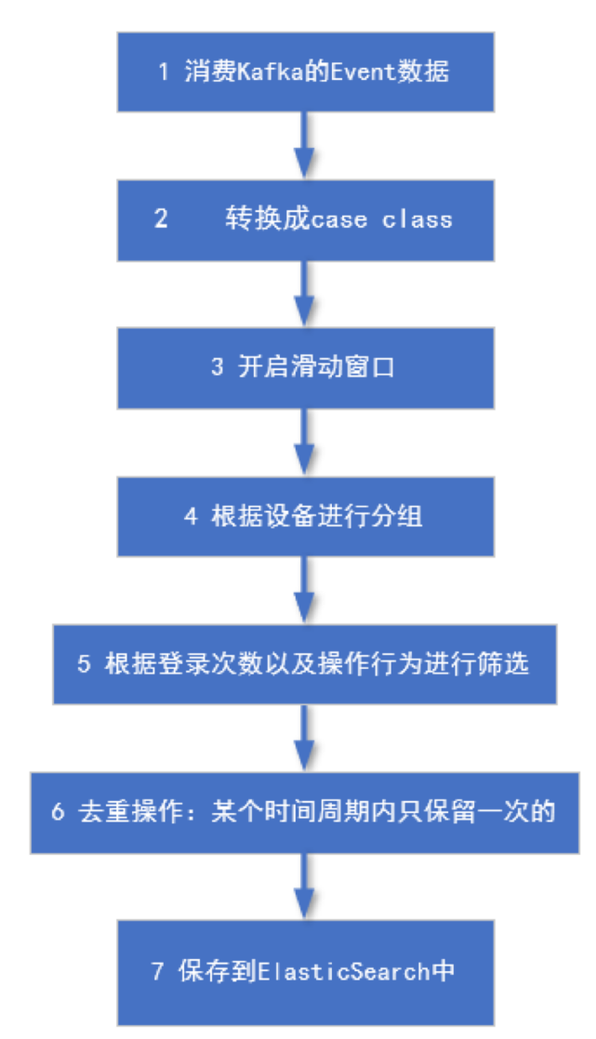

### 3.3 代码开发

代码添加到实时模块中

#### 3.3.1 事件日志样例类

case class EventLog(mid: String,  
 uid: String,  
 appId: String,  
 area: String,  
 os: String,  
 logType: String,  
 eventId: String,  
 pageId: String,  
 nextPageId: String,  
 itemId: String,  
 ts: Long,  
 var logDate: String,  
 var logHour: String)

#### 3.3.2 预警样例类

case class AlertInfo(mid: String,  
 uids: java.util.HashSet[String],  
 itemIds: java.util.HashSet[String],  
 events: java.util.List[String],  
 ts: Long)

#### 3.3.3 预警具体业务

package com.atguigu.gmall0225.realtime.app  
  
  
import java.text.SimpleDateFormat  
import java.util  
import java.util.Date  
  
import com.alibaba.fastjson.JSON  
import com.atguigu.gmall0225.common.util.{GmallConstant, MyESUtil}  
import com.atguigu.gmall0225.realtime.bean.{AlertInfo, EventLog}  
import com.atguigu.gmall0225.realtime.util.MyKafkaUtil  
import org.apache.spark.SparkConf  
import org.apache.spark.streaming.dstream.{DStream, InputDStream}  
import org.apache.spark.streaming.{Seconds, StreamingContext}  
  
import scala.util.control.Breaks._  
  
/**  
 * Author lzc  
 * Date 2019-07-23 08:50  
 */  
object AlertApp {  
 def main(args: Array[String]): Unit = {  
 // 1. 从kafka消费数据(事件日志)  
 val conf: SparkConf = new SparkConf().setAppName("DAUApp").setMaster("local[1]")  
 val ssc = new StreamingContext(conf, Seconds(5))  
 val sourceDStream: InputDStream[(String, String)] = MyKafkaUtil.getKafkaStream(ssc, GmallConstant.TOPIC_EVENT)  
   
 // 2. 添加窗口, 调整数据结构  
 val eventLogDStream: DStream[(String, EventLog)] = sourceDStream  
 .window(Seconds(5 * 60), Seconds(5))  
 .map {  
 case (_, jsonString) => {  
 val log = JSON.parseObject(jsonString, classOf[EventLog])  
 val date = new Date(log.ts)  
 log.logDate = new SimpleDateFormat("yyyy-MM-dd").format(date)  
 log.logHour = new SimpleDateFormat("HH").format(date)  
 (log.mid, log)  
 }  
 }  
   
 // 3. 按照 uid 分组  
 val groupedEventLogDStream: DStream[(String, Iterable[EventLog])] = eventLogDStream.groupByKey  
   
 // 4. 预警的业务逻辑  
 val checkCouponAlertDStream: DStream[(Boolean, AlertInfo)] = groupedEventLogDStream.map {  
 case (mid, logIt) => {  
 val uids: util.HashSet[String] = new util.HashSet[String]()  
 val itemIds: util.HashSet[String] = new util.HashSet[String]()  
 val eventIds: util.ArrayList[String] = new util.ArrayList[String]()  
   
 var isBrowserProduct: Boolean = false // 是否浏览商品, 默认没有浏览  
 // 1. 遍历这个设备上5分钟内的所有事件日志  
 breakable {  
 logIt.foreach(log => {  
 eventIds.add(log.eventId)  
 // 2. 记录下领优惠全的所有用户  
 if (log.eventId == "coupon") {  
 uids.add(log.uid) // 领优惠券的用户id  
 itemIds.add(log.itemId) // 用户领券的商品id  
 } else if (log.eventId == "clickItem") { // 如果有浏览商品  
 isBrowserProduct = true  
 break  
 }  
 })  
 }  
 //2. 组合成元组 (是否预警, 预警信息)  
 (!isBrowserProduct && uids.size() >= 3, AlertInfo(mid, uids, itemIds, eventIds, System.currentTimeMillis()))  
 }  
 }  
 // 5. 过滤掉不需要报警的信息  
 val filteredDStream: DStream[AlertInfo] = checkCouponAlertDStream.filter(_._1).map(_._2)  
 // 6. 把预警信息写入到 ES  
   
 ssc.start()  
 ssc.awaitTermination()  
   
 }  
}

## 第 4 章 保存到 ES

### 4.1 ES 回顾

#### 4.1.1 基本概念

|  |  |
| --- | --- |
| cluster | 整个elasticsearch 默认就是集群状态，整个集群是一份完整、互备的数据。 |
| node | 集群中的一个节点，一般只一个进程就是一个node |
| shard | 分片，即使是一个节点中的数据也会通过hash算法，分成多个片存放，默认是5片。（7.0默认改为1片） |
| index | 相当于rdbms的database, 对于用户来说是一个逻辑数据库，虽然物理上会被分多个shard存放，也可能存放在多个node中。 |
| type | 类似于rdbms的table，但是与其说像table，其实更像面向对象中的class , 同一Json的格式的数据集合。（6.x只允许建一个，7.0被废弃，造成index实际相当于table级） |
| document | 类似于rdbms的 row、面向对象里的object |
| field | 相当于字段、属性 |





#### 4.1.2 启动脚本

#!/bin/bash  
es_home=/opt/module/elasticsearch-6.3.1  
kibana_home=/opt/module/kibana-6.3.1  
case $1 in  
 "start") {  
 for i in hadoop201 hadoop202 hadoop203  
 do  
 ssh $i "source /etc/profile;${es_home}/bin/elasticsearch >/dev/null 2>&1 &"  
  
 done  
  
 nohup ${kibana_home}/bin/kibana >kibana.log 2>&1 &  
  
 };;  
 "stop") {  
 ps -ef|grep ${kibana_home} |grep -v grep|awk '{print $2}'|xargs kill  
  
 for i in hadoop201 hadoop202 hadoop203  
 do  
 ssh $i "ps -ef|grep $es_home |grep -v grep|awk '{print \$2}'|xargs kill" >/dev/null 2>&1  
 done  
  
  
 };;  
 *){  
 echo "你启动的姿势不正确, 请使用参数 start 来启动es集群, 使用参数 stop 来关闭es集群"  
 };;  
esac

#### 4.1.3 常用操作

# 查询健康状态  
GET /_cat/health?v  
# 查看所有的索引  
GET /_cat/indices?v  
# 查看索引分片情况  
  
# 增加一个索引  
PUT /movie_index   
  
# 删除一个索引  
DELETE /movie_index  
  
# 新增文档  
PUT /movie_index/movie/1  
{ "id":1,  
 "name":"operation red sea",  
 "doubanScore":8.5,  
 "actorList":[   
 {"id":1,"name":"zhang yi"},  
 {"id":2,"name":"hai qing"},  
 {"id":3,"name":"zhang han yu"}  
 ]  
}  
PUT /movie_index/movie/2  
{  
 "id":2,  
 "name":"operation meigong river",  
 "doubanScore":8.0,  
 "actorList":[   
 {"id":3,"name":"zhang han yu"}  
 ]  
}  
  
PUT /movie_index/movie/3  
{  
 "id":3,  
 "name":"incident red sea",  
 "doubanScore":5.0,  
 "actorList":[   
 {"id":4,"name":"zhang chen"}  
 ]  
}  
  
# 根据 _id 查找  
GET /movie_index/movie/1  
  
# 修改某一个 field 的值  
POST /movie_index/movie/1/_update  
{  
 "doc": {  
 "doubanScore": 10  
 }  
}  
  
# 搜索 匹配 过滤  
  
# 分词匹配  
GET /movie_index/movie/_search  
{  
 "query": {  
 "match": {  
 "name": "sea"  
 }  
 }  
}  
# 子查询匹配, 层级结构  
GET /movie_index/movie/_search  
{  
 "query": {  
 "match": {  
 "actorList.name": "zhang"  
 }  
 }  
}  
# 短语匹配: 不拆词 比如查询人名  
GET /movie_index/movie/_search  
{  
 "query": {  
 "match_phrase": {  
 "name": "operation meigong"  
 }  
 }  
}  
  
# 过滤  
  
## 查询后过滤  
GET /movie_index/movie/_search  
{  
 "query": {  
 "match": {  
 "name": "red sea"  
 }  
 }  
 , "post_filter": {  
 "term": {  
 "actorList.id": 4  
 }  
 }  
}  
## 查询前过滤  
GET /movie_index/movie/_search  
{  
 "query": {  
 "bool": {  
 "filter": {  
 "term": {  
 "actorList.name": "zhang"  
 }  
 }  
 , "must": [  
 {"match": {  
 "actorList.id": 3  
 }},{  
 "match": {  
 "actorList.name": "hai"  
 }  
 }  
 ]  
 }  
 }  
}  
  
# 排序  
GET /movie_index/movie/_search  
{  
 "query": {  
 "match": {  
 "actorList.name": "zhang"  
 }  
 }  
 , "sort": [  
 {  
 "doubanScore": {  
 "order": "asc"  
 }  
 }  
 ]  
}  
  
# 分页  
GET /movie_index/movie/_search  
{  
 "from": 1  
 , "size": 2  
}  
  
# 高亮  
GET /movie_index/movie/_search  
{  
 "query": {  
 "match": {  
 "name": "sea"  
 }  
 }  
 , "highlight": {  
 "fields": {  
 "name": {}  
 }  
 }  
}  
  
# 聚合  
GET /movie_index/movie/_search  
{  
 "aggs": {  
 "groupby_actor": {  
 "terms": {  
 "field": "actorList.name.keyword",  
 "size": 10  
 }  
 , "aggs": {  
 "avg_douban": {  
 "avg": {  
 "field": "doubanScore"  
 }  
 }  
 }  
 }  
 }  
}

### 4.2 在 ES 上创建索引

其实即使不提前建立索引，ES也是可以将数据保存进去的。这种情况，ES会根据第一条要插入的数据进行推断，但是ES的这种推断往往不够准确。

比如：要区分字段要不要进行索引，字段要不要进行分词，如果分词选用哪个分词器等等。

所以, 一般我们都是提前手动创建索引.

PUT gmall_coupon_alert  
{  
 "mappings": {  
 "_doc":{  
 "properties":{  
 "mid":{  
 "type":"keyword"  
 },  
 "uids":{  
 "type":"keyword"  
 },  
 "itemIds":{  
 "type":"keyword"  
 },  
 "events":{  
 "type":"keyword"  
 },  
 "ts":{  
 "type":"date"  
 }   
 }  
 }  
 }  
}

### 4.3 创建操作 ES 的工具类

由于多个子模块都会操作 ES, 所以, 我们把这个工具类定义在gmall-common包下.

#### 步骤 1: 在gmall-common模块中添加对 ES 的依赖

<!--es 相关依赖开始-->  
<dependency>  
 <groupId>io.searchbox</groupId>  
 <artifactId>jest</artifactId>  
 <version>6.3.1</version>  
</dependency>  
  
<dependency>  
 <groupId>net.java.dev.jna</groupId>  
 <artifactId>jna</artifactId>  
 <version>4.5.2</version>  
</dependency>  
  
<dependency>  
 <groupId>org.codehaus.janino</groupId>  
 <artifactId>commons-compiler</artifactId>  
 <version>2.7.8</version>  
</dependency>  
<!-- es 相关依赖结束 -->

#### 步骤 2: MyESUtil工具类源码

package com.atguigu.gmall0225.common.util  
  
import io.searchbox.client.config.HttpClientConfig  
import io.searchbox.client.{JestClient, JestClientFactory}  
import io.searchbox.core.{Bulk, Index}  
  
/**  
 * Author lzc  
 * Date 2019-07-24 09:50  
 */  
object MyESUtil {  
 val esUrl = "http://hadoop201:9200"  
 val factory = new JestClientFactory  
 val conf: HttpClientConfig = new HttpClientConfig.Builder(esUrl)  
 .multiThreaded(true)  
 .maxTotalConnection(20)  
 .connTimeout(10000)  
 .readTimeout(10000)  
 .build()  
 factory.setHttpClientConfig(conf)  
   
 // 获取客户端  
 def getESClient = factory.getObject  
   
 // 插入单条数据  
 def insertSingle(indexName: String, source: Any) = {  
 val client: JestClient = getESClient  
 val index: Index = new Index.Builder(source)  
 .`type`("_doc")  
 .index(indexName)  
 .build()  
 client.execute(index)  
 client.close()  
 }  
   
 // 插入多条数据 sources: Iterable[(id, caseClass)] 或者 Iterable[caseClass]  
 def insertBulk(indexName: String, sources: Iterator[Any]): Unit = {  
 if (sources.isEmpty) return  
   
 val client: JestClient = getESClient  
 val bulkBuilder = new Bulk.Builder()  
 .defaultIndex(indexName)  
 .defaultType("_doc")  
 sources.foreach { // 把所有的source变成action添加buck中  
 //传入的是值是元组, 第一个表示id  
 case (id: String, data) => bulkBuilder.addAction(new Index.Builder(data).id(id).build())  
 // 其他类型 没有id, 将来省的数据会自动生成默认id  
 case data => bulkBuilder.addAction(new Index.Builder(data).build())  
 }  
 client.execute(bulkBuilder.build())  
 closeClient(client)  
 }  
   
 def main(args: Array[String]): Unit = {  
 // insertSingle("user", User("a", 20))  
 insertBulk("user", Iterator(User("aa", 20), User("bb", 30)))  
   
 }  
   
 /**  
 * 关闭客户端  
 *  
 * @param client  
 */  
 def closeClient(client: JestClient) = {  
 if (client != null) {  
 try {  
 client.shutdownClient()  
 } catch {  
 case e => e.printStackTrace()  
 }  
 }  
 }  
   
}  
case class User(name: String, age: Int)

### 4.4 保存数据到 ES 中

// 6. 把预警信息写入到 ES  
// 6.1 对同一个mid, 每分钟最多预警一次. 所以需要做去重处理. 去重使用es来实现去重: 当id相同的时候, 后面的会自动覆盖前面的  
// id: mid_分钟  
val alertInfoWithIdDStream = filteredDStream.map(alertInfo => (alertInfo.mid + "_" + alertInfo.ts / 1000 / 60, alertInfo))  
  
// 6.2 写入到es中  
alertInfoWithIdDStream.foreachRDD(rdd => {  
 rdd.foreachPartition(it => MyESUtil.insertBulk("gmall_coupon_alert", it))  
})

## 第 5 章 使用 Kibana 发布可视化界面

### 5.1 建立Index pattern

选择数据源

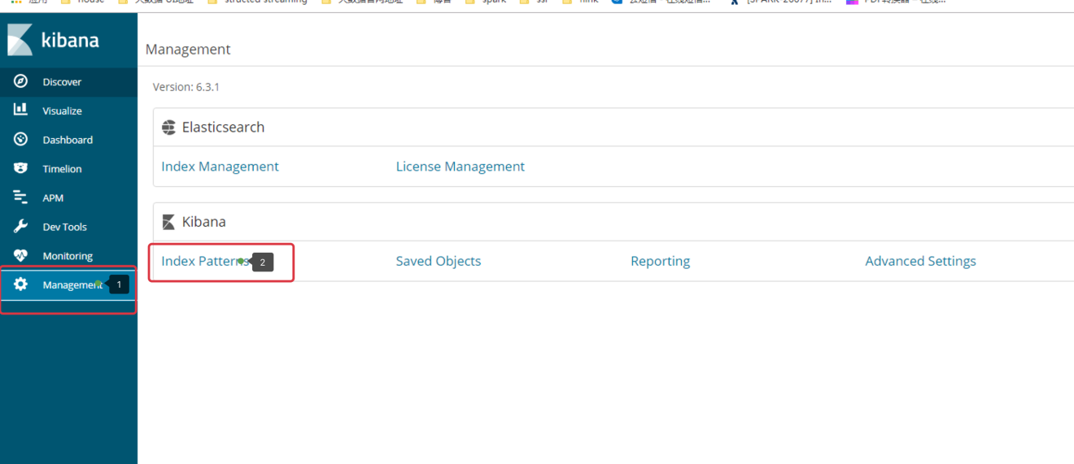

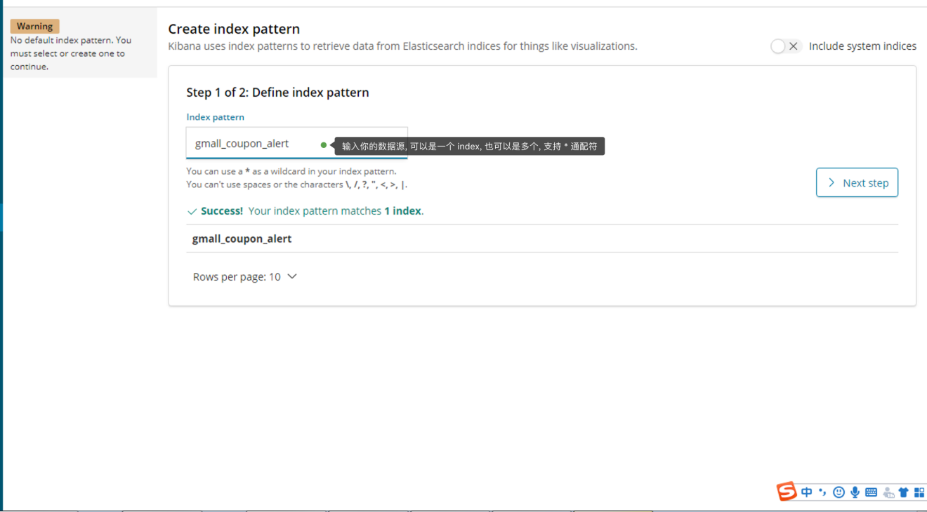

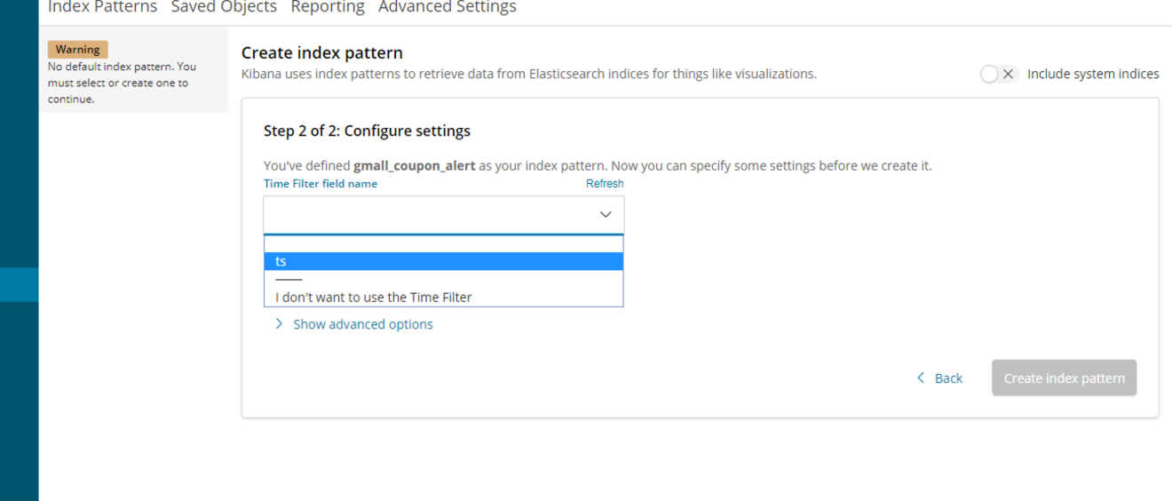

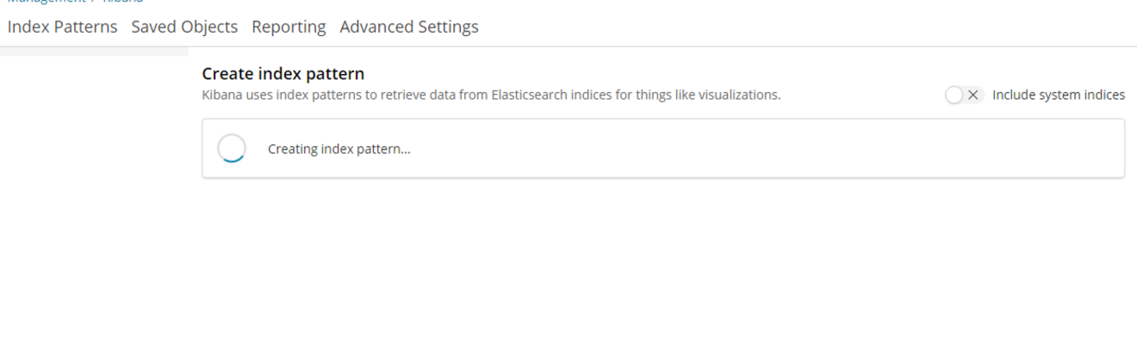

### 5.2 建立可视化图表

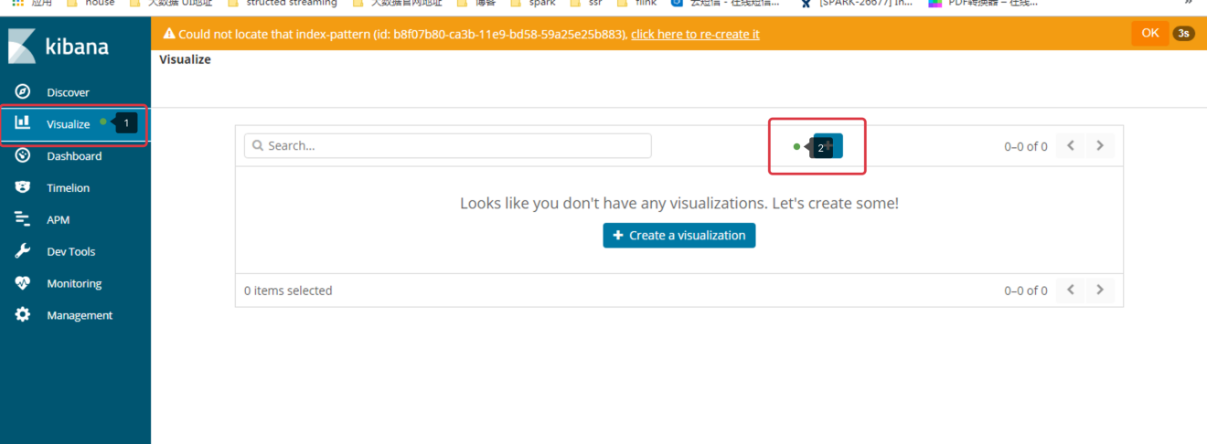

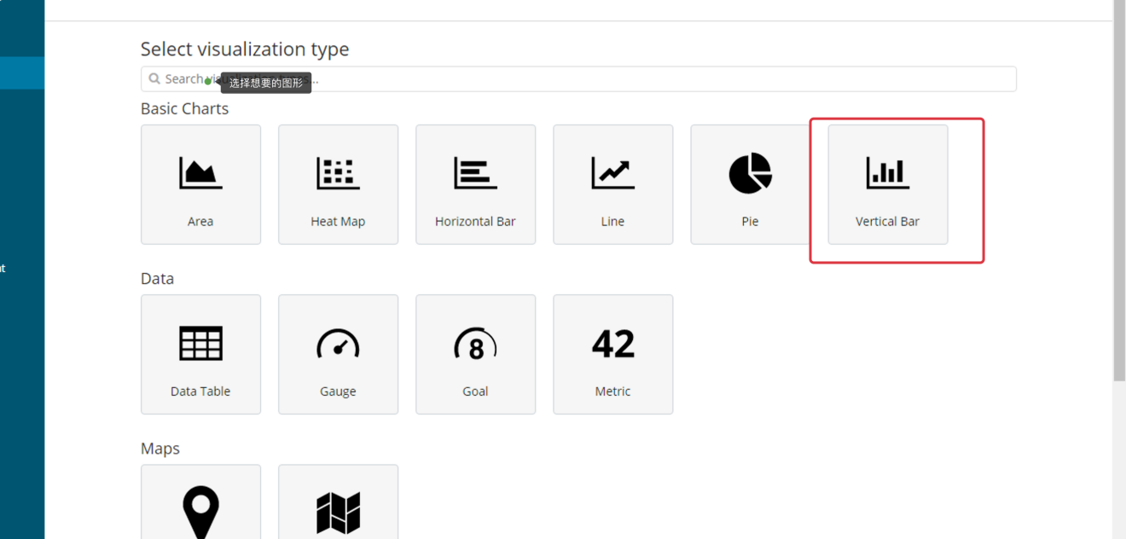

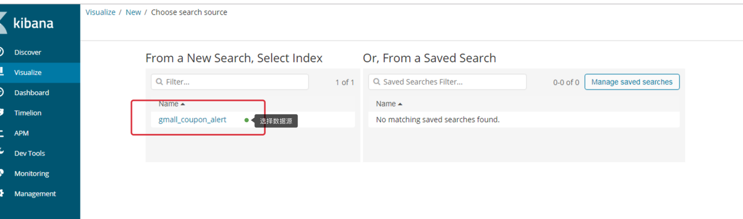

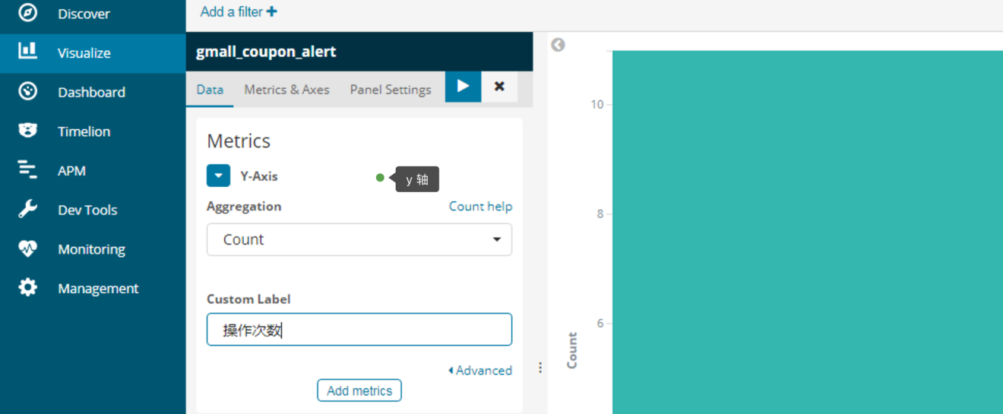



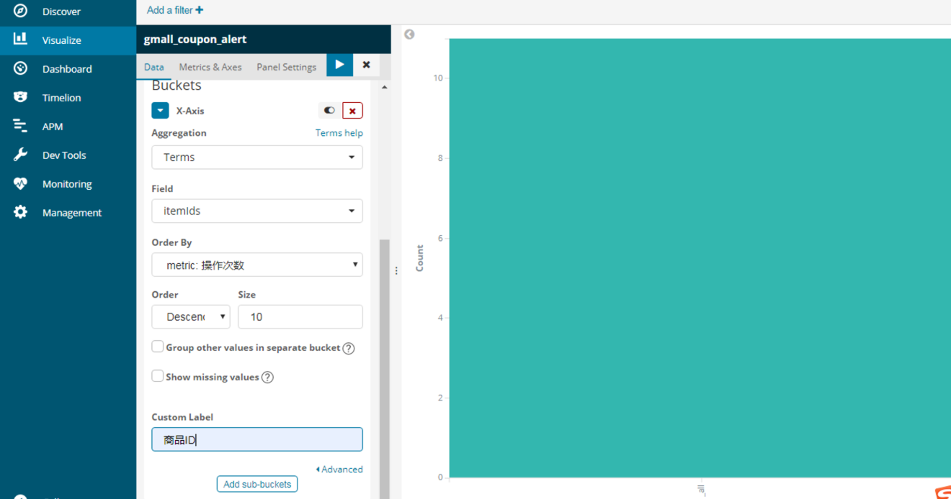

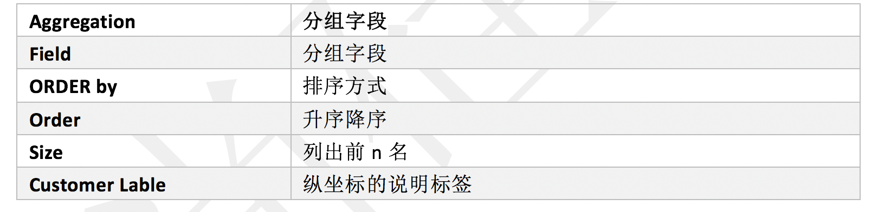

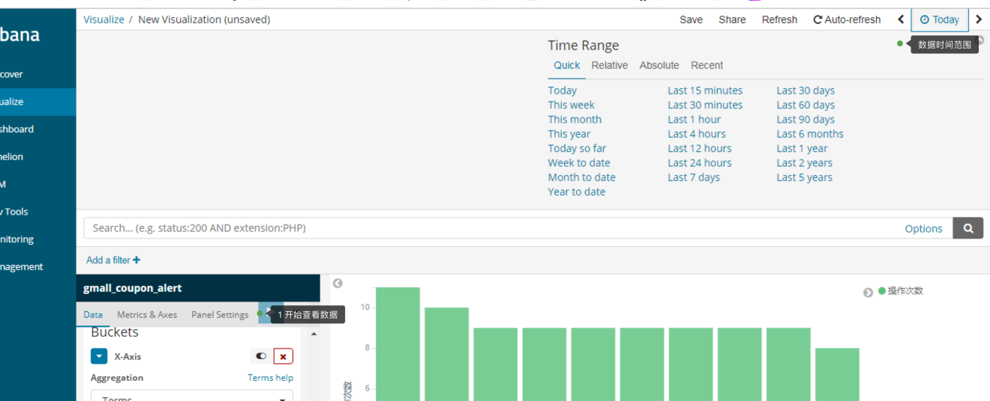

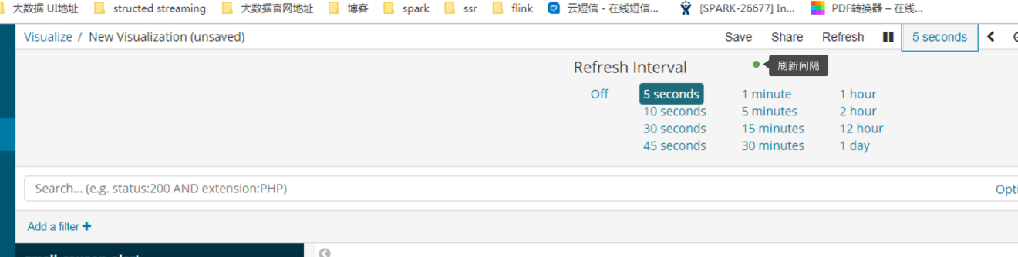

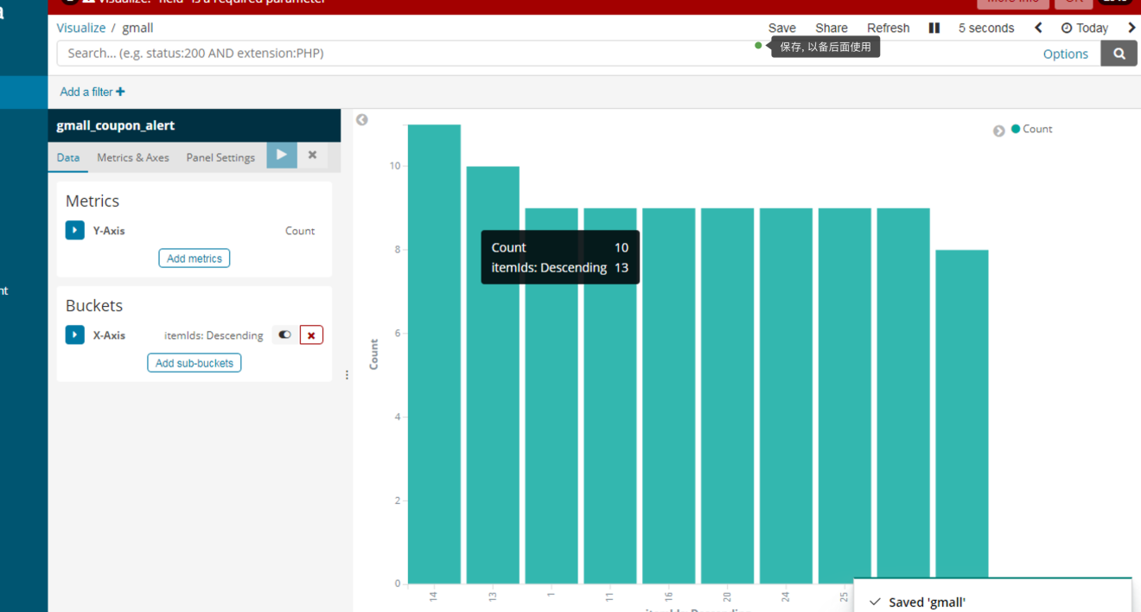

### 5.3 建立 Dashboard

一个仪表盘上可以显示多个视图.